Absorption of Radiant Energy
Color affects the absorption of radiant energy. You can use the results of this experiment to better dress for the season—to keep cooler in the summer and warmer in the winter. Home designers and city planners use the principles being studied to design more energy-efficient homes and cities.

OBJECTIVES
- Use Thermal Analysis to monitor temperature change due to radiant energy absorption.
- Transfer data to Graphical Analysis.
- Interpret your results.

MATERIALS
iPad®, iPhone®, or iPod® with Lightning® connector | piece of white paper
Vernier Thermal Analysis for FLIR ONE™ app | piece of black paper
Vernier Graphical Analysis app | lamp and incandescent bulb
FLIR ONE thermal camera for iOS

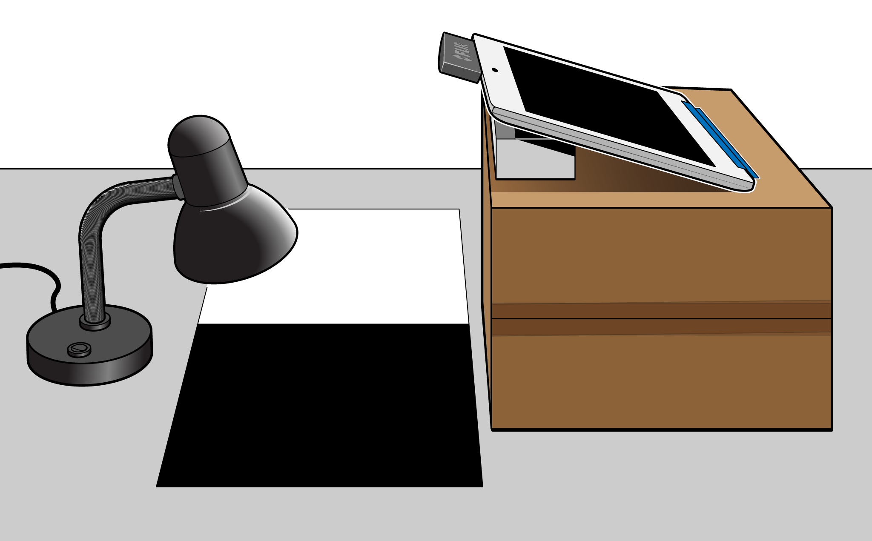
Figure 1

PROCEDURE
1. Position a piece of white paper and a piece of black paper next to each other, as shown in Figure 1.
2. Position a light bulb directly over the boundary between the two pieces of paper and about 10 cm (4 inches) above the paper pieces.
3. Open the Vernier Thermal Analysis app on your mobile device.
4. Tap the + sign to start a new experiment.
5. Attach the FLIR ONE thermal camera to the Lightning connector with the lenses aimed away from you.
- If you also have the FLIR ONE app on your device, you will see a message that FLIR ONE would like to communicate with the FLIR Systems FLIR ONE Camera. Tap Ignore.
- If the camera battery does not have enough charge, the app will close.

6. Set up the Thermal Analysis app to record the temperature of the white paper and the black paper.
- Set the device and camera on a box so that the camera is aimed at the pieces of paper and directly under the lamp. It may help to put a second, smaller box under the device so that it is at an angle, as shown in Figure 1.
- Add two spot thermometers, one on the black paper and one on the white paper, both under the lamp.

7. Record data for 100 seconds.
- Tap the red, circular Record button.
- Wait 100 seconds, watching the graph.
- Stop recording data when the graph reaches 100 seconds.

8. When the app prompts, save the data.
- Tap Save. The Experiments list will appear.
- Find the most recent experiment, and rename it with your name by tapping the circled i.
- Open your experiment by tapping the name.

9. Export the data to Graphical Analysis.
- Tap Export. Choose Data file.
- Choose Open in… and tap Copy to Graphical.
- Graphical Analysis should open, showing the graph of your data.

10. Tap and drag to select your data on the graph, and then turn on statistics. Record the minimum and maximum temperatures for the two pieces of paper.

DATA
White Black
Minimum temperature ______ °C ______ °C
Maximum temperature ______ °C ______ °C

analysis questions
1. Calculate the temperature change, ΔT, for each color by subtracting the initial temperature from the final temperature (ΔT = T f – T i).

2. Which color had the larger temperature increase?

3. Which color had the smaller temperature increase?

4. Why is it better to wear light-colored clothing in the summertime?

5. Solar collectors can be used to absorb the sun’s radiation and change it to heat. What color would work best for solar collectors? Explain.

EXTENSIONS
1. Investigate the abilities of other colors to absorb radiant energy.
2. Investigate the abilities of different materials, such as soils, concrete, asphalt, water, and grass, to absorb radiant energy.
3. Repeat the experiment with an LED light bulb or compact fluorescent light bulb.

