Inquiry Activity: Study of Trusses

Learning Objectives

* Engage in an inquiry activity to explore key elements of truss construction.
* Evaluate whether truss members are in tension or compression. Develop understanding of which type of force is more likely to cause failure.
* Analyze data to identify design features or characteristics of the truss components to optimize the strength of a bridge.

Recommended Grades/ Subjects

Grades 9–12 or college-level physical science, physics, or engineering

The activity can also be modified for middle school students.

Time needed

As written, this activity will take up to three 45-minute periods for the truss testing activity. You may be able to accomplish the activity in two periods and some class discussion on the third day if you assign investigations of factors affecting truss strength to different groups.

Related Next Generation Science Standards

|  |  |  |
| --- | --- | --- |
| Disciplinary Core Ideas | Crosscutting Concepts | Science and Engineering Practices |
| ETS1.A. Defining and Delimiting Engineering Problems  ETS1.B. Developing Possible Solutions  ETS1.C. Optimizing the Design Solution | Patterns  Cause and effect  Scale, proportion, and quantity  Systems and system models | Asking questions and defining problems  Developing and using models  Planning and carrying out investigations  Analyzing and interpreting data  Using mathematics and computational thinking  Constructing explanations and designing solutions  Engaging in argument from evidence  Obtaining, evaluating, and communicating information |

Information for the Instructor

The overarching goal of the activity is to use the engineering design process and in particular to emphasize the cyclical nature of design, construct, evaluate, and improve. The activity was developed for use with the Vernier Structures and Materials Tester (VSMT) and the VSMT Truss Tester Accessory (VSMT-TRUSS). It is, however, readily adaptable to any platform for data collection and evaluation.

Building and investigating trusses is a great way to start an exercise in bridge design and engineering (or a bridge-building classroom competition). Trusses can be built quickly, without requiring a lot of material, and the simplicity of the truss allows students to study particular aspects of engineering design. Students use the results of their investigation to build a truss of their own design.

Approach

Part 1: Factors Affecting Simple Truss Strength

Although students may not be aware of their prevalence, with a little prompting they will discover trusses in a variety of places. House roof structures and bridges may be some of the most familiar trusses. Take a minute to probe your students with questions to see what they already know and to prime their curiosity about what they don't know. This might be most effective when the students have a simple (triangular) truss in their hands to manipulate. Here are some sample questions:

* What is the purpose of a truss?
* Which members of the truss are in compression and which are in tension?
* Are trusses loaded from the top or the bottom?
* Can the forces internal to the truss ever be larger than the external forces?
* Which way is it easier to break a truss member: in compression or tension?
* If you apply a force to the top of a triangular truss that is supported on the other corners, where do you think it will break?

A follow-on question to brainstorm is, "What makes a good truss?" While this is more subjective, several ideas that will be useful in identifying your bridge design criteria may become evident:

* Maximum force held *vs*. force held per unit of weight of the structure
* Built to sustain a target force and no more
* Cheapest bridge to carry some minimum weight or load
* Aesthetically pleasing/beauty

The next step would be for the students to brainstorm what factors will affect the strength of the truss. Several answers are possible:

* Angle of the truss
* Type of joint that connects the members
* Cross-sectional shape and size of the member
* Span (distance between supports)
* The type of material used

At this point students can be directed in basic construction of trusses and the outline of expectations you set for the activity. Encourage students to make good observations of how the trusses fail. They will use these observations, along with the data from the experiments, to create the best truss in Part 2. Depending on the time allotted for this activity you can assign lab groups to evaluate one or more of these variables and then facilitate a class discussion to share the lessons learned from each evaluation.

The student handout for this activity is organized with the intent of each lab group identifying their own criteria to investigate and developing and conducting their investigation without interacting with other groups. This can be modified to encourage a common set of criteria to be considered.

Tips

Students will come to this activity with a wide-variety of skill in working with their hands. The lessons from this activity are best experienced without the added variability of construction techniques.

The Truss Tester Accessory comes with a pair of plastic corner brackets that takes some of this variability out of the equation. These simple brackets can be attached to the base of the truss with small brads or a block of wood glued in place behind it to hold it in place. The angled pieces fit into the top. Using this method, construction of the truss is quick and the students can focus on the results rather than wondering if their ability to make a good joint affected their results. We have posted a 3D printable template for these corner brackets at www.thingiverse.com/thing:1081393 if you wish to make some of your own. If you don't have a 3D printer, you may have access to one through your library system or other public resource.

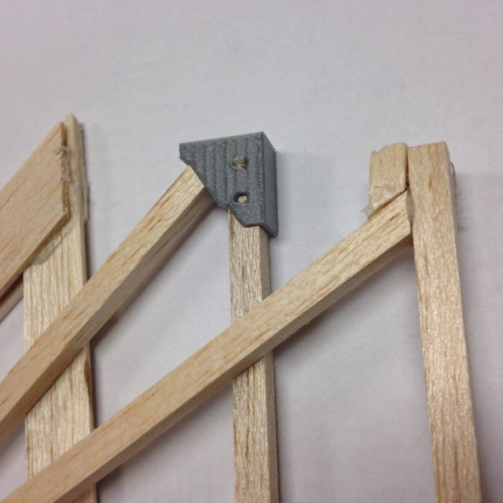

Figure 1 Examples of truss joints

If you choose to have students create their own trusses without the corner brackets, balsa wood and hot glue make excellent joints. There is a lot of information regarding the wide variety of wood glues available on the internet, but for the investigation of simple trusses, balsa and hot glue works very well. This type of bonding sets up very quickly and can be tested without waiting for a lot of curing time or tricky epoxies. Some practice in working with hot glue will allow students to make solid joints that will not fail before the member breaks. Gussets and stops will help ensure joints don't fail before the wood breaks.

Part 2: Improving Truss Strength

The next part of this activity is to take the data and observations from Part 1 and design a truss (or series of trusses) to support the highest load (or whatever design criteria you set). Students should clearly articulate how they use the data and observations from Part 1 in their design.

If time allows, giving the students the opportunity to revise their design is a great way to stress the iterative aspect of engineering design. You may also consider a constraint on the amount of material available to students in order to ensure that the truss does not exceed the 1000-N limit of the VSMT.

Tips

Students should observe that during the initial investigation failure typically occurs through buckling of a member in compression. Providing some additional support for lengthy members will provide a significant benefit. There is considerable information related to buckling of members. Some research by students should uncover a wealth of information related to this phenomena.

If you used the truss corner brackets mentioned above for constructing simple trusses, you might consider removing this assistance and require the students to include more robust consideration of joint construction. You may also introduce a study of different adhesives if time allows.

General Considerations

There are several Vernier interface and software options for this activity. The use of the Displacement Sensor on the Vernier Structures and Materials Tester (VSMT) is not specifically required for this activity, so any interface and software combination that can accommodate the VSMT Force sensor will work. Refer to the compatibility chart on the VSMT webpage to determine the best option for your class: www.vernier.com/vsmt

There are a number of things that are useful to keep in mind when using the VSMT and the VSMT Truss Tester Accessory (Truss Tester):

1. Trusses built with 1/4" square Balsa wood or 3/32" Balsa wood planks up to 3/4" wide are building materials that have been used successfully with this investigation. Other dimension stock and other types of wood can be used, but be careful not to exceed the load limitations of the VSMT (1000 N).

2. The Truss Tester is designed with 1/2" spacers separating the two walls.

3. Follow these safety recommendations, and see the VSMT *User Manual* for additional safety and use tips.

Wear safety glasses

Tackle using threaded parts should be attached so that a sufficient amount of the threaded component is engaged

Quick links should be secured and not left open

troubleshooting

Note that the Displacement Sensor will not auto-ID in LabQuest App or Logger *Pro*. If displacement data is desired, be sure to select the Displacement Sensor, as explained in the VSMT *User Manual*.

Additional Resources

The following information is provided as background for instructors regarding truss statics.

Truss

A truss is a rigid framework with internal members that are connected in a triangular pattern. Trusses have a very high strength-to-weight ratio, which allows them to span long distances. Historically, trusses were frequently used in bridge design; due to their efficiency and low cost, they are also becoming common elements in homes for roof and floor framing construction. A truss bridge is built from two trusses (one on either side) connected by a horizontal bridge deck. The bridge deck serves as the vehicle navigation surface and can be located at the top or the bottom of the bridge. Additional lateral bracing is applied as necessary to improve stability, but it must not obstruct the travel pathway along the bridge deck.

Pins and gusset plates (the connections that join bridge members together) are critically important to the overall structural integrity of the bridge. Bridges are supported by *abutments*, foundations that support the weight of the bridge and hold back the soil behind it. If additional supports are required in the middle, they are called piers. Abutments and piers are usually made of concrete, while bridge members are made of steel.

Bridges must carry three different kinds of forces: loads, reactions, and internal forces. Loads are the external forces that are applied to the bridge, such as the weight of the cars and trucks that cross it. Loads also include the weight of the bridge itself, the weight of snow and rain, the force of wind, and the forces caused by earthquakes. Reactions are the support forces supplied by the abutments or piers. Internal forces are the tension and compression forces developed along structural members when a load is applied. Members in tension are being pulled or stretched, while members in compression are being pushed together.

One of the most common truss configurations is the Warren truss. The Warren truss is known for its simplicity because no vertical members are used. Two other common designs are the Pratt and Howe trusses.

In the Pratt truss, all inner diagonal members slant down toward the center, while in the Howe truss they slant toward the outside. The Pratt truss is much more economical to build than the Howe truss. Most of its diagonal members are in tension allowing them to be thinner than the compressive diagonals in the Howe truss.

Truss bridges' support forces are equal to the applied load, and the moments about any point are zero. The strength of a bridge is determined by the largest internal force it can withstand before failing, but no internal force can exceed the material strength of the individual member. Tensile and compressive strength depend on the material used in fabrication, as well as the width and thickness of the structural member cross-section. The compressive strength is also dependent upon the length and shape of individual structural members, but length and shape have no influence on tensile strength.



Figure 2

Calculating Forces in a Truss

The basic approach in solving for the forces acting on individual members in a truss follow the general steps of (1) solving for reaction forces where the truss connects to the ground, (2) isolating individual joints and using an equilibrium of forces and trigonometry to determine the forces along each member (either in tension or compression). The following illustrates this process for this simple truss:

1. Draw a free-body diagram of the bridge. A free-body diagram is a sketch of the bridge showing all forces acting on it. The entire applied load should be drawn as a downward force acting on the center of the bridge (50 N in the example shown below). Calculate the upward reaction forces at the outer supports so that the bridge is in equilibrium.

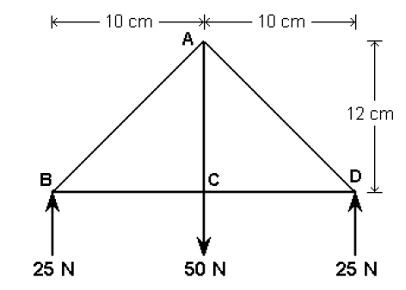

Figure 3

2. Isolate the left-most joint. Use trigonometry to calculate the angle between the diagonal and horizontal members (assume the diagonal member is the hypotenuse of a right triangle).

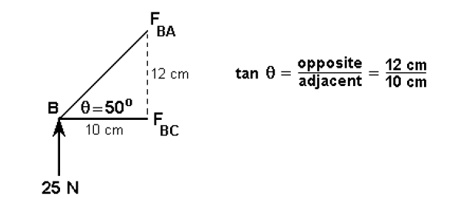

Figure 4

3. Resolve the diagonal member into its horizontal and vertical components. For the joint to be in equilibrium, the sum of all forces in the vertical direction must equal zero. Since there is only one vertical force of 25 N acting in an upward direction, the vertical component of FBA must also equal 25 N, but it must be acting in a downward direction. Notice that both vertical components are “pushing” on joint B, so the force in member BA must be a compressive force.

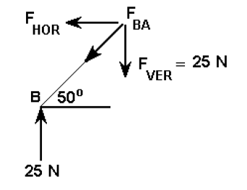

Figure 5

4. Use trig twice more to calculate the horizontal component and the magnitude of the resultant force for FBA.

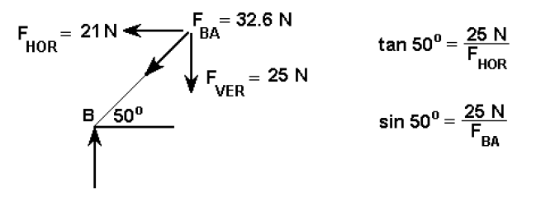

Figure 6

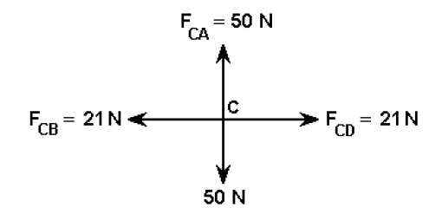5. For the joint to be in equilibrium, the sum of all forces in the horizontal direction must also equal zero. Since there are only two horizontal forces, FBC is "pulling" on joint B, so the force in member BC must be a tension force.

Figure 7

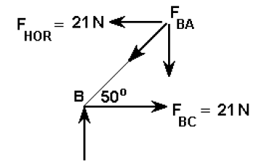6. Repeat Steps 2–5 to calculate the forces acting on joint C. When transferring the value of any known forces (in this case the force in member BC), be sure to apply it in the opposite direction.

Figure 8