Bridge Competition
Your task in this project sounds pretty simple: you are going to build a bridge out of wood and glue. Your bridge will be evaluated on its "efficiency"—how much weight it can hold compared to its own weight. But before you just start gluing sticks together take a look at the other requirements for the bridge!

MATERIALS
Vernier data-collection interface (e.g., LabQuest or LabQuest Mini)
Vernier data-collection software (e.g., LabQuest app or Logger Pro)
computer (only if using Logger Pro)
Vernier Structures and Materials Tester (VSMT)
wood (as supplied by the instructor)
other materials (as supplied by the instructor)

General Considerations
First of all, don't underestimate the effort required to build a quality bridge. There are a lot of factors you might consider as you begin thinking about design and construction.
Adhesives: What species of wood are you using? The type of wood will greatly affect what type of adhesive works best with the wood. Ideally, your glued joints will be stronger than the wood they hold so that, ultimately, the wood fails. How much glue should you use? Do you need to prepare the wood in some way prior to applying the glue? This may include wetting the surface or sanding the wood. You may benefit by practicing gluing.
Joints: An investigation of the types of joints used to join two pieces of wood is worthwhile. When is a butt joint preferable to a lap joint and why? Is there value in using gussets or pins? Does it matter whether the pieces of wood are in tension or compression?
Trusses: The bridges you typically make with wood are some variation of truss bridges. What makes a strong truss? Is there an optimum angle? Do they fail in a predictable way? Where is the load going to be? Which wood members are going to be under the most significant forces? Which parts are in compression and which ones are in tension?
Construction: Building a small wooden bridge well takes skill. This comes through practice. Note that symmetry of a bridge is important and that tying the two sides together is equally important as building a good truss system on one side. If you have the time, you will benefit from building and testing a design in order to improve both the design and construction.

Bridge Design Requirements
The following bridge competition rules are modified from the Illinois Institute of Technology's International Bridge Competition rules from 2016. For more information, see http://bridgecontest.phys.iit.edu/public/international/index
The constraints for the design and construction are as follows:
- The design will be drawn on paper with a 1:1 scale. Include side, end, and top views.
- The bridge must be constructed only from the 3/32-inch square cross-section basswood and any commonly available adhesive.
- The wood may be notched, cut, sanded or laminated (e.g., two or more pieces glued together to make a larger dimension) in any manner but must still be identifiable as the wood species provided.
- No other materials may be used. The bridge may not be stained, painted, or coated in any fashion with any foreign substance.

The bridge complies with the following physical constraints (Note: All lengths are intended to be accurate to the nearest mm, unless otherwise noted.):
- The bridge mass shall be no greater than 25.00 g.
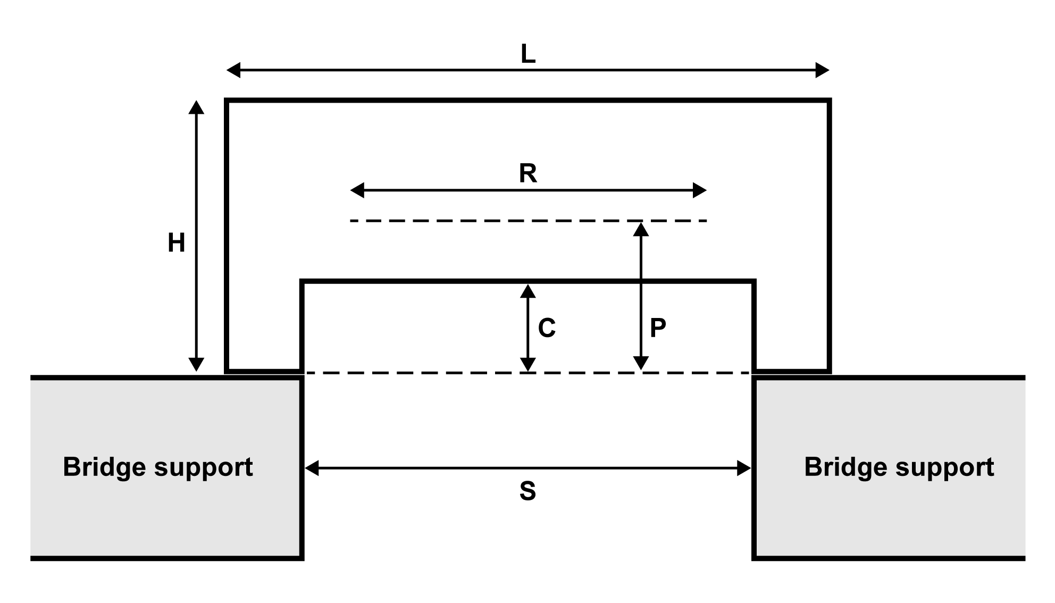
- The bridge must span a gap (S) of 300 mm, be no longer (L) than 400 mm, be no taller (H) than 180 mm above the support surfaces, and have a maximum width (W) of 70 mm. It must have a horizontal loading plane that is a height (P) above the support surfaces where 60 mm ≤ P ≤ 80 mm (see Figure 1). The bridge structure may not project below the support surfaces.
Figure 1 Schematic of the bridge constraints

- The bridge must be constructed to provide a horizontal support surface for the loading plate and rod at the loading position. The position will be at the mid-span of the bridge. The structure of the horizontal loading plane must be a minimum length (R) of 160 mm and centered on the mid-span of the bridge. The bridge structure must allow the loading rod to be attached to the loading plate from below.
- The bridge must have a minimum clearance (C) of 60 mm in height above the support surfaces. This clearance also extends 80 mm toward either end of the bridge from the center point of the bridge. No part of the bridge structure may be in this clearance area, and a 60 mm high, by 160 mm long block oriented with its 160 mm dimension parallel to the span of the bridge must pass cleanly under the bridge when the bridge is placed on a flat table top.
- The load will be applied by means of a 50 mm square plate that is 6.35 mm (1/4 inch) in thickness. A 6.35 mm (1/4 inch) diameter loading rod is attached from below to the center of the plate and screws into the top of the VSMT force sensor. Alternatively, the loading plate may be connected to an eye-bolt that connects to a short chain or quick-link that attaches to the VSMT force sensor. The plate will be horizontal, it will not pivot on the loading rod, and the sides of the plate will be parallel to the longitudinal axis of the bridge.
- The loading position will be located on the horizontal loading plane. The center loading position will be located at the center point of the bridge.

competition procedure
At the time of the competition, participants will (one at a time) center their bridge on the loading surfaces. The participant will connect the bridge to the VSMT with the provided hardware. Once there is coordination between the participant and those performing the data collection that everything is ready, the participant will turn the wheel to apply the load to their bridge.
The goal of the competition is to have the bridge with the highest efficiency. Efficiency, E, is calculated by taking the force applied to the bridge at failure and dividing it by the weight of the bridge and then multiplying it by 100 to make it a percentage. (You can also think of this as a ratio of mass of an object supported by a bridge to the mass of the bridge itself multiplied by 100.)
$$E=\frac{force applied}{weight of the bridge} ×100$$
The maximum scoring load supported by any bridge will be 490.5 N (50 kg). Any amount over this quantity will not count in the calculation of the bridge's efficiency.
- Bridge failure is defined as the inability of the bridge to carry additional load, or a load deflection of 25 mm, whichever occurs first.
- The bridge with the highest structural efficiency, E, will be declared the winner.

