Inquiry Activity: Test Methods for Chalk
A horizontal beam that has a uniform composition (i.e., a homogenous material), such as a metal or a plastic, is easily tested for its response to a load. You can do this by applying a force at the center point relative to the vertical supports. This test, often referred to as a "3-point test" can be used to determine the maximum load the beam is able to sustain before breaking.
Now consider a material that is non-homogenous—concrete, for example. It might have too much cement in one place, or have too much rock in another location, making it weaker in places. Do you think the 3-point test is the best method for this type of material?
A test method for beams should be a reliable means of comparing materials, as well as providing meaningful data that allows you to design a structure to withstand a specific load. In this activity, your challenge is to modify the "3-point" test method (or create a completely different approach) so that your test method provides meaningful data in the evaluation of a non-homogenous material.
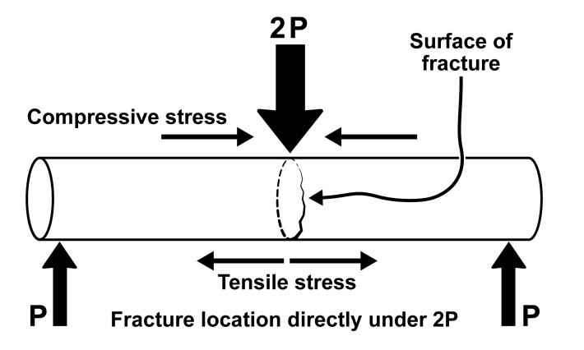
The 3-point test applies a point load to the center of the beam

MATERIALS
Vernier data-collection interface (e.g., LabQuest 2)
data-analysis software (e.g., Logger Pro)
Vernier Structures and Materials Tester (VSMT)
chalk (supplied by the instructor)
high-strength line
other materials (supplied by the instructor)

INVESTIGATION Design
1. As a class or in your lab group, observe 3-point testing of several pieces of chalk. Note how and where the chalk breaks. Discuss variability in the data, including the range and distribution of the data points.
2. In your lab group, discuss the purpose of this type of destructive testing. What are the drawbacks in using the 3-point test for non-homogenous materials? What data seem most appropriate to consider: average, high, or low? Explain. Write a summary of your discussion.
3. Brainstorm and design a new test method (or a modification of the 3-point test) that addresses the problems identified in Step 2.
4. Build or create any devices necessary to conduct your new test method, and conduct a test of a large sample size (as resources allow). Compare and contrast your data with 3-point test data for the same type of chalk.
5. Compare your results with other groups in your class and comment on the different test protocols and results.

Report your findings
Write a report that addresses the items noted in the Investigation Design section. Summarize your data and draw conclusions regarding the effectiveness of your revised test method. Include a short paragraph addressing how you could improve your test method and/or hardware required to conduct this test.

A center loaded beam has three points of contact: two supports on either end and the applied downward force in the center. Hence, the name: 3-Point Test.

