Inquiry Activity: Test Methods for Chalk
Learning Objectives
- Engage in an inquiry activity to explore the nature of failure of a cylinder of non-homogenous material.
- Analyze data and consider implications of variability in the samples.
- Experience how a test design can affect the data and analysis of results.

Recommended Grades/ Subjects
College courses in physics or engineering—may also be used with advanced high school engineering or physics students.

Time needed
You should plan on three 45-minute periods with time in the final class period to discuss the results for a full investigation. If time or supplies are short, you can provide data to the class for a discussion of 3-point testing.

related EXPERIMENTS
This activity can be conducted as part of a series exploring the properties of materials. There are several activities related specifically to deflection of beams. Follow-on activities involving trusses and bridge building can stand alone or act as a culminating activity to this investigation.

Related Next Generation Science Standards
Disciplinary Core Ideas | Crosscutting Concepts | Science and Engineering Practices
ETS1.A. Defining and Delimiting Engineering Problems  ETS1.B. Developing Possible Solutions  ETS1.C. Optimizing the Design Solution | Patterns  Cause and effect  Scale, proportion, and quantity  Systems and system models | Asking questions and defining problems  Developing and using models  Planning and carrying out investigations  Analyzing and interpreting data  Using mathematics and computational thinking  Constructing explanations and designing solutions  Engaging in argument from evidence  Obtaining, evaluating, and communicating information
Information for the Instructor
Introduction
The activity starts with a standard 3-point load test and the poses the challenge for students to devise a better test method for non-homogeneous materials. The goal of the activity is for students to explore how the design of a test method can be modified to address the non-uniformity of the material being tested.
A non-homogenous material such as classroom chalk is expected to have a high degree of variability in its ultimate strength (as compared to uniform/homogenous materials, such as steel) in a 3-point load test. The reason for this is the random imperfections in the structure of the chalk. For example, a single piece of chalk may have several weak points near the loading point (resulting in a low ultimate strength). Alternatively, it may be relatively flawless in the area near the load (resulting in a high ultimate strength). This variability introduced from the test procedure may mask the variability of the material itself. The challenge is to try to modify the test method to provide data that more effectively captures the weakest point of the chalk, and thereby is a better predictor of the strength of the material.
On the most basic level, students should observe that different test methods give different results. The implication is that there is an opportunity to optimize the test protocol. For example, a 3-point test will (almost) always fail at the point the force is applied. Contrast that with a 4-point test and you will see the material fail at other locations. With a 4-point test you will often observe failure that makes it clear that the top of the sample is in compression while the bottom tears apart in tension. These are valuable observations.
The loftier goal of this activity is to give students an opportunity for tangible application of Shear and Moment Diagrams. This activity, as designed, should provide context for understanding these diagrams, as well as a hands-on activity to explore the strength of materials of this type.
This activity was inspired by a project developed by Shane Clarkson while working on his MS in Mechanical Engineering at Stanford University.
Approach to Inquiry Activity: test methods for chalk
Ideally, students will have explored the nature of factors affecting the flex of a rectangular beam, as well as investigated the effect that the cross-section shape of a beam has on its flexibility. These activities can be reviewed, if desired.
The concept behind this activity is that a 3-point test places a maximum shear and maximum bending moment right at the point the load is being applied. This will be the location of failure, barring a massive weakness elsewhere in the sample. Students should recognize that this point may not be the location of the weakest point in the sample. The challenge is for the students to modify the test protocol in order to be able to test for the minimum force required to cause failure of the sample.
Introduce this activity by having students break a piece of chalk using their fingers and thumbs to apply leverage to the cylinder and ask them to compare the results with others in their lab group. A magnifying glass, cell phone camera, or microscope can be used to enhance student observations.
The next step of the activity is to conduct a 3-point test of chalk samples. We recommend that the initial 3-point testing be conducted as group activity. Alternatively, groups can each conduct several trials and then combine results with other groups to get an appropriately large data set. If you are low on time, a third option is to provide pre-collected data to allow the students to see the range of variability. If you choose the third option, it is beneficial to keep the chalk samples that were broken so they can be examined by the students. Consider integrating video capture into your data collection .
Discuss observations such as maximum force at failure, and the location of failure. Displaying the data graphically may emphasize the variability observed.
You might pose the following questions to the students:
1. Why is there this much variation in data? Is this a concern?
2. Where does the failure occur relative to the location where the force is applied? Is that the weakest point in the chalk?
3. Does failure occur at the top or the bottom of the beam first? Is that material in tension or compression?
The discussion points are intended to bring out the following points:
There is variability in the results because the material has some "non-uniform" flaws due to its structure or contaminants.
The chalk tends to break where the single force is applied, not necessarily its weakest point.
The failure tends to start at the bottom of the chalk where it is in tension. This may be difficult to determine.

The discussion should ultimately come around to the question: "What is the purpose of a test protocol for beams constructed of non-uniform material?" Is it to determine the maximum supported load or the minimum supported load? Does it matter if it is a distributed load or a point load? Should it seek out that weakest point or just take a large enough data set to compensate for this variability? This questioning and discussion should set the stage for students to work in small groups to determine the purpose of such a test method and develop a method designed to address the short comings of the 3-point test.
The students may come up with any number of alternatives that may address these shortfalls, including a distributed load over some length of the chalk, a multi-point test, and an offset 3-point test.
Note: If your students are not familiar with Shear and Moment Diagrams, it may be sufficient to provide the theoretical relationship between a 3-point test and a 4-point test, have them conduct the testing in both modes, and reflect on the implications of that testing.
Depending on time available and progress of the class, you may want to share information regarding the Shear and Moment diagrams and the 4-point load test. Refer to the Background section of this Instructor Information.
General Considerations
There are a number of additional items that are useful to keep in mind when conducting the investigation:
1. There are several sources of chalk.
- Classroom chalk is readily available at stationery and craft stores, as well as online retailers. Standard Crayola Chalk was used to generate data presented in this document.
- Railroad chalk is larger in diameter, but often has a tapered diameter. Forces in the neighborhood of 200 N are required to break this material, so good knot tying is critical. A double fisherman's knot is a good way to secure the loop. Refer to www.animatedknots.com or some other websites for instructions for tying knots.
- Railroad chalk can be used "as is" or shaped on a lathe into a "dog bone" shape to create a standard uniform diameter test sample. The material is prone to fracture, so use a fast rotation and a very sharp cutting tool.
- If a tapered chalk is used, you will still see variation in location of the break for the 4-point test, but the majority of the breaks will be on side with the smaller diameter.
2. A loop of strong thread or fishing line is useful for transferring the loads to the chalk. A simple loop that passes through an eye bolt before being tied works well for a 3-point load. A longer loop that is passed through the eye bolt after it is tied can be used for the 4-point load. The string will self-adjust to apply the same force on each end, assuming friction is small (see Figure 1).
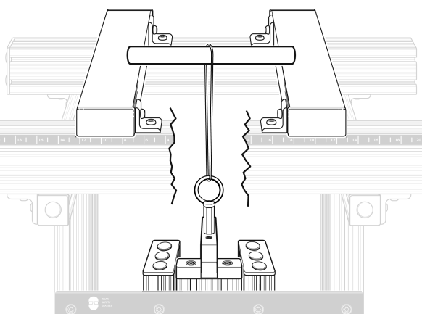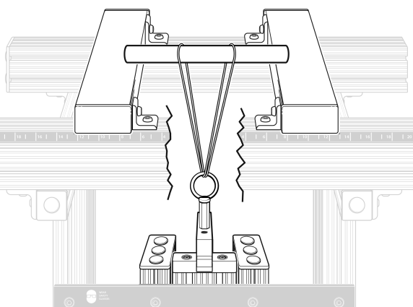
Figure 1 Connecting the string for 3- and 4-point load tests

3. It is not necessary to use the displacement sensor for this activity. If you do, realize that most of the displacement measured will be of the thread/line tightening and stretching. The Logger Pro experiment file "3 and 4-Point Testing" only collects data from the VSMT Force Sensor. Find the experiment file by choosing Open►Experiments►Probes & Sensors►Structures & Materials Tester from the File menu.
4. Marking the chalk with a pencil mark where the load(s) is/are applied will assist in evaluating where the chalk breaks relative to the applied load.
5. We have created a simple bracket to help hold the chalk in place on the VSMT. It is available on the Thingiverse, so you can download the file and 3D-print a pair for use with the Structures and Materials Tester: www.thingiverse.com/thing:1792522
6. Follow these safety recommendations, and see the VSMT User Manual for additional safety and use tips:
Wear safety glasses.
Tackle using threaded parts should be attached so that a sufficient amount of the threaded component is engaged.
Quick links should be secured and not left open.

Equipment Setup Suggestions
- The experiment file "3 and 4-Point Testing" can be used for this investigation. Find it by choosing Open►Experiments►Probes & Sensors►Structures & Materials Tester from the File menu. This file allows you to collect a series of data and displays it in a bar chart format.
- You can also use the default settings that load when you connect the load cell/force sensor of the VSMT.

troubleshooting
Although not required for this activity, the most common point of note related to using the VSMT is that the Displacement Sensor will not auto-ID. Be sure to select the Displacement Sensor as explained in the VSMT User Manual, if desired.
Background
An approach commonly used for non-homogenous materials is the 4-point test. In a 4-point test, a load is applied at two points equidistant from the center of the sample. The section between the two loads experiences a bending moment, but the shear is neutral. This results in the bottom of the sample (between the two applied loads) being placed in tension so that the weakest point along this surface starts to fail. Once this starts, the crack propagates quickly through the cross section of the chalk.
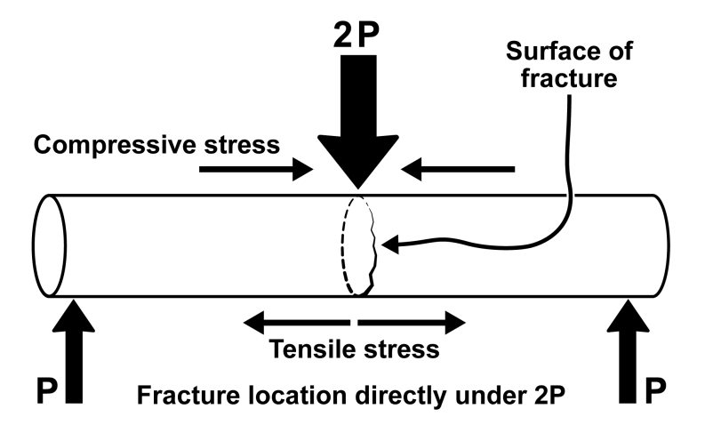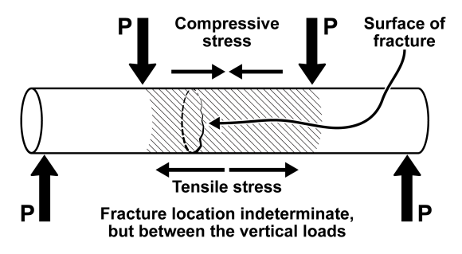
Figure 2 Range of failure locations for 3-point and 4-point load tests
The following information may be useful for instructors who have not been introduced to Shear and Moment Diagrams. This is not critical to the activity, but provides a depth that may be appropriate for some classes—especially engineering classes.
To understand how different loading patterns affect beams, it is useful to think about the beam just before it fails. A beam that is stationary is in equilibrium. That is to say, all of the forces are in equilibrium, as well as the moments. We can use this information to develop Shear and Moment diagrams. These can be very helpful visual aids to quickly identify where the maximum shear and moments occur. Examples of some configurations are shown in Figures 3 through 6.
The shear can be determined by considering the internal forces required to keep the beam in equilibrium at any point along the beam. Likewise, the bending moment can be determined by calculating the moment necessary to counter all existing moments. The standard convention is to identify a positive shear as one that tends to move the left side of a beam up and the right side down. A positive moment is one that tends to put the top in compression and the bottom in tension.
For a center-loaded beam with a load of 2P and reaction forces of P. The shear remains essentially constant throughout the beam, transitioning direction at the center.
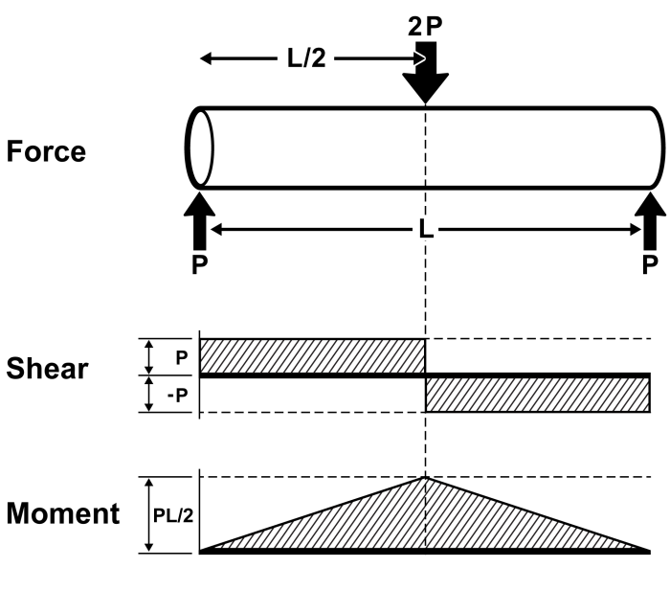
Figure 3 Shear and Moment Diagram for center loaded beam

Notice that the maximum moment is experienced at the point where the load is applied. It is also helpful to recognize that the Moment diagram can be constructed by considering the integration of the area under the Shear diagram.
If we apply this same tool to a beam where the load is offset the diagrams change slightly:
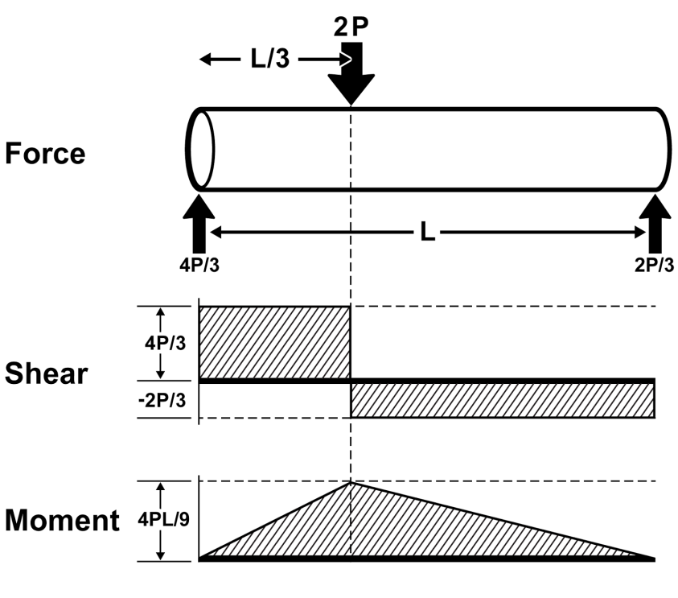
Figure 4 Offset load
There are two notable effects due to this shift:
1. Since more of the load is transferred to the left side of this beam, the shear is higher on that end.
2. Because the applied load is closer to the support, the maximum internal moment is reduced. It is still located at the point of the applied load.
Now consider a load that is distributed over some length.
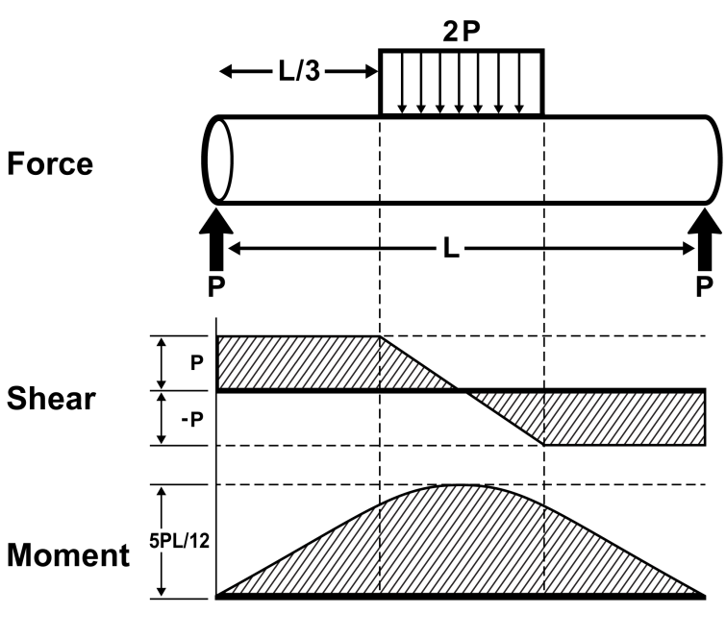
Figure 5 Load distributed over the center third of the sample
The effect is to gradually change the shear along the length of the load. The moment peaks in the center of the load, but the transition from an increasing moment to decreasing is not as abrupt.
Finally, the 4-point test has some additional unique characteristics.
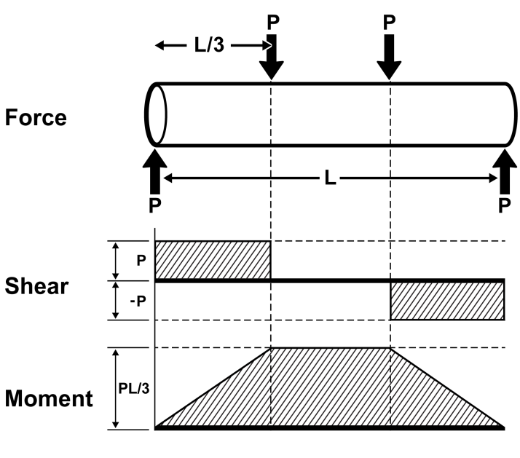
Figure 6 The 4-point load places a uniform moment between the loading points.

The span between the two loads is theoretically free of shear. However, a constant bending moment is present throughout the span. This tends to stress the bottom surface (in tension) and create micro-fractures that will propagate to failure with an increase in the moment. In this way a section of the sample is put under a uniform stress that and will tend to fail at the weak point in that span.
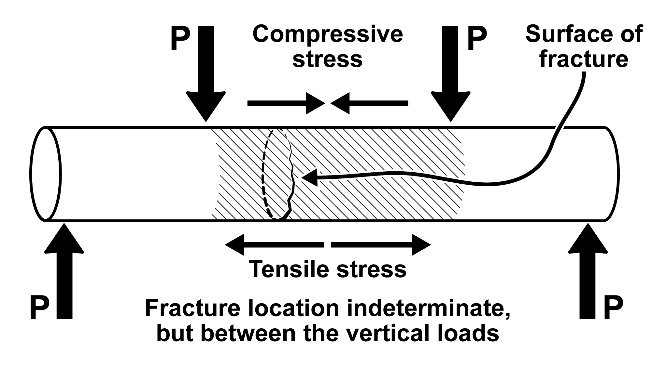
Figure 7 Area between the applied downward forces experiences a torque, but no shear force.

The following provides some explanation of how these diagrams are generated. If you consider a center-loaded beam supported on each end, the force in the center pushing down is equal in magnitude to the forces pushing up at the supports (assuming the weight of the beam is negligible in comparison). Through symmetry you can see that the support forces are each equal to half the load force. You can also determine this by calculating the sum of the forces and the sum of the moments about one of the ends. If the total length of the beam is L, then these equations become:
ΣF_{y} = 0 = F_{A} – 2P + F_{B}
ΣM_{A} = 0 = –P (L/2) + F_{B}(L) [moments relative to Point A]
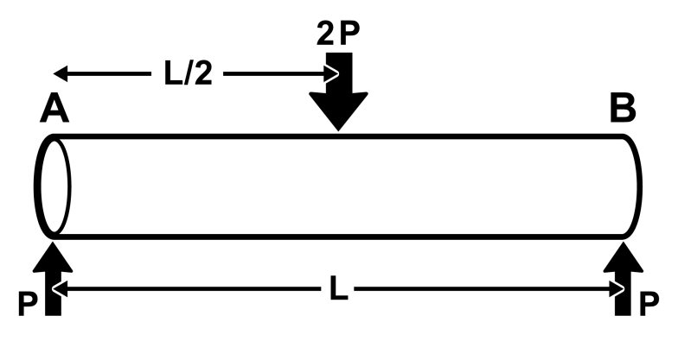
Figure 8 Determining the reaction forces in a 3-point load

Through substitution we find that F_{A} = F_{B} = P (i.e., half of the load).
The same is true for the internal forces and moments. At each point within the beam there must be forces and moments that keep the beam from failing. We can apply this same logic to determine the internal forces and moments at any point along the length of the beam. For example, consider Point C along the beam between the load and Point B.
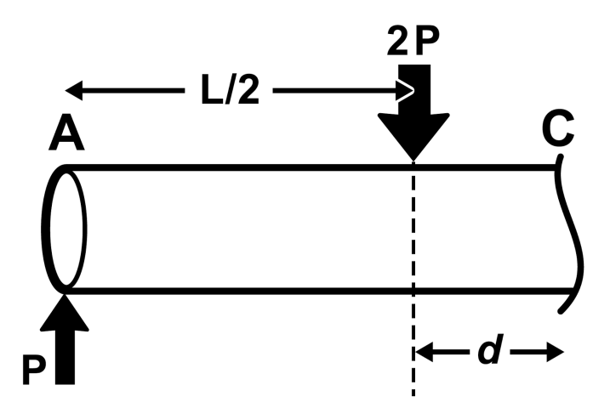
Figure 9 Constructing the shear and moment diagrams

We know that the sum of the forces must equal zero:
ΣF_{y} = 0 = F_{A} – 2P + V_{C}
Where V_{C} is the shear present in the beam that "pushes" up at that point
F_{A} = P therefore V_{C} = P
The sum of the moments takes into account the downward force and the shear, as well as the internal moment:
ΣM_{A} = 0 = –2P(L/2) + V_{C}(d+L/2) + M_{C}
Where M_{C} is the moment that resists the torque from the load beyond that provided by the internal shear force. Substituting V_{C} = P results in:
0 = –PL + P (d + L/2) + M_{C}
This simplifies (somewhat) to:
M_{C} = P (L/2 – d)
Recall that d is measured from the mid-span. Notice that when d = 0 M_{C} is at maximum and when d is at L/2 (the end of the beam) the moment is zero.
Shear and Moment Diagrams can be generated using this approach for each scenario above, as well as other beam loading configurations. This activity will provide context for engineering students testing different loading scenarios and evaluating the Force and Moment Diagrams.

Sample data
The following data were collected using Crayola® White Chalk Sticks measuring 8 cm in length with a 1 cm diameter. The span of chalk was 5 cm and the load was applied at the center. Each piece of chalk is represented by a bar line to indicate the maximum force measured before failure. Using the statistics tool you can determine the average force required to break the chalk. Note the wide range of data (Δy = 6.05N).
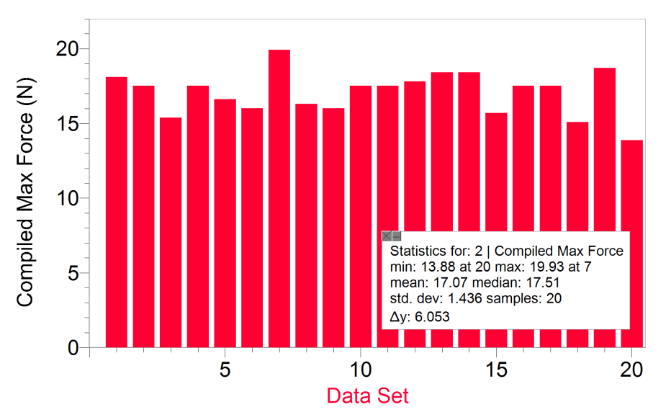
Figure 10 Data for chalk 3-point load test
The average value of 17.07 N can be used to determine a theoretical force you would expect under a 4-point load test. Recognize that the failure occurs primarily as a result of the moment applied to the chalk causing tension in the bottom of the sample that leads to fractures on this surface and then failure. The moment for a center loaded 3-point test can be calculated as:
M₁ = P₁L/2 = 8.5 L Nm
where P is the load, and L is the length between supports. In a 4-point test the same moment should (theoretically) be required to cause failure. Each of the 4-point load locations are equidistant from each other and the supports, effectively dividing the sample into thirds. Then the moment equation becomes
M₂ = P₂L/3
which we know to equal to 8.5 L Nm. Therefore the theoretical force required to achieve this moment is equal to 25.5 N. Note that the force required to cause failure is greater than the 3-point test.
The following data are from tests using the same sample material as above, but the load was applied using a 4-point test. We observed during 4-point tests that the material failed at its weak point, rather than at the center.
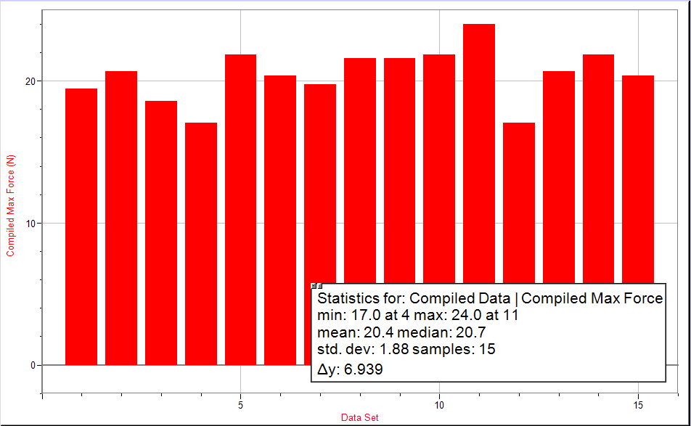
Figure 11 Data set for 4-point test of chalk
You will note that the average value (20.4 N) is significantly less than the theoretical value. In addition, the maximum force observed for the 4-point test is also below this theoretical value (based on the average).
There is still considerable variation due to the nature of the material. The 4point test method does not reduce this variability, but rather tends to find the actual weak point and thereby requires a smaller force than predicted. This is further illustrated in Figure 12:
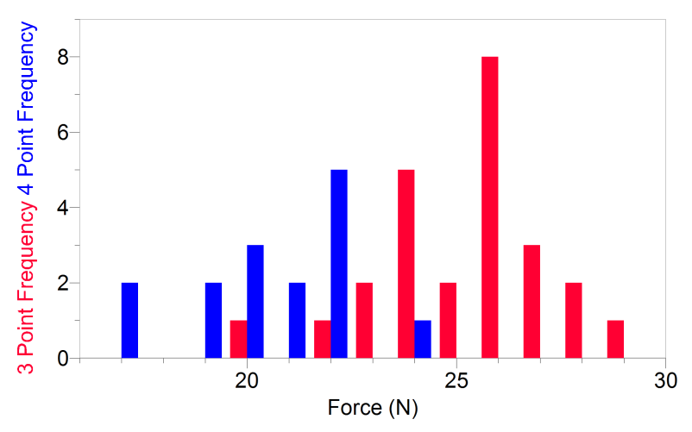
Figure 12 Comparison of shifted 3-point data (red) to 4-point data (blue)
Figure 12 shows 3-point data that has been multiplied by a theoretical factor (in this case 1.5) to compare to the 4-point data. Notice that the theoretical data suggest a greater force than that measured during 4-point tests. This indicates that the failure of the 4-point tests was significantly lower, presumably due to the test stressing a larger portion of the sample. This makes it more likely that the test will uncover the weakest location in the sample.

Challenge Activities
1. Provide students the opportunity to refine their designs for their testing apparatus. This is a great example of how the engineering design process can be used to improve a design.
2. This project provides a unique opportunity to evaluate the role that the sophistication of the testing device plays in investigations of this type. You can conduct the same experiment using a spring force scale and compare it to the results of testing using the VSMT. Consider this as a preliminary (or parallel) activity and prompt the students with the following questions:
  - What are the limitations of using a spring scale?
  - Does the spring scale introduce error?
  - If so, does that error obscure the variable nature of chalk strength?
  - What do we gain by using the VSMT vs a spring scale (i.e., a more precise tool)? Be specific.
  - Is there a point where more precision offers no additional value? Explain.

3. Ask your students to calculate and draw Shear and Moment Diagrams for the chalk under 3- and 4-point load scenarios. Using the 3-point loading as a reference point, students can calculate a theoretical maximum force for a 4-point test and compare that to the value achieved experimentally.

