Beta Particle Radiation Deflector: Supplemental Instructions
The beta particle deflection apparatus can be used with either a wireless Go Direct Radiation Monitor (GDX-RAD) or with a wired Radiation Monitor (VRM-BTD). It can be operated manually, rotating the equipment by hand and measuring angles with a protractor. It can also be operated by computer, using an Arduino™ and servo motor to rotate the radiation source while measuring angles with a Rotary Motion Sensor.

THE EQUIPMENT: MANUAL MODE
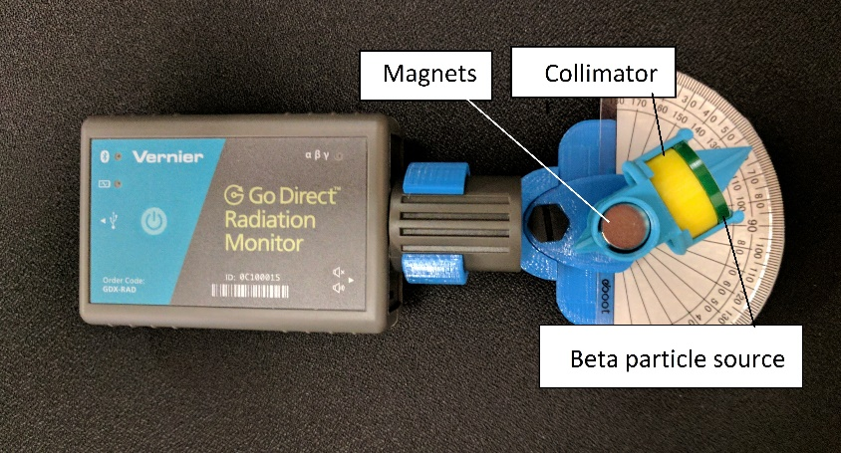
Figure 1
As shown in Figure 1, a source of beta radiation is placed in a bracket that holds the sample and a collimator made from a solid plastic disk with a small hole. The disk must be solid to appropriately block stray radiation, but an aluminum washer could also be used. Heavier metals should be avoided since their nuclei can alter beta radiation.
On the other side of the collimator there is an air gap with strong magnets above and below. This deflects charged particles to the left or right. The particles, which emerge at the other side of the magnets, are detected by a radiation monitor. The angle between the initial path (determined by the collimator) and the final detection is measured with a protractor. In Figure 1, the arrow attached to the radiation source points to the number 60, while zero deflection would show the arrow pointing toward 90. Thus this represents a deflection of 30 degrees.
More precise collimation could be achieved by placing a second collimator in front of the radiation detector. However, this would also greatly reduce the number of particles detected increasing statistical error. One experiment could be the tradeoff between improved collimation as opposed to improved statistics. Low counts can also be compensated by increasing the time for data collection.

THE EQUIPMENT: AUTOMATED MODE
An automated mode of operation allows a computer to rotate the radioactive sample while recording data on both deflection angle and counts per minute. The radiation deflection device can be mounted on a Rotary Motion Sensor to measure angle while it is slowly rotated by a servo motor controlled by an Arduino or similar device. The setup shown in Figure 2 was used to collect data for six minutes at each angle, which varied from zero to 120 degrees over a period of 12 hours.
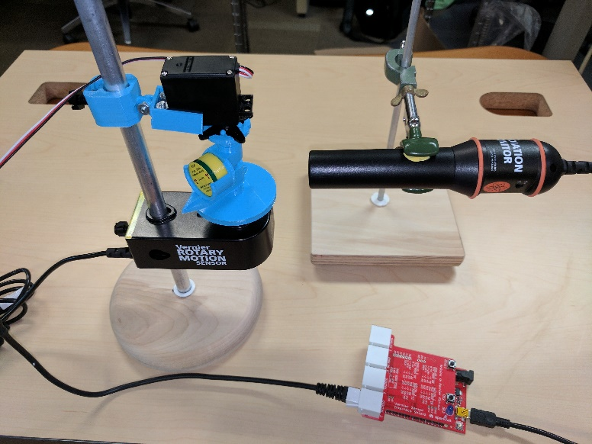
Figure 2

HOW IT WORKS
The idea for the radiation deflector came from instructor Barry Gragg of the Dwight School. When a charged particle moves through a magnetic field, magnetic forces that are perpendicular to the velocity cause the particle to turn. Beta particles carry negative charge and typically have low enough momentum that their deflection is significant after traveling a centimeter or so between a pair of strong magnets.
Using a Radiation Monitor to measure the angle of deflection of a beam of beta particles demonstrates this principle and allows calculations of the momentum, energy, and/or speed of the particles. Careful measurement of radiation level as a function of angle allows conversion to radiation level as a function of kinetic energy, turning this device into a low-cost nuclear spectrometer.
The beta particles are first sent through a solid plastic cylinder with a small hole through the center. This acts as a collimator to produce a narrow beam with an entry angle that can be measured with a protractor or a Rotary Motion Sensor.
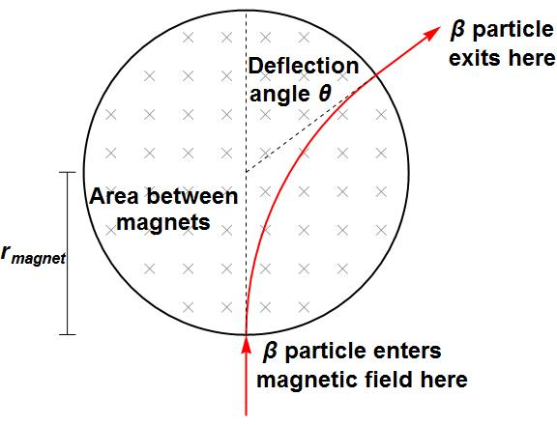
Figure 3
After emerging from the collimator, the beta particles pass through a gap between two cylindrical neodymium magnets, as shown at the bottom of Figure 3. The magnetic field in Figure 3 is shown pointing into the plane of the paper causing the negatively charged particles to deflect to the right (the experiment could be repeated with magnets reversed to show the relationship between magnetic field and force). The particles then emerge from the other side of the magnets having been deflected. The Radiation Monitor can be moved about the magnets to detect the intensity of radiation for different values of the angle. If desired, the angle between the original trajectory (the collimator) and the final trajectory (the radiation monitor) can be used to calculate the momentum and then the energy of a beta particle deflected at that angle.

CALCULATING BETA PARTICLE ENERGY
As it passes between the magnets, the trajectory of the particle is the arc of a circle of radius R_{path}, not to be confused with the radius r_{magnet} of the disk magnets themselves. The relationship between the radius R_{path} of the trajectory and the radius r_{magnet} of the magnets is shown in
Figure 4.
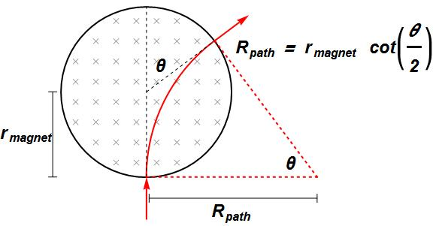
Figure 4
Applying Newton’s second law to a non-relativistic situation yields the relationship
$$\frac{mv^{2}}{R_{path}}= q v B$$
where q is the charge of an electron and B is the strength of the magnetic field. Canceling like terms yields an expression for the momentum of the beta particle as a function of R_{path,} which in turn is a function of the measured angle of deflection:
$$mv=q B R_{path}=q B r_{magnet} \cot\left(\frac{θ}{2}\right)$$
As shown in Figure 5, relativistic analysis of the physics reveals an equation of the same form but with the Newtonian expression for momentum replaced by the relativistic form:
$q B R_{path}=q B r_{magnet}\cot\left(\frac{θ}{2}\right)= γ mv$, where $γ={\left(1-\frac{v^{2}}{c^{2}}\right)}^{-\frac{1}{2}}$
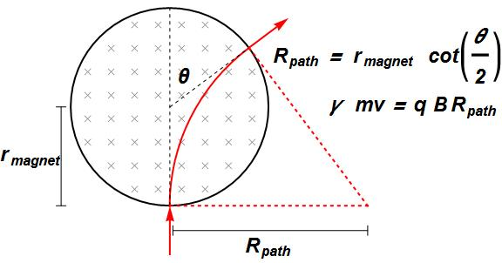
Figure 5
In practice, there are two difficulties in the use of the previous equation:
- It assumes that the magnetic field is strong and uniform in the gap between the magnets and negligible elsewhere. While it is true that the magnetic field between the magnets will be orders of magnitude greater than the field elsewhere, this assumption is not completely accurate since there are fringes of the magnetic field outside of the gap.
- It assumes that the user knows the magnitude of the magnetic field between the magnets, a space which is likely to be too small for the use of a field sensor.

Both of these problems can be mitigated by measuring the effect of the magnetic field on a conducting length of wire under similar circumstances.

MEASURING THE MAGNETIC FIELD
One can measure the effective magnitude of the magnetic field by running a current-carrying wire through the gap between the magnets. Calculation of the force per unit of current per unit length of wire will provide a measurement of the magnetic field. Since this measurement will also be hindered by ignorance of the magnetic field outside of the gap between the magnets, it will only provide an effective average of the magnetic field over the length of wire in the field. But since this is precisely the same difficulty encountered for the beam of beta particles, it provides a very good estimate of the effective average of the magnetic field experienced by the beta particles.
Even with strong neodymium magnets and a current of several amps, the force on a short length of wire is very small. For this reason we recommend the use of a Ohaus Scout® milligram balance to measure the force.
For this purpose the deflection apparatus can be placed on its side on a balance. A horizontal current carrying wire can be placed in the gap between the magnets. Varying the current in the wire will cause the weight measured by the balance to vary as the magnetic force adds to or detracts from the normal force on the scale. The slope of this additional force measured as a function of current can be used to find the effective magnetic field between the magnets (after dividing by the length of wire in the gap).
A Vernier Current Sensor and a Ohaus Scout balance can simultaneously record current and downward force. Zeroing the Ohaus balance in the absence of current allows the balance to report magnetic force directly. One possible setup is shown in Figure 6.
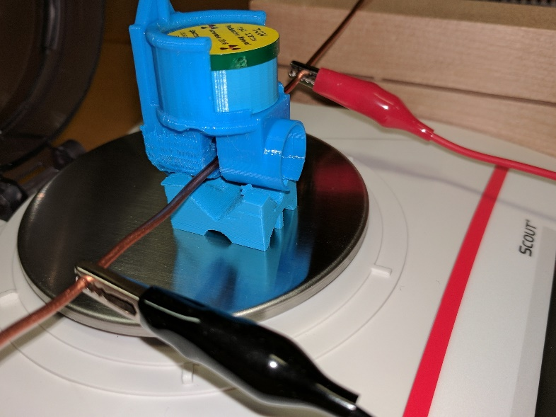
Figure 6

