John Barbara MSTC 4047 11/17/14
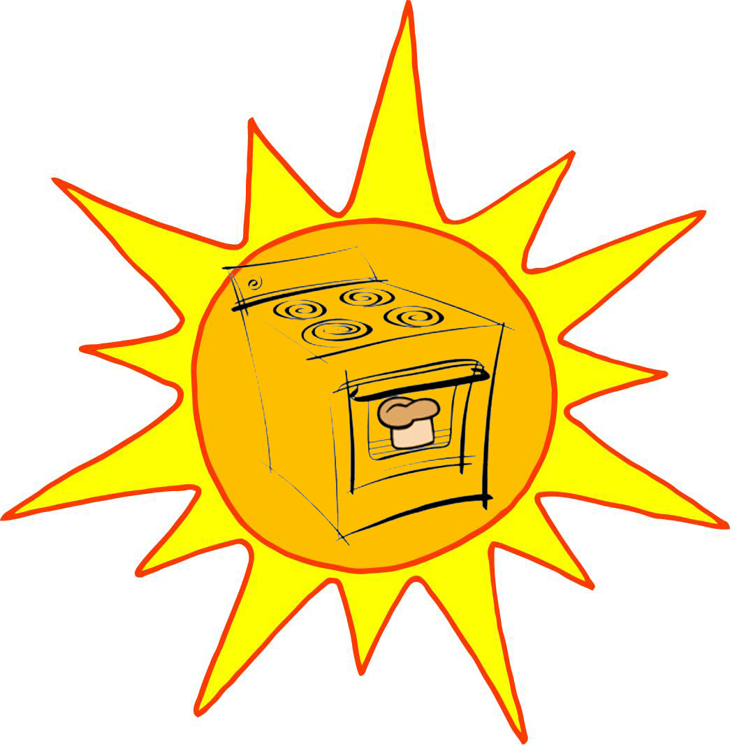
The Solar Oven Engineering Project

Prerequisite Lab: Reflection and Absorption of Light-Earth Science with Vernier #23.

The Problem: Modern electric and gas ovens are extremely convenient but their use comes at a financial and environmental cost.

The Challenge:
1.Use common household materials to engineer a solar oven that converts sunlight into usable heat energy.
2.Determine the most appropriate materials for reflecting and absorbing light and heat using light sensors, temperature probes and logger pro.

Scientific Principles:
- Conversion of light energy into heat energy
- Greenhouse Effect
- Energy transfer (via radiation, conduction, convection)
- Reflection and absorption

The Design:
- After experimenting with different materials and types of boxes using light sensors and temperature probes to determine their reflectivity and absorption capacity ,I settled on a design that uses a cardboard box with a reflective flap (covered in tin foil) to collect sunlight. Tin foil was attached to the inside walls of the box to maximize the collection of sunlight and the box has a black floor to help increase the absorption of energy. The opening of the box is sealed with plastic wrap, allowing sunlight to pass through while trapping the longer wavelength infrared radiation inside.

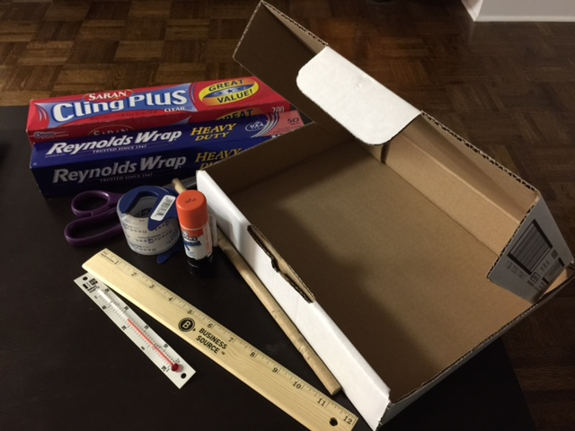
Required Materials:
- Cardboard Box
- Tin Foil
- Plastic Wrap
- Black Construction Paper
- Wooden Dowel
- Scissors
- Ruler
- Tape
- Glue Stick
- Computer, Vernier computer interface, logger Pro, light sensors and temperature probes/thermometer

Build Procedure:
- Using your ruler, draw the outline of a square on the top flap of the cardboard box approximately 1 – 2 inches from the edges.
- Use your scissors to CAREFULLY cut along three of the lines you’ve drawn: the two sides and the front edge. *Be sure not to cut the fourth line toward the rear, as this is your “hinge.”
- Fold open the flap on the top of your box.
- Use glue and/or tape to attach tin foil to the underside of your flap.
- Use glue and/or tape and attach tin foil to the inside walls and floor of your solar oven.
- Tape or glue black construction paper to the floor of your oven. (The dark paper will help absorb sunlight.)
- Stretch the plastic wrap over the opening of your box and seal the edges securely with tape.
- Attach the wooden dowel to prop open your reflective flap.

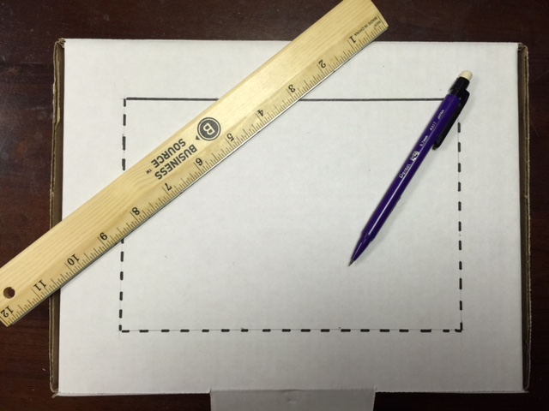

Results:
- The design was a success! I tested my solar oven by placing a 150-watt incandescent light bulb approximately 8 inches above the opening for 10 minutes. The temperature inside the oven increased from 22⁰ C to 50⁰ C and was still climbing after 10 minutes. As a control, I placed the temperature probes the same distance from the light source (without using the oven) and in 10 minutes the temperature increased from 22⁰ C to 27⁰ C, confirming that the oven is in fact trapping at some longer wavelength infrared radiation.
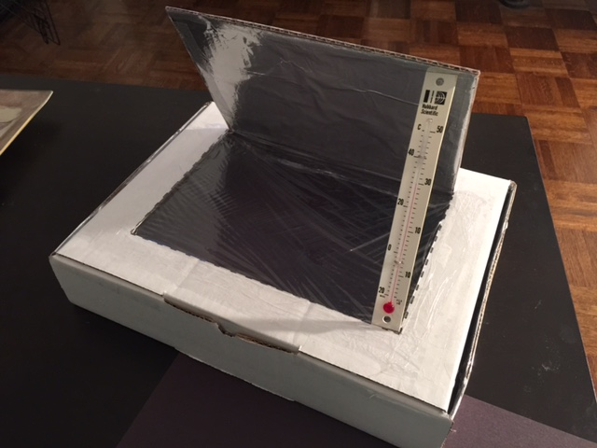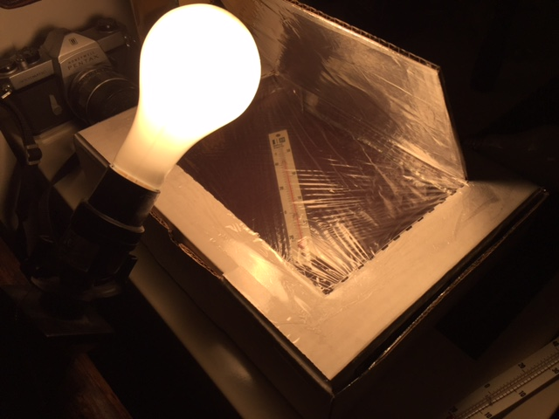

Ideas for Improving the Design:
- Add additional reflective flaps to capture more sunlight.
- Minimize heat loss by adding insulation to the inside of the box.
- Adjust the angle of the oven to achieve direct sunlight.

Lesson Plan John Barbara /MSTC 4047 Date: 11/17/14

Unit 2: Interactions Between Matter and Energy.

Prerequisite Lab: Reflection and Absorption of Light &Heat-Earth Science with Vernier #23.

Topic: Solar Oven Engineering Design

Do Now:
- Entrance Question: Why does the inside of your car get so hot on a sunny summer day?
  - Students record answer in notebooks.

Learning Objectives:
- Learn principles of light energy, heat energy, and the greenhouse effect.
- Learn about engineering principles.
- Learn about engineering planning and design.
- Learn problem solving and teamwork.
- Demonstrate mastery in using light sensors and temperature probes for data collection and material selection .

Standards/CCLS:
New York State:
- PS 4.1a, c, d: Light energy vs. heat energy.
- PS 4.2a: Transfer of heat.
- PS 4.2b: Radiation, convection, and conduction.
- PS 4.4a: Electromagnetic energy.
- PS 4.4b: Light reflection and refraction.
- PS 4.5a, b: Law of conservation of energy.
- LE 3.2b: Environmental concerns: Acquisition and depletion of resources.
- LE 6.1: Renewable and non-renewable sources of materials.
- ICT 5.1, 5.2: Renewable and non-renewable sources of energy.
- IPS 2.1: Water issue: depletion; pollution.

NGSS:
- MS-PS1-3: Gather and make sense of information to describe that synthetic materials come from natural resources and impact society.
- MS-PS1-4: Develop a model that predicts and describes changes in particle motion, temperature, and state of a pure substance when thermal energy is added or removed.
- MS-PS3-3: Apply scientific principles to design, construct, and test a device that either minimizes or maximizes thermal energy transfer.
- MS-PS4-2: Develop and use a model to describe that waves are reflected, absorbed, or transmitted through various materials.
- MS-ESS3-3: Apply scientific principles to design a method for monitoring and minimizing a human impact on the environment.
- MS-ESS3-5: Ask question to clarify evidence of the factors that have caused the rise in global temperatures over the past century.
- MS-ETS1-1: Define the criteria and constraints of a design problem with sufficient precision to ensure a successful solution, taking into account relevant scientific principles and potential impacts on people and the natural environment that may limit possible solutions.
- MS-ETS1-2: Evaluate competing design solutions using a systematic process to determine how well they meet the criteria and constraints of the problem.
- MS-ETS1-3: Analyze data from tests to determine similarities and differences among several design solutions to identify the best characteristics of each that can be combined into a new solution to better meet the criteria for success.
- MS-ETS1-4: Develop a model to generate data for iterative testing and modification of a proposed object, tool, or process such that an optimal design can be achieved.

Common Core State Standards:
ELA/Literacy:
- RST.6-8.3: Follow a precisely a multistep procedure when carrying out experiments, taking measurements, or performing technical tasks.
- RST.6-8.7: Integrate quantitative or technical information expressed in words in a text with a version of that information expressed visually (e.g., in a flowchart, diagram, model, graph or table).
- RST.6-8.9: Compare and contrast the information gained from experiments, simulations, video, or multimedia sources with that gained from reading a text on the same topic.
Mathematics:
- MP.2: Reason abstractly and quantitatively.
- MP.4: Model with mathematics.
- 6.NS.C.5: Understand that positive and negative numbers are used together to describe quantities having opposite direction or values (e.g., temperature above/below zero, elevation above/below sea level, credits/debts, positive/negative electric charge); use positive and negative numbers to represent quantities in real-world contexts, explaining the meaning of 0 in each situation.
- 7.EE.B.4: Use variables to represent quantities in a real-world or mathematical problem, and construct simple equations and inequalities to solve problems by reasoning about the quantities.
- 6.SP.B.5: Summarize numerical data sets in relation to their context.

Essential Driving Questions:
- How can we convert sunlight into usable heat energy?
- What is the greenhouse effect and how does it work?

I Do:
- Review principles of the light energy, heat energy, and the greenhouse effect.
- Explain that students will work in groups as “engineers” who have been given the task of designing an oven that converts sunlight into heat energy.
- Provide students with light sensors and temperature probes to determine the best materials for their engineering design projects.
- Divide students into groups.
- Distribute activity sheet and materials (ensure all groups have the same materials).
- Walk around classroom and assess student learning.
- Provide follow-up challenges for those students who finish early:
  - Would the angle of incoming sunlight affect the maximum achievable temperature inside your cooker? Test this and record results.

Students Do: __________Individual _____X____Groups __________Pairs

- Brainstorm, plan, and sketch their solar oven design.
- Test materials using light sensors and temperature probes to determine which have the highest reflective and absorption capacity of light and heat.
- Construct solar oven.
- Take turns testing cookers using temperature probes /thermometers (in direct sunlight or under light bulb).
- Revise or redesign as necessary.
- Complete activity sheet.

Follow up Questions/Check for Understanding:

- What purpose does the black construction paper serve?
- How did the vernier light sensors and temperature probes facilitate data collection in determining the materials you used for your project?
- If we remove the black construction paper do you think you would achieve lower or higher temperatures inside your cooker?

Exit Questions:
- If you had an opportunity to do this project again, what would you do differently?

Vocabulary:
- Radiation
- Convection
- Conduction
- Greenhouse Effect
- Wavelength
- Absorption
- Reflection
- Renewable Resource
- Non-renewable Resource
- Energy conservation

Homework:
- Students write a reflection on the design lab being sure to include ideas about how they might improve the design to (1) maximize the collection of sunlight and (2) minimize heat loss.

Safety Precautions:
- Students will be instructed to handle scissors with care:
  - Never run with scissors!
  - Offer handle-first whenever scissors exchange hands!
- Students will be instructed to wear safety goggles during activity.

Differentiated Instruction: Layered Curriculum tests, graphic organizers, think aloud, 10 novel ideas, gradual release of responsibility/opportunities to advance daily, specific support for students needing added guidance, pair collaboration, differentiated assessment.

Supplemental Content/Resources:
- Student activity sheet: Solar Oven Engineering Design Lab.
- Materials:
  - Cardboard Box
  - Tin foil
  - Plastic wrap
  - Black construction paper
  - Wooden dowel
  - Scissors
  - Ruler
  - Tape
  - Glue stick
  - Thermometer

Activity Sheet John Barbara /MSTC 4047 Date: 11/17/14
Student Activity Sheet – Solar Oven Engineering Design Lab

Your Challenge:
Design and build a solar oven that converts sunlight into usable heat energy.

Materials:
- Cardboard Box
- Tin Foil
- Plastic Wrap
- Black Construction Paper
- Wooden Dowel
- Scissors
- Ruler
- Tape
- Glue Stick
- Thermometer

Brainstorm and Design:
- All good engineers start with a plan! Take time to brainstorm and consider what materials you will use and how you will use them before you begin construction. Once you have formulated your plan you should then sketch your design in your notebook.

Build:
- Using your ruler, draw the outline of a square on the top flap of the cardboard box approximately 1 – 2 inches from the edges.
- Use your scissors to CAREFULLY cut along three of the lines you’ve drawn: the two sides and the front edge. *Be sure not to cut the fourth line toward the rear, as this is your “hinge.”
- Fold open the flap on the top of your box.
- Use glue and/or tape to attach tin foil to the underside of your flap.
- Use glue and/or tape and attach tin foil to the inside walls and floor of your solar oven.
- Tape or glue black construction paper to the floor of your oven. (The dark paper will help absorb sunlight.)
- Stretch the plastic wrap over the opening of your box and seal the edges securely with tape.
- Attach the wooden dowel to prop open your reflective flap.

Test, Evaluate and Redesign:
- With your thermometer inside, place your solar oven in direct sunlight for a total of ten minutes and record temperature in 2-minute intervals.

Time: | Start | 2 min | 4 min | 6 min | 8 min | 10 min
Temp:

- Did the temperature increase inside your oven? If so, by how much?

- Given more materials, how might you maximize the collection of sunlight? And how might you help minimize heat loss?

Bonus Challenge (for teams that finish early):
- Implement your ideas for improving your design! See me if you need more materials.

Engineering Design Lab Rubric

LAB 1: Engineering Design – Solar Oven
Name:
Team:
Date:
Category | Scoring Criteria | Points | Student Evaluation | Teacher Evaluation
Plan/Design | The team was careful to brainstorm, plan, and sketch design before beginning construction. | 10
Teamwork | Team members cooperated, shared responsibilities and tasks. | 10
Modification | We were able to recognize potential problems, adapt and redesign when/if necessary. | 10
Process | Team members followed procedure and guidelines without difficulty. | 10
Execution | We were able to successfully execute our design and meet the challenge. | 10
Safety | I followed all safety protocols and was careful not to unnecessarily endanger others or myself. | 10
Use of class time | Our team dedicated all class time to the project. | 10
Scientific knowledge | Each group member has a clear and accurate understanding of the scientific principles involved in the process of converting sunlight to a heat source. | 10
Overall Good Engineers? | We were able to creatively use math and science to solve this problem. | 20
Score | Total Points | 100

