Conservation of Angular Momentum
You have used linear momentum conservation in problems. Angular momentum has many parallels with linear momentum. Just as a system with no external force will continue to have the same total momentum, it is also true that the absence of an external torque, the angular momentum of a system is conserved. This activity will allow you to observe momentum conservation.

OBJECTIVES
- Arrange a rotational collision between spinning and stationary disks.
- Predict the angular velocity of a two identical disks after a collision between one stationary and one spinning disk.

Figure 1

MATERIALS
Vernier data-collection interface | Vernier Rotary Motion Sensor
Logger Pro or LabQuest App | Rotary Motion Accessory Kit

Procedure
1. Attach the Rotary Motion Sensor to a ring stand.
2. Slide the three-step pulley onto the shaft of the sensor, with the large pulley upward.
3. Place the narrow-holed aluminum disk from the Rotary Motion Accessory Kit atop the pulley and attach it with the spindle/screw.
4. Connect the Rotary Motion Sensor to your data-collection interface.
5. Spin the disk.
6. Start data-collection.
7. Observe the graph. You will likely notice that the angular velocity is decreasing at a fairly steady rate. This is due to the effects of friction. In later trials, you will ignore this steady decline and pay attention to more rapid changes in velocity.
8. Stop data-collection.
9. In a moment, you will drop a second disk onto the rotating disk. Predict: What will happen to the motion of the first disk when a second disk of nearly equal mass is added? How much change do you expect to see?
10. Give the rotating disk another spin, start data-collection, and then drop the second disk onto the first disk.
11. Use the stylus (LabQuest) or the Examine tool (Logger Pro) to select the point on the graph just before the disk was dropped. Record the angular velocity.
12. Select the point when the angular velocity becomes steady again after the disk is dropped, and record the angular velocity at that point.
DATA and calculations
Angular velocity (ω): one disk  (radians/s) | Angular velocity (ω): two disks  (radians/s) | Ratio: ω_{f}/ ω_{i}

Discussion
The angular momentum L of an object is the product of the object’s moment of inertia I and its angular velocity ω.
L = Iω
The Principle of Conservation of Angular momentum states that angular momentum remains constant when no net torque is applied to a system. Therefore:
L_{f} = L_{i}
and:
Iω_{f} = Iω_{i}
The moment of inertia of a disk rotating about its central axis is represented by I = ½ mr². Therefore, when we doubled the mass:
½ (2m)r²ω_{f} = ½ mr²ω_{i}
Dividing both sides by the constants yields:
2 ω_{f} = ω_{i} or ω_{f} = ½ ω_{i}

analysis
1. How does the angular velocity after the second disk is added compare to initial angular velocity?
2. How does the moment of inertia after the second disk is added compare to initial moment of inertia?
3. How does the angular momentum before the disk is added compare to the angular momentum after the disk is added?

Extension
1. Is the kinetic energy of the system conserved by the collision? You may have to look up how to find the kinetic energy of a rotating system.
2. Is the kinetic energy of the system constant before the collision? If not, can you still draw a conclusion about energy conservation during the collision? Why or why not?
3. Is the angular momentum of the single disk constant if you do not drop the second disk on it? Explain. Is the angular momentum constant over a short period of time?
Instructor Information

analysis
1. How does the angular velocity before the second disk is added compare to the angular velocity after the disk is added?
The expected value is about half the velocity after the addition of the second disk.
2. How does the rotational inertia before the disk is added compare to the inertia after the disk is added?
The two disks together have twice the inertia of a single disk.
3. How does the angular momentum before the disk is added compare to the angular momentum after the disk is added?
The angular momentum is the same.

Sample data
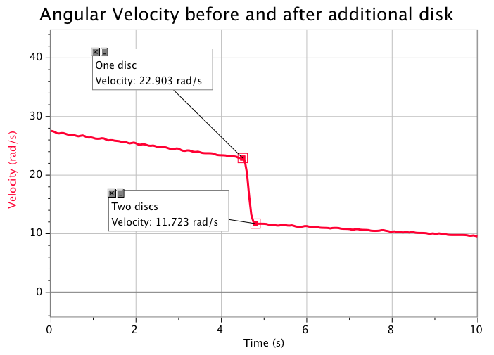
Sample data

