Experiment 15
Observing the Reaction Kinetics of Sucrose with Polarimetry
Required Vernier skills
In order for student success in this experiment, it is expected that students know how to perform data collection and analysis using the Polarimeter. This is addressed in Experiment 6 and in the Polarimeter user guide.
Instructor notes
- In the Electronic Resources you will find PDF and word-processing files of the student pages so you can print the activity for your students or distribute the file to them electronically. Sign in to your account at www.vernier.com/account to access the Electronic Resources. See Appendix A for more information.
- If using computers, the Polarimeter requires Logger Pro version 3.8.4.2 or newer. LabQuest users require LabQuest App version 1.6 or newer. An update can be downloaded from www.vernier.com/support/updates
- The Vernier Polarimeter has two cables. One is a BTA connector that should be connected to CH1 of your interface and one is a BTD connector that should be connected to DIG1 of your interface. Both connections are required for data collection.
- After connecting the Polarimeter to a Vernier interface, open the data-collection program. If using Logger Pro, an experiment file will appear after a few seconds that has a graph of Illumination on the y-axis and Angle on the x-axis. If this does not occur, choose New from the File menu.
- Sucrose is often used as a calibration standard for polarimeters, which is why it is suggested in this experiment. You may also use other sugars and should obtain similar results for Part I.
- Literature values for specific rotation were obtained from the CRC Handbook, determined in water at concentrations of 1–5 g per 100 mL of solution, at 20–25°C, and at 589 nm.
- Invertase can be purchased from most chemical supply companies. However, you can also isolate invertase from baker’s yeast by doing the following: mix half a package of baker’s yeast with 40 mL of distilled water and centrifuge the mixture for 5 minutes. Decant the top layer; the remaining bottom layer is crude invertase enzyme.
- Invertase concentrations listed in the student guide are highly dependent on the activity of the enzyme, which varies based on manufacturer and species. Therefore, the concentrations listed are simply guidelines that produced the sample results below. It is strongly suggested that you run the experiment beforehand to ensure the proper concentrations for your specific enzyme.
- If you would like your students to linearize the data to determine the reaction order instead of using a nonlinear fit, you will need to reduce the concentrations of acid and invertase used. The lab is currently designed to get an exponential decay quickly. To use the method of initial rates, you should try 1 M HCl and 5 mg/mL invertase. The change in angle of rotation will not be as obvious here and the reaction will need to be watched for a longer period of time.
- There are several ways to locate the angle at which the maximum illumination occurs. This experiment suggests the student use a Gaussian fit.
  - Statistics: To simply get the angle with the highest illumination, highlight the peak of interest in Logger Pro or LabQuest App, as shown in Figure 1. Choose Statistics from the Analyze menu. Record the angle value where the illumination is at a maximum, as presented in the box. This method is the fastest and will result in reproducibility of the angle of rotation measurement of ±2.0°.
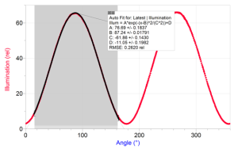
Figure 1 Selection for fits
- Gaussian: To improve your accuracy with a better fit, highlight the peak of interest using Logger Pro or LabQuest App, as shown in Figure 1. Then, choose Curve Fit from the Analyze menu. From the list of available Equations, select Gaussian. Select Try Fit in Logger Pro; in LabQuest App, the fit will run automatically. The B coefficient presented represents the angle at maximum illumination. This method will result in reproducibility of the angle of rotation measurement of ±0.3°. The data are not a true Gaussian, but the ease and accuracy of this methodology make it a good option. For best results, be consistent in the way you select your peaks.
- Cosine Squared: To incorporate all of your data into the fit, you can fit the data to its true waveform, a cosine squared, in either Logger Pro or LabQuest App. Choose Curve Fit from the Analyze menu. From the list of available General Equations, select Cosine Squared. Select Try Fit in Logger Pro; in LabQuest App, the fit will run automatically. In this fit, the x-value corresponding to the maximum y-value is obtained from the negative of the phase shift parameter, –C. This is a nonlinear fit which undergoes numerous iterations and has the possibility of no convergence, which will result in an unreasonable answer. With all nonlinear fits, it is important to make sure the resulting value is reasonable based on the data presented in the graph. This method is the most time consuming; however, it will result in reproducibility of the angle of rotation measurement of ±0.1°.
- If a LabPro interface is being used, allow a few seconds at both the beginning and ending of the 15 second data-collection period without moving the analyzer. Typically, a warning “Waiting for data…” will appear when data collection has been initiated; wait until this message has disappeared before rotating the analyzer. It may be helpful to extend the data collection time to ensure students do not continue to rotate the analyzer after data collection has ended.
LabPro users have these extended instructions because the rotary motion sensor that tells Logger Pro what angle the analyzer is sitting on does not continuously collect data on the LabPro like it does on the LabQuest and LabQuest Mini interfaces.
HAZARD ALERTS
The chemical safety signal words used in this experiment (DANGER and WARNING) are part of the Globally Harmonized System of Classification and labeling of Chemicals (GHS). Refer to the Safety Data Sheet (SDS) that came with the chemical for proper handling, storage, and disposal information. These can also be found online from the manufacturer. See Appendix C for more information.
Hydrochloric acid, 12 M, HCl: DANGER: Causes severe skin and eye burns and damage. Harmful if swallowed or inhaled. Do not eat or drink when using this product. Do not breathe mist, vapors, or spray. May be corrosive to metals. Industrial exposure to vapors and mists is listed as a known human carcinogen by International Agency for Research on Cancer (IARC).
Iinvertase, enzyme: This chemical is considered nonhazardous according to GHS classifications. Treat all laboratory chemicals with caution. Prudent laboratory practices should be observed.
Sucrose, C12H22O11: This chemical is considered nonhazardous according to GHS classifications. Treat all laboratory chemicals with caution. Prudent laboratory practices should be observed
COMPOUND INFORMATION
Compound | Chemical formula | Molar mass (g/moL) | Specific rotation  (°) | Melting point  (°C)
sucrose | C12H22O11 | 342.3 | +66.5 | 186
Sample Data
Part I Specific Rotation of Sucrose
15% Sucrose Sample
Angleblank (°) = 12.5
 | Run 1 | Run 2 | Run 3 | Average
Sample height (cm) | 9.0 | 9.2 | 9.2 | 9.1
Anglesample (°) | 20.9 | 20.8 | 21.0 | 20.9
Angle of rotation, α (°)  = Anglesample – Angleblank | 8.4 | 8.3 | 8.5 | 8.4
30% Sucrose Sample
Angleblank (°) = 12.5
 | Run 1 | Run 2 | Run 3 | Average
Sample height (cm) | 10.1 | 10.0 | 9.9 | 10.0
Anglesample (°) | 31.6 | 31.9 | 31.7 | 31.7
Angle of rotation, α (°)  = Anglesample – Angleblank | 19.1 | 19.4 | 19.2 | 19.2
ANSWERS TO THE DATA ANALYSIS QUESTIONS
Part I Specific Rotation of Sucrose

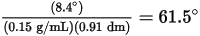

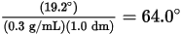

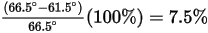
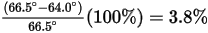
Part II Kinetics of Sucrose with Acid
- It is a first order reaction based on the nonlinear fit to a single exponential decay.
- Using a single exponential fit, the rate constant is 0.0749 min–1 or 0.00124 s–1.
Part III Kinetics of Sucrose with Invertase Enzyme
- It is a first order reaction based on the nonlinear fit to a single exponential decay.
- Using a single exponential fit, the rate constant is 4.53 hr–1 = 0.0756 min–1.
Sample graphs
Part II Kinetics of Sucrose with Acid
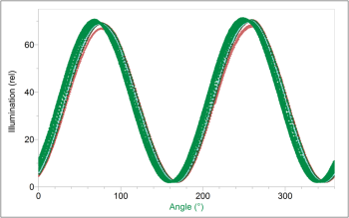
Figure 2 Raw data runs for reaction of sucrose and HCl
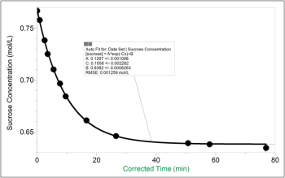
Figure 3 Kinetic trace and single exponential fit for reaction of sucrose and HCl
Part III Kinetics of Sucrose with Invertase Enzyme
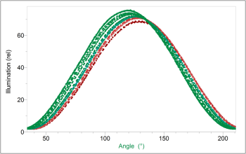
Figure 4 Raw data runs for reaction of sucrose and invertase
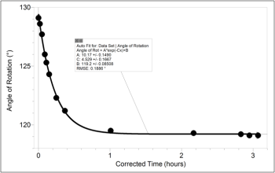
Figure 5 Kinetic trace and single exponential fit for reaction of sucrose and invertase

