Isolation and Characterization of Protein and Sugar from Milk
Milk is an important food for mammalian development. It is the only food ingested by young mammals in the weeks following birth; therefore, it must contain an enormous amount of nutritionally significant vitamins, minerals, proteins, carbohydrates, and lipids. Due to the varying chemical properties of each of these compounds, it is easy to separate many of them using common organic chemistry techniques. In this experiment, you will separate several of the chemical substances found in milk. First, you will isolate two proteins, casein and albumin. The remaining milk mixture will then be used as a source of sugar, α-lactose. After you isolate the milk sugar, you will perform several chemical tests on this material. Fats, which are present in whole milk, are not isolated in this experiment because powdered nonfat milk is used.
After isolation of the various chemical compounds, characterization of the optically active compounds can be performed using polarimetry. The sugar isolated in this experiment, α-lactose, is optically active and slowly interconverts to β-lactose in water:
α-lactose β-lactose
[α] = 92.6° [α] = 34.0°
Figure 1 The mutarotation of α-lactose

A compound will consistently have the same specific rotation under identical experimental conditions. The specific rotation is related to a compound’s concentration through Biot’s law:
α = [α] ℓ c
where α is the observed optical rotation in units of degrees, [α] is the specific rotation in units of degrees (the formal unit for specific rotation is degrees dm⁻¹ mL g⁻¹, but scientific literature uses just degrees), ℓ is the length of the cell in units of dm, and c is the sample concentration in units of grams per milliliter.

OBJECTIVES
In this experiment, you will
- Isolate several of the chemical compounds found in milk, including casein, α-lactose, and albumin.
- Determine your yield for each of these compounds.
- Observe the optical rotation of α-lactose using polarimetry.
MATERIALS
LabQuest or computer interface | watch glass
LabQuest App or Logger Pro | 100 mL and 50 mL beakers
Vernier Polarimeter | 95% ethanol
Polarimeter sample cell | apparatus for heating and monitoring
250 mL Erlenmeyer flask | temperature (e.g., sand bath)
10% acetic acid | bench-top centrifuge
powdered nonfat milk | vacuum filtration apparatus
calcium carbonate

PROCEDURE
Part I Isolation and Purification of Casein
1. Obtain and wear goggles. Protect your arms and hands by wearing a long-sleeve lab coat and gloves. Conduct this reaction in a fume hood.
2. Dissolve 4.0 g of powdered nonfat milk in 10 mL of water in a 100 mL beaker. Heat the solution on a sand bath or aluminum block to about 40°C, monitoring the temperature with a thermometer or temperature probe.
3. When the mixture has reached 40°C, add 1 mL of 10% acetic acid dropwise to the warm milk. Maintain the solution temperature at 40°C and, after every 5 drops of acid, stir the solution gently using a small spatula. Using the spatula, push the precipitated casein onto the side of the beaker so that most of the liquid drains from the solid.
4. Transfer the congealed casein to a 50 mL beaker in small portions. If any liquid separates from the casein, use a Pasteur pipet to transfer the liquid back into the original 100 mL beaker.
5. Slowly continue the dropwise addition of the 1 mL 10% acetic acid solution to the 100 mL beaker to complete the casein precipitation. Remove as much casein as possible but avoid adding excess of acetic acid to the milk solution, as this will cause the lactose in the milk to hydrolyze to glucose and galactose.
6. When most of the casein has been removed from the milk solution, add 0.2 g of calcium carbonate to the milk in the 100 mL beaker. Stir this mixture for a few minutes and save it for use in the isolation of lactose (Part II). Caution: this mixture should be used as soon as possible, during the same lab period.
7. Transfer the casein from the 50 mL beaker to a vacuum filter funnel; make sure you place the casein on the appropriate filter paper. Draw a vacuum on the casein for about five minutes to remove as much liquid as possible, pressing the casein with a spatula or stopper during this time.
8. Remove the filter paper containing the casein from the funnel. Using another piece of filter paper, gently press the paper into the solid to absorb any remaining liquid. Place the casein on a pre-weighed watch glass, let air dry until the next lab period, and weigh. Casein is used to make white glue, so it is important that you don’t leave it on the filter paper or it will become glued to it.
Part II Isolation of Lactose and Albumin
9. After the isolation of casein, the milk mixture contains the sugar (lactose) and the protein (albumin). Heat the mixture to about 75°C for about five minutes. This heating will result in complete denaturization and precipitation of the albumins from solution.
10. Decant the liquid in the beaker away from the solid into a clean centrifuge tube. You may need to hold the solid with a spatula when transferring the liquid. Press the solid albumins with a spatula to remove as much liquid as possible and pour the liquid into the centrifuge tube. Save the albumins in the original 100 mL beaker. Allow the albumins to dry for
2–3 days in the original beaker in which they were precipitated. Record its weight.
11. When the liquid has cooled to about room temperature, place it in the centrifuge. Make sure the centrifuge is balanced. Centrifuge for five minutes.
12. Following centrifugation, decant the liquid away from the solid into a 50 mL beaker. Add 15 mL of 95% ethanol to the beaker. Solids will precipitate. Heat this solution to about 60°C to dissolve some of the solid.
13. Pour equal amounts of the hot solution into two 10 mL plastic centrifuge tubes and centrifuge the solution as soon as possible before it cools too much. Centrifuge for two minutes. It is important to centrifuge the solution while it is still warm to prevent premature crystallization of the lactose. A considerable quantity of solid material will be deposited on the bottom of the centrifuge tube.
14. Remove the warm, supernatant liquid from the tube using a Pasteur pipet, and transfer the liquid to a 100 mL Erlenmeyer flask. Discard the solid that is remaining in the centrifuge tube. Stopper the flask and allow the lactose to crystallize for at least two days. Granular crystals should form during this time.
15. Collect the lactose crystals by vacuum filtration using pre-weighed filter paper. Use about 3 mL of 95% ethanol to aid the transfer and to wash the product. Record the product’s weight after it is thoroughly dry.
Part III Measuring the Optical Activity of Lactose
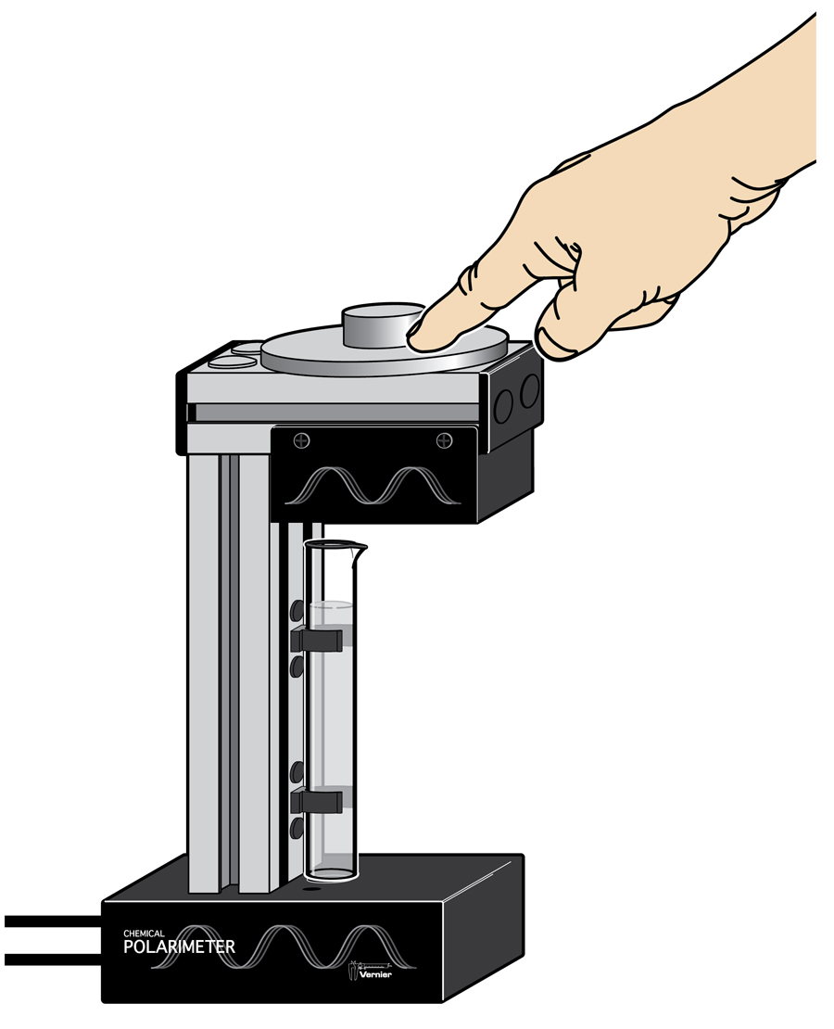
16. Connect the Vernier Polarimeter cables to their respective ports on your Vernier interface. Start the data-collection program and choose New from the File menu. Note: In Logger Pro, wait until a graph of Illumination (rel) on the y-axis and Angle (°) on the x˗axis appears before continuing.
Figure 2 Rotation of the analyzer
17. Dissolve all of your α-lactose in a minimal amount of water and record the exact concentration in the table below.
18. Calibrate the Polarimeter.
- Pour distilled water in the Polarimeter cell to a height of 10 cm. It is important to read the height to the nearest 0.1 cm. Read to the bottom of the meniscus.
- Place the cell in the Polarimeter.
- Start data collection and slowly rotate the analyzer clockwise or counterclockwise until data collection stops (15 s), as shown in Figure 2. Note: If you are using a LabPro interface, only rotate the analyzer while data collection is active. Allow a few seconds at both the beginning and ending of data collection without moving the analyzer.

19. Record the first angle above 0° where the illumination is at a maximum for the blank. There are several ways to locate this angle using analysis features in Logger Pro or LabQuest App. One way to locate this angle is to use a Gaussian fit.
20. Store the run. In Logger Pro, do this by choosing Store Latest Run from the Experiment menu. In LabQuest App, you can store a run by tapping on the file cabinet icon in the upper right of your screen.
21. You are now ready to add your optically active sample into the Polarimeter cell.
- Pour your lactose solution in the Polarimeter cell. Record its height to the nearest 0.1cm in the table below.
- Place the sample cell in the Polarimeter.
- Start data collection and slowly rotate the analyzer clockwise or counterclockwise until data collection stops.

22. Record the first angle above 0° where the illumination is at a maximum for the sample.
DATA tables
Part I Isolation and Purification of Casein
Weight of powdered nonfat milk (g)
Weight of watch glass alone (g)
Weight of watch glass with dry casein (g)
Weight of dry casein (g)

Part II Isolation of the Lactose and Albumin
Weight of synthesized albumin (g)
Weight of filter paper (g)
Weight of filter paper with synthesized α˗lactose (g)
Weight of synthesized α-lactose (g)

Part III Measuring the Optical Activity of Lactose
Volume of water added to dissolve α˗lactose (mL)
α˗lactose sample concentration (g/mL)
Angle_{blank} (°)
Height of α˗lactose solution (dm)
Angle_{sample} (°)
Angle of rotation, α (°)
= Angle_{sample} – Angle_{blank}

DATA ANALYSIS
Part I Isolation and Purification of Casein
1. Calculate the weight percent of casein isolated from the powdered milk.
Part II Isolation of the Lactose and Albumin
2. Calculate the weight percent of α-lactose isolated from the powdered milk.
3. Calculate the weight percent of albumin isolated from the powdered milk.
Part III Measuring the Optical Activity of Lactose
4. Calculate the specific rotation for your isolated α-lactose.
5. Using the literature value for the specific rotation of α-lactose, calculate your product purity. If necessary, explain why your enantiomeric purity is not 100%.

