Isolation and Characterization of Protein and Sugar from Milk
Required vernier skills
In order for student success in this experiment, it is expected that students know how to perform data collection and analysis using the Polarimeter. This is addressed in the user guide.

Instructor notes
1. If using computers, the Polarimeter requires Logger Pro version 3.8.4.2 or newer. LabQuest users require LabQuest App version 1.6 or newer. An update can be downloaded from the Vernier web site.
2. If you are using a LabPro interface, turn off Live Readouts under the Experiment menu prior to starting data collection. This must be done each time a new session is started. Note: This requirement should go away in Logger Pro 3.8.5, available in April 2012.
3. The Vernier Polarimeter has two cables. One is a BTA connector that should be plugged into CH1 of your interface and one is a BTD connector that should be plugged into DIG1 of your interface. Both connections are required for data collection.
4. After connecting the Polarimeter to a Vernier interface, open the data-collection software. If using Logger Pro, an experiment file will appear after a few seconds that has a graph of Illumination on the y-axis and Angle on the x-axis. If this does not occur, choose New from the File menu.
5. There are several ways to locate the angle at which the maximum illumination occurs. This experiment suggests the student use a Gaussian fit.
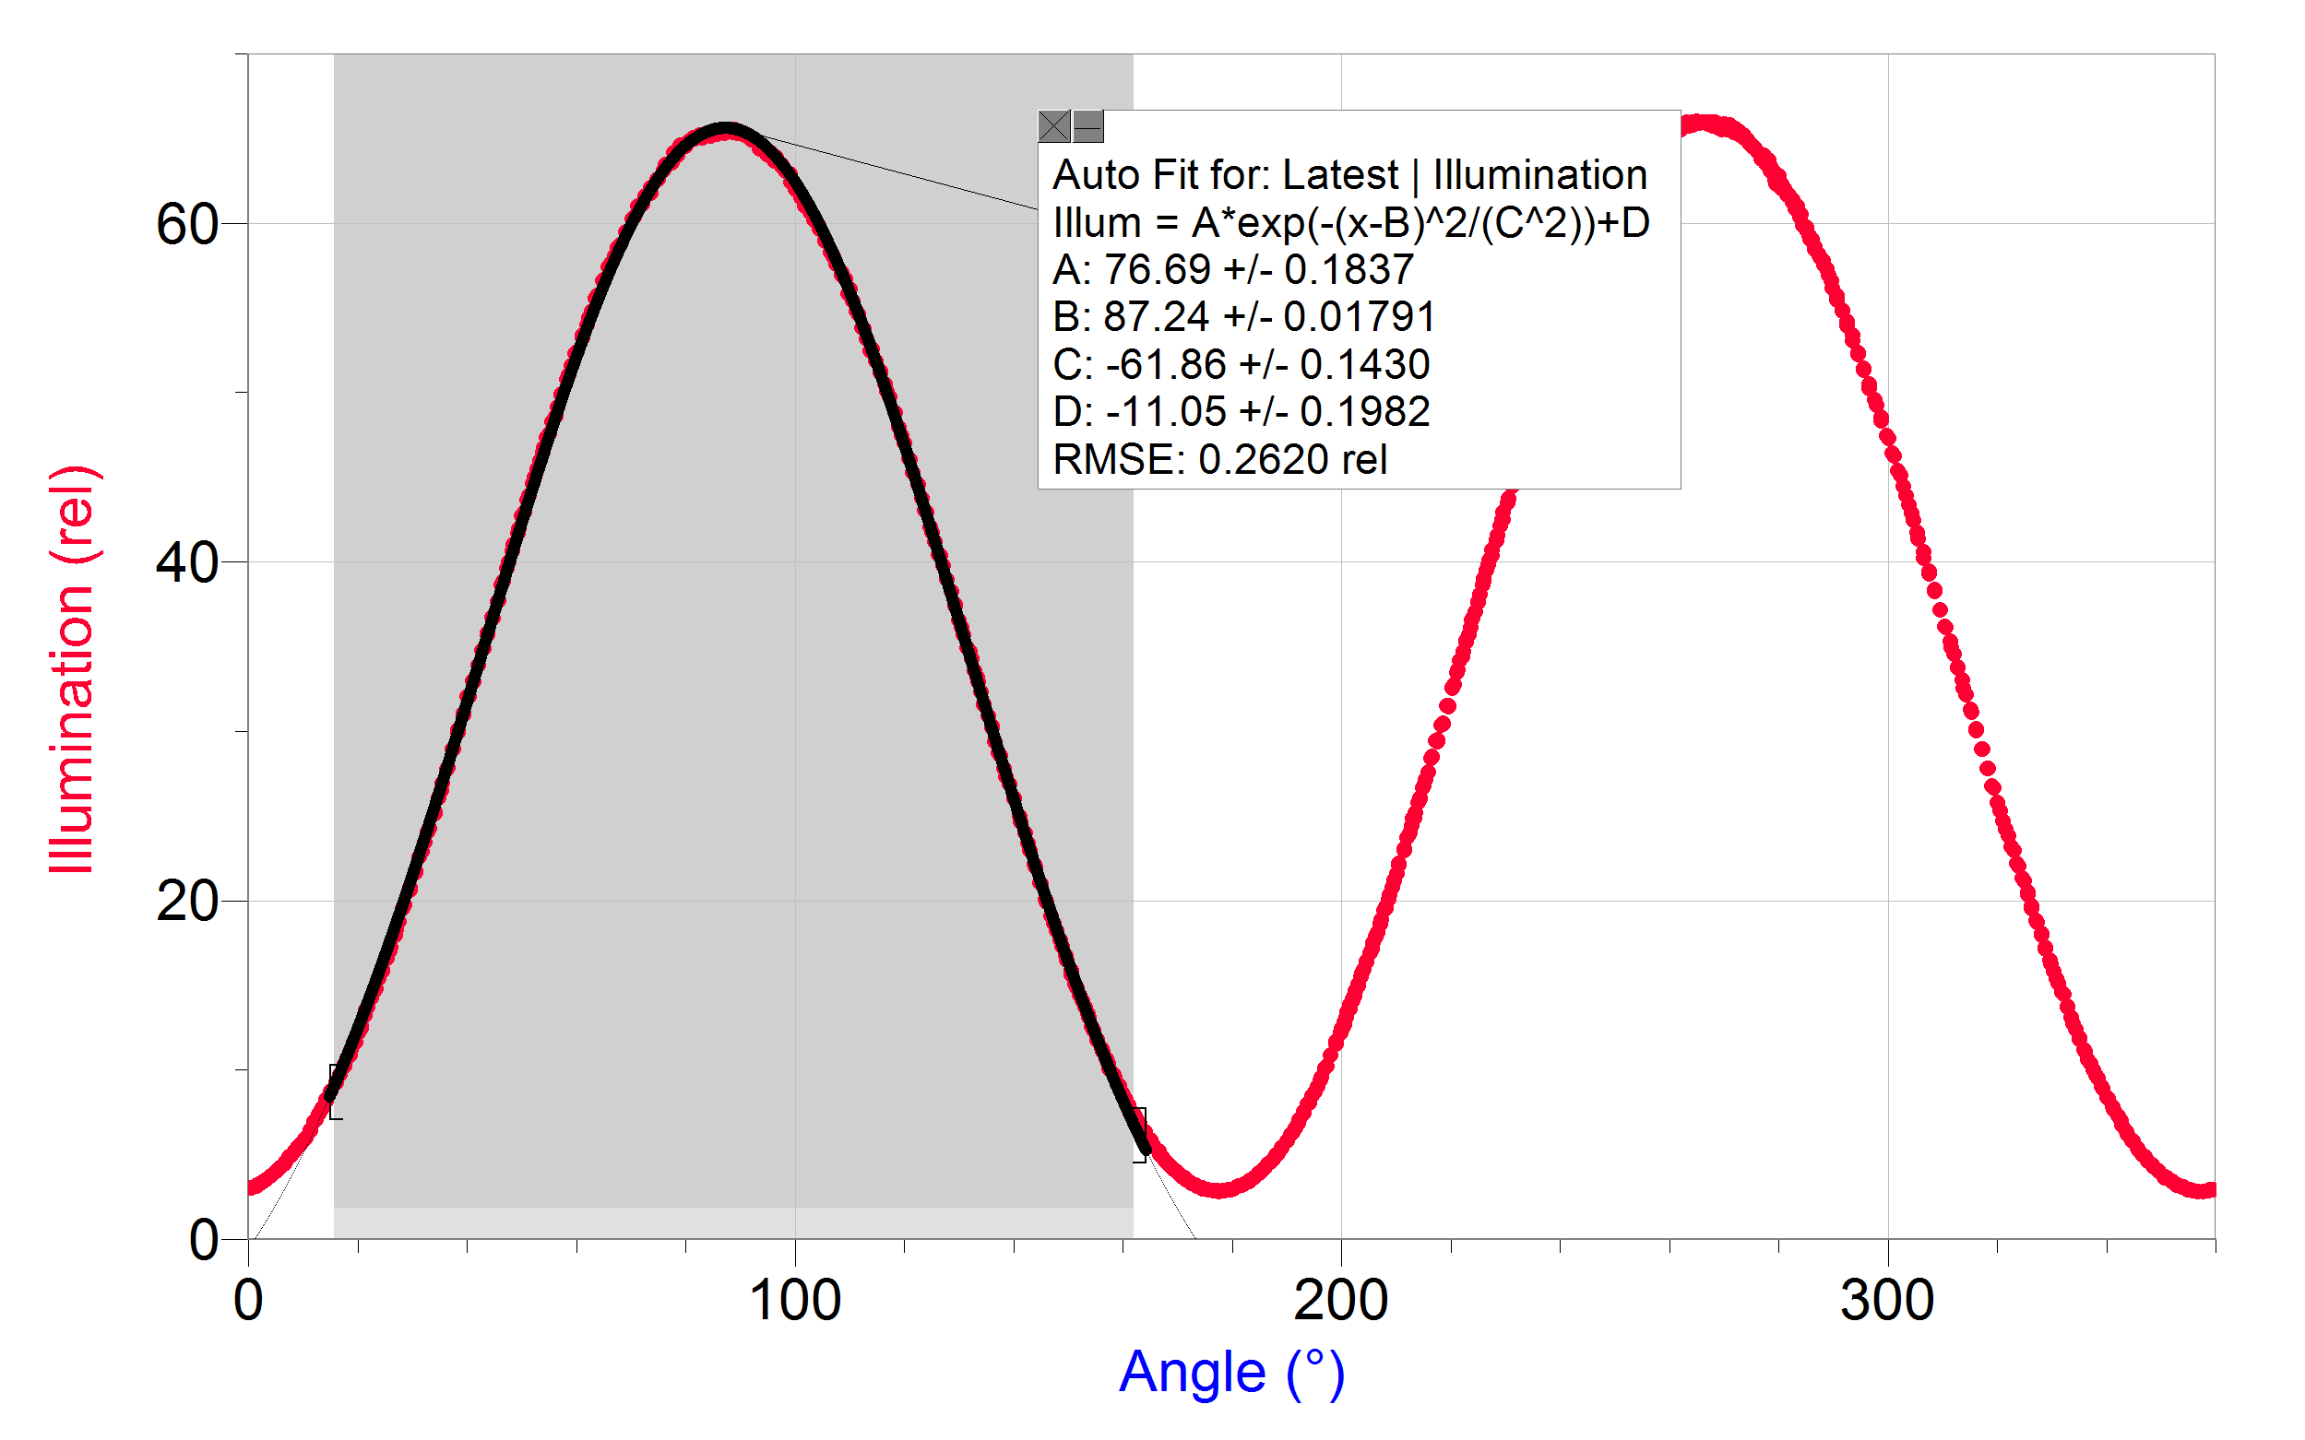
- Statistics: To simply get the angle with the highest illumination, highlight the peak of interest in Logger Pro or LabQuest App, as shown in Figure 1. Choose Statistics from the Analyze menu. Record the angle value where the illumination is at a maximum, as presented in the box. This method is the fastest and will result in reproducibility of the angle of rotation measurement of ±2.0°.
Figure 1 Selection for fits
- Gaussian: To improve your accuracy with a better fit, highlight the peak of interest using Logger Pro or LabQuest App, as shown in Figure 1. Then, choose Curve Fit from the Analyze menu. From the list of available Equations, select Gaussian. Select Try Fit in Logger Pro; in LabQuest App, the fit will run automatically. The B coefficient presented represents the angle at maximum illumination. This method will result in reproducibility of the angle of rotation measurement of ±0.3°. The data are not a true Gaussian, but the ease and accuracy of this methodology make it a good option. For best results, be consistent in the way you select your peaks.
- Cosine Squared: To incorporate all of your data into the fit, you can fit the data to its true waveform, a cosine squared, in either Logger Pro or LabQuest App. Choose Curve Fit from the Analyze menu. From the list of available General Equations, select Cosine Squared. Select Try Fit in Logger Pro; in LabQuest App, the fit will run automatically. In this fit, the x-value corresponding to the maximum y-value is obtained from the negative of the phase shift parameter, –C. This is a nonlinear fit which undergoes numerous iterations and has the possibility of no convergence, which will result in an unreasonable answer. With all nonlinear fits, it is important to make sure the resulting value is reasonable based on the data presented in the graph. This method is the most time consuming; however, it will result in reproducibility of the angle of rotation measurement of ±0.1°.

6. If a LabPro interface is being used, allow a few seconds at both the beginning and ending of the 15 second data-collection period without moving the analyzer. Typically, a warning “Waiting for data…” will appear when data collection has been initiated; wait until this message has disappeared before rotating the analyzer. It may be helpful to extend the data collection time to ensure students do not continue to rotate the analyzer after data collection has ended.
LabPro users have these extended instructions because the optical encoder that tells Logger Pro what angle the analyzer is sitting on does not continuously collect data on the LabPro like it does on the LabQuest and LabQuest Mini interfaces.
7. α-lactose interconverts to β-lactose in aqueous solution over time causing the time˗dependent change in optical rotation of the synthesized sample. In order for students to see this change, the α-lactose cannot be sitting in water for too long prior to data collection. To have students observe the kinetics of this reaction, see Vernier Polarimetry Experiment 2 “Observing the Reaction Kinetics of Sucrose with Polarimetry.”

HAZARD ALERTS
Acetic acid: May be harmful if inhaled, absorbed through skin or swallowed. Causes skin and eye burns. NFPA Rating: Health hazard−3, Fire−2, Reactivity hazard−0.

Calcium carbonate: May be harmful if inhaled, absorbed through skin or swallowed. May cause skin and eye irritation. NFPA Rating: Health hazard−0, Fire−0, Reactivity hazard−0.

Ethanol: May be harmful if inhaled, absorbed through skin or swallowed. Causes skin and eye irritation. NFPA Rating: Health hazard−2, Fire−3, Reactivity hazard−0.

The hazard information reference is:
Sigma-Aldrich Co., 1-800-325-3010, www.sigmaaldrich.com/safety-center/msds-search.html

COMPOUND INFORMATION
Compound | Molar mass (g/moL) | Specific rotation (°)
α-lactose | 342.3 | +92.6
β-lactose | 342.3 | +34.0

Sample results
Part I Isolation and Purification of Casein
Weight of powdered nonfat milk (g) | 4.13
Weight of watch glass alone (g) | 48.39
Weight of watch glass with dry casein (g) | 50.55
Weight of dry casein (g) | 2.16

Part II Isolation of the Lactose and Albumin
Weight of synthesized albumin (g) | 2.38
Weight of filter paper (g) | 0.40
Weight of filter paper with synthesized α˗lactose (g) | 1.82
Weight of synthesized α-lactose (g) | 1.42

Part III Measuring the Optical Activity of Lactose
Volume of water added to dissolve α˗lactose (mL) | 5.0
α˗lactose sample concentration (g/mL) | 0.28
Angle_{blank} (°) | 60.2
Height of α˗lactose solution (dm) | 0.21
Angle_{sample} (°) | 65.3
Angle of rotation, α (°)  = Angle_{sample} – Angle_{blank} | 5.1

Answers to DATA ANALYSIS questions
Part I Isolation and Purification of Casein
1. $\frac{2\text{.}\text{16}}{4\text{.}\text{13}}×\text{100}=\text{52}\text{.}3\text{\%}$
Part II Isolation of the Lactose and Albumin
2. $\frac{1\text{.}\text{42}}{4\text{.}\text{13}}×\text{100}=\text{34}\text{.}4\text{\%}$
3. $\frac{2\text{.}\text{38}}{4\text{.}\text{13}}×\text{100}=\text{57}\text{.}6\text{\%}$
Part III Measuring the Optical Activity of Lactose
4.
$\begin{aligned}α=[α]ℓc \\ [α]_{\text{obs}}=\frac{5\text{.}1°}{\left(0\text{.}\text{21dm}\right)\left(0\text{.}\text{28g/mL}\right)}=\text{86}\text{.}7° \\ \frac{\text{86}\text{.}7°}{\text{92}\text{.}6°}×\text{100}=\text{93}\text{.}6\text{\%}\end{aligned}$
5.
$$\frac{\text{86}\text{.}7°}{\text{92}\text{.}6°}×\text{100}=\text{93}\text{.}6\text{\%}$$
Therefore, only 93.6% of the sample is α-lactose. The impurity is contamination, most likely from the β-lactose enantiomer.

Sample Graph
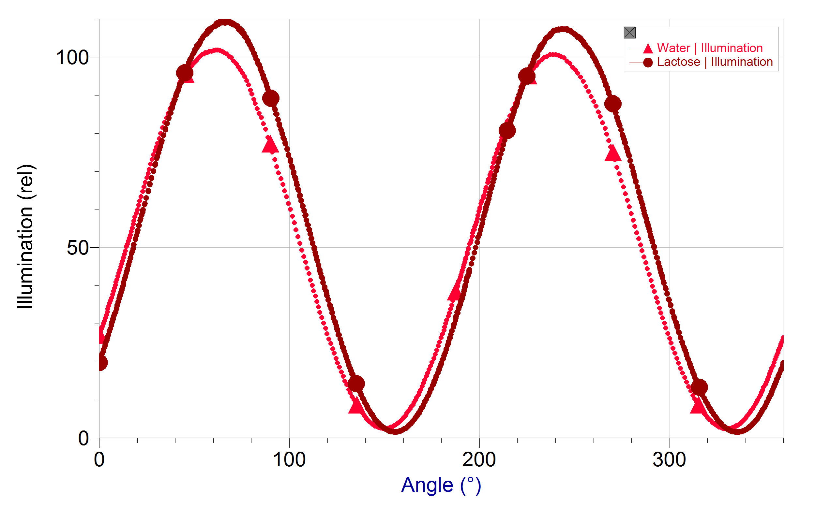
Optical rotation data for lactose

