Isolating the Enantiomers of
1-Phenylethylamine by Fractional Crystalization
Enantiomers are pairs of stereoisomers that have the same atom connectivity, yet they are non-superimposable mirror images. They exhibit identical physical properties (e.g., melting point and boiling point) and cannot be distinguished by most spectroscopic techniques. This means that it is impossible to separate enantiomers using common organic techniques such as distillation and extraction. They do, however, exhibit two key differences. First, the two enantiomers rotate plane-polarized light in opposite directions and so are called “optically active.” Second, they show different behavior in the presence of other optically active compounds. The first of these is important for identifying these compounds and the second is important for separating them.
1-phenylethylamine (i.e., α-methylbenzylamine) is a chiral compound that can exist as one of two enantiomers:
S-(–) R-(+)
Figure 1 Enantiomers of 1-phenylethylamine
This compound can be synthesized in a variety of ways. However, unless optically active precursors and careful conditions are chosen, the synthesis will yield a 50:50 mixture of the two enantiomers. This is called a racemic mixture, which will not rotate plane-polarized light because one enantiomer cancels the rotating effect of the other. Thus, optical activity only results if the enantiomers are present in unequal amounts. In this lab, you will separate the two stereoisomers of 1-phenylethylamine and use polarimetry to explore their optical activity.
Polarimetry is a common technique for distinguishing between optically active stereoisomers, i.e., enantiomers. This makes it a very important tool in organic chemistry because the optical rotation of a molecule can dictate what reactions it will undergo. This is true for most chiral molecules, including organic, inorganic, and biological compounds. An enantiomer will consistently have the same specific rotation under identical experimental conditions. To determine the specific rotation of the sample, use Biot’s law:
α = [α] ℓ c
where α is the observed optical rotation in units of degrees, [α] is the specific rotation in units of degrees (the formal unit for specific rotation is degrees dm⁻¹ mL g⁻¹, but scientific literature uses just degrees), ℓ is the length of the cell in units of dm, and c is the sample concentration in units of grams per milliliter.

OBJECTIVES
In this experiment, you will
- Isolate the stereoisomers of 1-phenylethylamine from the racemic mixture.
- Confirm the identity of each stereoisomer using a Polarimeter.
- Determine the optical purity of your isolation using polarimetry.

MATERIALS
LabQuest or computer interface | vacuum filtration apparatus
LabQuest App or Logger Pro | 250 mL Erlenmeyer flask
Vernier Polarimeter | aluminum foil
Polarimeter sample cell | ice bath
l-(+)-tartaric acid | 50% aqueous NaOH
methanol | Na₂SO₄
racemic 1-phenylethylamine | gravity filtration apparatus
dichloromethane | hot plate
separatory funnel
PROCEDURE
Part I Isolation of 1-phenylethylamine enantiomers
1. Obtain and wear goggles. Protect your arms and hands by wearing a long-sleeve lab coat and gloves. Conduct this reaction in a fume hood.
2. Using a hot plate, heat a solution of 7.8 g of l-(+)-tartaric acid and 125 mL of methanol in a 250 mL Erlenmeyer flask.
3. When the solution is almost boiling, slowly add 6.25 g of racemic 1-phenylethylamine. CAUTION: Adding the amine too fast will result in the mixture boiling over.
4. Remove the flask from the hot plate and allow it to cool to room temperature undisturbed to promote crystallization. Since crystallization will occur slowly, cover the top of the flask loosely with aluminum foil, and allow it to sit overnight.
5. Prismatic crystals should have crystallized out of the solution. Note: If needle crystals form instead of prismatic crystals, you must redissolve them with careful heating. Then allow them to slowly cool again, undisturbed. Needles will result in product that is not optically pure.
6. Collect the crystals using a vacuum filtration apparatus.
7. After removing the filtrate, rinse the crystals with a small amount of cold methanol.
8. Partially dissolve the crystals in 25 mL of water and treat with 4 mL 50% aqueous NaOH to pH 13. The amine salt should now be converted to the organic-soluble free amine.
9. Transfer the mixture to a separatory funnel and extract three times with 10 mL of dichloromethane.
10. Dry the organic extracts over Na₂SO₄, filter using gravity filtration.
11. Remove the dichloromethane using rotary evaporation or similar process. Record your yield.
12. Dissolve your product in a minimal amount of methanol to use in measuring its optical rotation (Part II). Record the exact concentrations in the table below.
Part II Measuring the Optical Rotation
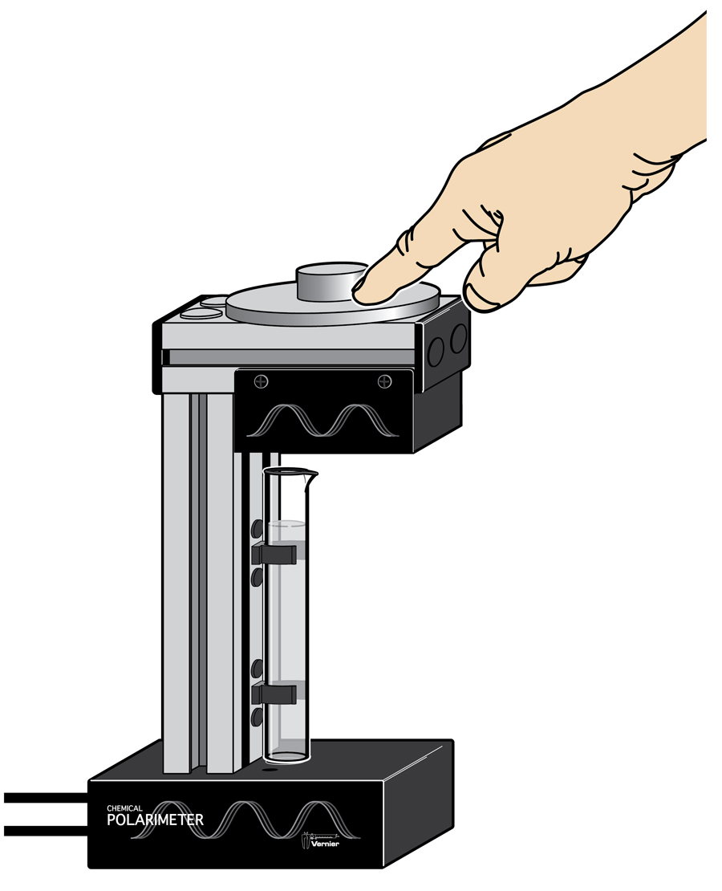
13. In addition to your product from Part I, prepare a solution of 2 g of racemic
1-phenylethylamine in 25 mL methanol to use in measuring its optical rotation.
Figure 2 Rotation of the analyzer
14. Connect the Vernier Polarimeter cables to their respective ports on your Vernier interface. Start the data-collection program and choose New from the File menu. Note: In Logger Pro, wait until a graph of Illumination (rel) on the y-axis and Angle (°) on the x˗axis appears before continuing.
15. Calibrate the Polarimeter.
a. Pour methanol in the Polarimeter cell to a height of 10 cm. Record the height to the nearest 0.1 cm.
- Place the cell in the Polarimeter.
- Start data collection and slowly rotate the analyzer clockwise or counterclockwise until data collection stops (15 s), as shown in Figure 2. Note: If you are using a LabPro interface, only rotate the analyzer while data collection is active. Allow a few seconds at both the beginning and ending of data collection without moving the analyzer.

16. Record the first angle above 0° where the illumination is at a maximum for the blank. There are several ways to locate this angle using analysis features in Logger Pro or LabQuest App. One way to locate this angle is to use a Gaussian fit.
17. Store the run. In Logger Pro, do this by selecting Store Latest Run from the Experiment menu. In LabQuest App, you can store a run by tapping on the file cabinet icon in the upper right of your screen.
18. You are now ready to add your optically active sample into the Polarimeter cell.
- Pour your product into the Polarimeter cell. Record its height to the nearest 0.1cm in the table below.
- Place the sample cell in the Polarimeter.
- Start data collection and slowly rotate the analyzer clockwise or counterclockwise until data collection stops.

19. Record the first angle above 0° where the illumination is at a maximum. Record this value in the table below.
20. Repeat Steps 17–19 for the racemic 1-phenylethylamine.

DATA tables
Part I Isolation of 1-phenylethylamine
Weight of starting material (g)
Weight of product (g)

Part II Measuring the Optical Rotation
Angle_{blank} (°) = __________
 | Starting material | Product
Height (cm)
Concentration (g/mL)
Angle_{sample} (°)
Angle of rotation, α (°)
= Angle_{sample} – Angle_{blank}

DATA ANALYSIS
1. Calculate the percent yield of the product.
2. Calculate the specific rotation of the starting material.
3. What stereoisomer of 1-phenylethylamine did you isolate as your product? Explain.
4. Using the literature value for the specific rotation of S-(–)-1-phenylethylamine, calculate your product purity.

