Respiration with Thermal Analysis
OverView
This experiment is excellent for introducing the features of the Vernier Thermal Analysis for FLIR ONE™ app to students. The procedure is not complicated, but it requires the use of the Calibrate, Mirror, and Range settings as well as the collection of video and graphical data. Students will have to interpret the graph to determine their respiration rate.

RELATED SKILLS
- Change the settings used in the Thermal Analysis app.
- Use the temperature vs. time graph in the Thermal Analysis app to answer questions about respiration.

Estimated Time
Data collection, analysis, and class discussion can be completed in 20–30 minutes.

Next Generation Science Standards (NGSS)
Disciplinary Core Ideas | Crosscutting Concepts | Science and Engineering Practices
PS4.B Electromagnetic Radiation | Patterns  Cause and effect | Analyzing and interpreting data  Engaging in argument from evidence

EQUIPMENT TIPS
1. Charge the FLIR ONE camera before use. If the battery is low, the Thermal Analysis app will close.
2. Aligning the thermal image with the visible outline is not required, but it helps students locate the thermometer accurately.

Data-Collection and Analysis Tips
1. It is important for the student to stay still while taking data so that the nose remains in the temperature measurement region for the entire 60 seconds.
2. Students must not touch their face during data collection or the app may record the hand temperature instead of the nostril temperature.
3. In step 4e of the procedure, the student is instructed to set the area temperature meter to MIN. This choice is made because one needs the temperature near the nostril only. It is too difficult to set a very small region over only the nostril, and the uniform temperature around the nostril will make an average temperature reading difficult to use due to that measurement’s small variation. The MINimum setting is therefore the better choice to record the largest temperature change with a non-critical configuration.

SAMPLE DATA
Run | Number of inhales | Number of exhales | Average breaths per minute
1 | 12 | 12 | 12
2 | 11 | 12 | 11.5
3 | 9 | 9 | 9
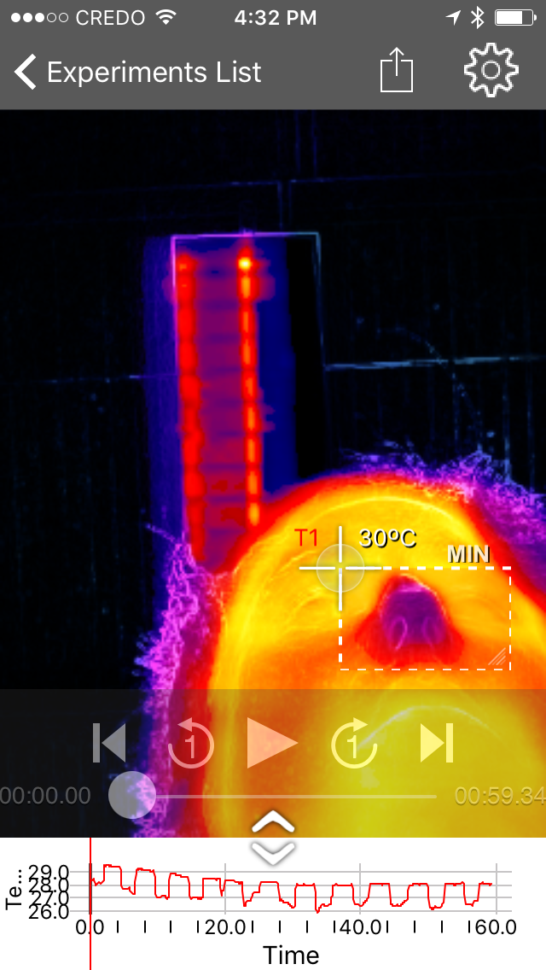

Figure 1

Answers to ANALYSIS Questions
1. Answers will vary.
2. Answers will vary.
3. Answers will vary.
4. Answers will vary.

