Absorption of Radiant Energy
Overview
This experiment is an excellent way to introduce students to the features of the Vernier Thermal Analysis for FLIR ONE™ app. Students look at how black and white pieces of paper heat up when illuminated by an incandescent bulb. After analyzing their data in Graphical Analysis app, students draw conclusions about their own comfort in the sun while wearing different colored clothing.

related skills
- Change the settings used in the Thermal Analysis app.
- Use the temperature vs. time graph in the Graphical Analysis app to answer questions about absorption of radiant energy.

estimated time
Data collection, analysis, and class discussion can be completed in 20–30 minutes.

next generation science standards
Disciplinary Core Ideas | Crosscutting Concepts | Science and Engineering Practices
PS4.B Electromagnetic Radiation | Patterns  Cause and effect | Analyzing and interpreting data  Engaging in argument from evidence

equipment tips
1. Construction paper works well in this experiment. Try to obtain pieces with the same texture and thickness.
2. Rectangular paper pieces 10 cm × 20 cm (4" × 8") work well.
3. We suggest the use of 60 W or 75 W incandescent bulbs. Remind your students not to touch a hot bulb.
4. Charge the FLIR ONE camera before use. If the battery is low, the Thermal Analysis app will close.
5. Aligning the thermal image with the visible outline is not required, but it helps students locate the thermometer accurately.
data collection and analysis tips
1. An alternative method for data collection is to use regions instead of spot thermometers. Set the region to measure maximum temperature by scrolling to MAX.
2. Another option for data collection is to use the Delta mode. Choose Delta from the Graph Mode menu in Settings in the Thermal Analysis app. If Delta mode is chosen, the difference between the two temperatures will be graphed instead of the temperature of each spot.

SAMPLE DATA
White Black

Minimum temperature 21.6°C 21.7°C
Maximum temperature 32.3°C 50.1°C

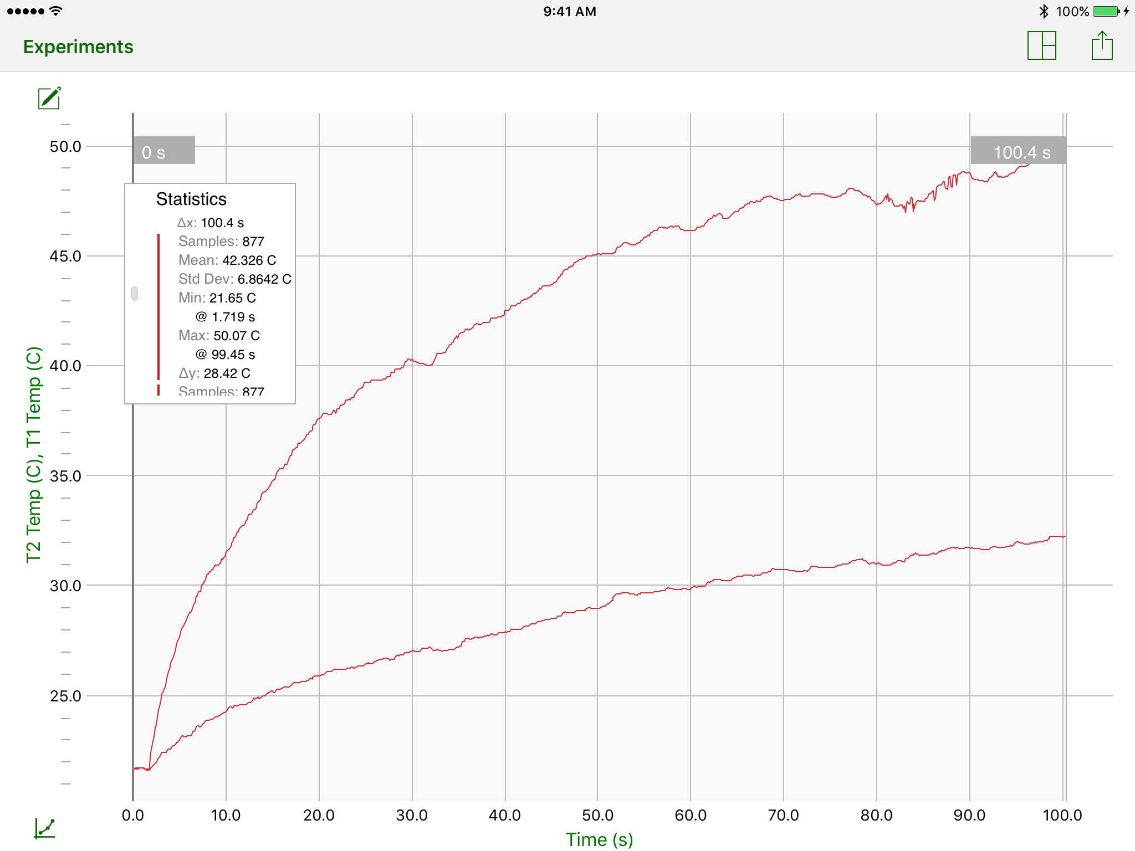

answers to analysis questions
1.
 | White |  | Black
 | 32.3° |  | 50.1°C
 | – 21.6°C |  | – 21.7°C
ΔT = | 10.7°C |  | 28.4°C
2. The temperature of the black paper increased more.
3. The temperature of the white paper increased less.
4. It is better to wear light-colored clothing in the summertime because it absorbs less radiant energy from the sun and keeps you cooler than dark clothing does.
5. Black works best for use with solar collectors because black absorbs radiant energy best.

