Evaporation and Cooling
There are several methods for reducing the temperature of an object. For example, you could place the object next to an object with a lower temperature—this is cooling by conduction. Or, you could cool the object with evaporation. In the process of evaporation, a liquid makes a phase change into a gas. This phase change takes energy and thus reduces the thermal energy (and temperature) of a nearby object.

OBJECTIVES
Use the FLIR ONE™ thermal camera and the Vernier Thermal Analysis app to measure temperature of both wet and dry objects.
Explore rates of evaporation and cooling.

MATERIALS
iPad®, iPhone®, or iPod® with lightning port | 5 beakers
Vernier Thermal Analysis for FLIR ONE™ app | paper towels
FLIR ONE thermal camera for iOS | rubber bands
tripod or support for iOS device | eye dropper
hot plate

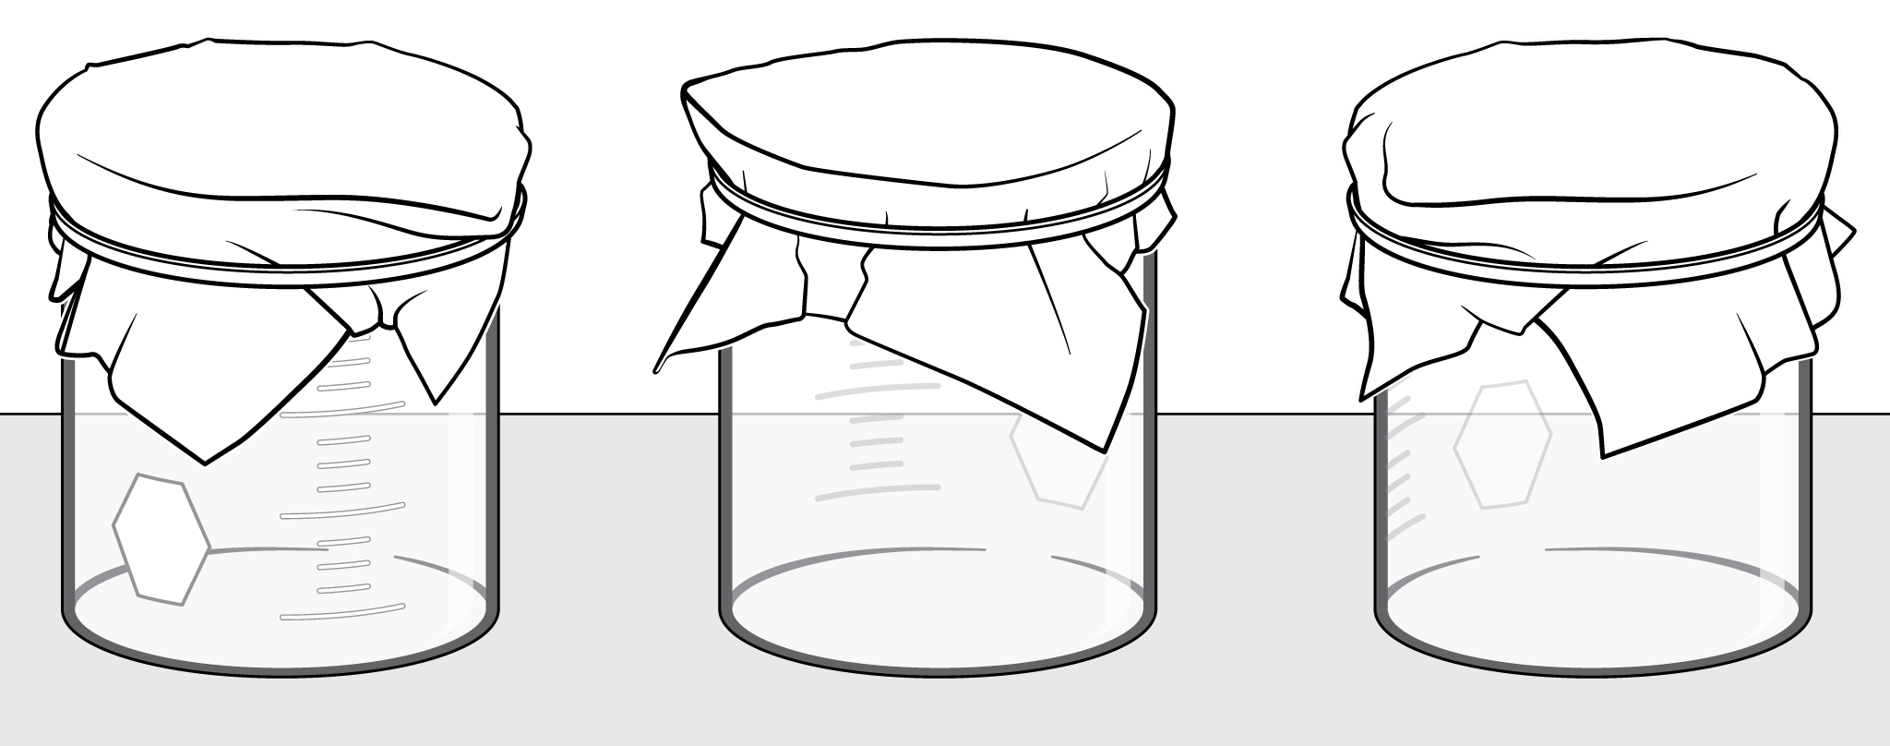
Figure 1

PROCEDURE
1. Start by heating some water in a beaker on a hot plate. You don’t need to bring the water to a boil—it just needs to be hotter than room temperature. A starting temperature of 70–100°C works well.
2. Obtain another beaker containing water at room temperature.
3. Obtain three small beakers. Place a section of paper towel over each beaker and use a rubber band to secure the paper towel such that it doesn’t fall into the beaker, as shown in Figure 1.
4. Position the three beakers with paper towels next to each other so that all three beakers can be viewed with the FLIR ONE.
5. Open the Vernier Thermal Analysis app on your device.
6. Tap the + sign to start a new experiment.
7. Attach the FLIR ONE thermal camera to the lightning port of your iOS device with the lenses aimed down at the paper towels, and turn on the camera.
If you also have the FLIR ONE app on your device, there will be a box that pops up with the message that FLIR ONE would like to communicate with the FLIR Systems FLIR ONE Camera. Tap Ignore.
If the camera battery does not have enough charge, the app will close.

8. Set up the app to record a spot temperature at the center of each paper towel by tapping on the image in the center of each paper towel.
9. Once the water is hot, use the eye dropper to place a small amount of hot water onto the towel on top of one of the containers. You need enough water so that the towel is wet but not enough water that it pools at the top. Repeat the wetting process with room temperature water on a second towel and leave the third towel dry.
10. Tap the red circle in the Thermal Analysis app to record the temperature. After 60 seconds, stop collecting data and save the video.
11. Wait for 5 minutes while leaving the paper towels undisturbed.
12. After 5 minutes, again use the Thermal Analysis app to record the temperatures of the three towels for an additional 60 seconds.

DATA
 | Temperature at Time = 0 s  (°C) | Temperature at Time = 60 s  (°C) | Temperature at Time = 6 min  (°C) | Temperature at Time = 7 min  (°C)
Dry towel
Towel with room temperature water
Towel with hot water

ANALYSIS Questions
1. After 7 minutes with water on the towel, which of the three towels had the lowest temperature? Why do you think this was the coldest towel?
2. Which was colder, the towel with no water or the towel with hot water? Can you explain?
3. Suppose the relative humidity was very high. What effect might this have on the evaporation and temperature of the three towels?
4. If a fan is placed near the three towels such that it blows room temperature air, what effect will this have on the temperature of the three towels?

Extensions
1. There is a type of refrigerator called a pot-in-pot refrigerator (also called a zeer cooler). This cooler uses two terracotta (porous clay) pots. An object to keep cool is placed in the first pot. This pot is then placed into a larger pot along with wet sand with a wet towel covering the top. Temperatures inside the inner pot can get as low as 5 degrees Celsius. See if you can create one of these pots.
2. Suppose your friend created a zeer cooler but used plastic pots instead of porous materials. Would the cooler still be effective?
3. Try cooling a bottle of water with a wet cloth. How cold can you get the water?
4. One use of a thermal camera like the FLIR ONE is to look for water leaks in a house or building. Describe how the FLIR ONE can be used to find a wall or ceiling that is wet from a leak.
5. Test your prediction from Analysis Question 4.
6. Devise a way to measure how much water evaporated.

