Fractional Distillation of Esters
Fractional distillation is a technique used to separate mixtures of compounds into pure components. At a given temperature, a pure liquid has a specific vapor pressure. Heating the liquid provides a greater mole fraction of molecules with the kinetic energy needed to escape into the gas phase. This temperature, when the vapor pressure of a liquid equals the atmospheric pressure, is defined as the boiling temperature of a substance.
If substances in a mixture have significantly different vapor pressures, they can be separated by a technique known as simple distillation. In simple distillation, a mixture is warmed slowly and the most volatile liquid vaporizes first. The vapor is then condensed back to liquid and collected in a separate flask. For mixtures of compounds with similar boiling points, you could perform a simple distillation multiple times, or employ fractional distillation.
A fractionating column is one designed to allow multiple simple distillations to occur over its length (see Figure 1). One type of fractionating column is a long glass tube packed with glass or ceramic beads which allows the vapor to condense and vaporize multiple times as it travels up the column. Each cycle of condensation and evaporation is called a theoretical plate. The more theoretical plates in the column, the better the separation between the compounds in a mixture will be.
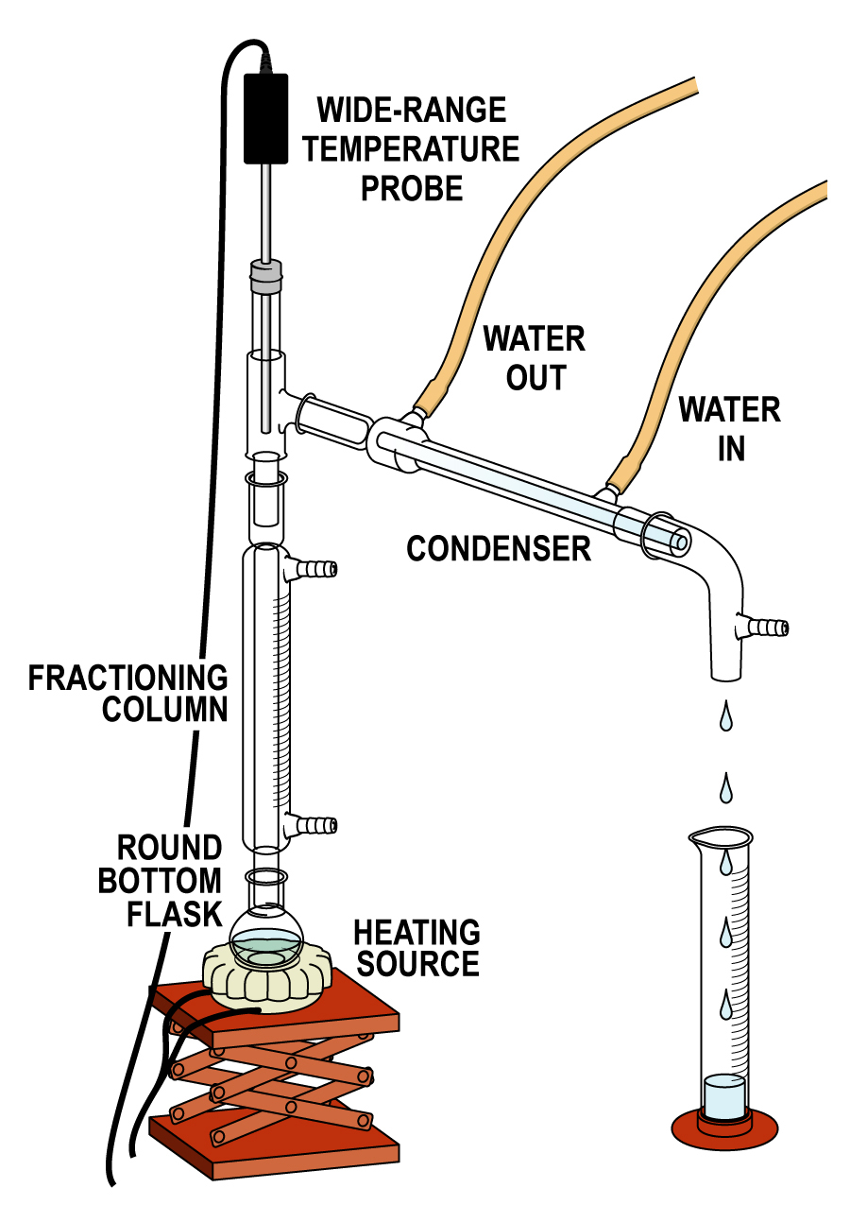
Figure 1 Distillation column

Figure 2 is a graphical representation of the temperature of the distilling vapor as a function of the volume of distillate in a two-component mixture. The black curve represents a practically ideal distillation in which the lower boiling component distills completely (the volume of collected fraction increases as the temperature stays constant) and then the higher boiling component distills. The gray curve is an example of what actually occurs in many distillation processes; the first distillate is enriched in the lower boiling component and the final distillate is enriched in the higher boiling component. By carefully controlling the temperature and by using a column with an optimum surface area for your mixture, it is possible to conduct a fractional distillation that will make the empirical curve (gray) closely follow the ideal curve (black), thus achieving the best possible separation of the mixture’s components.

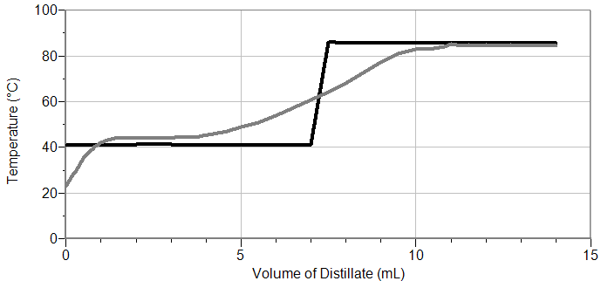

Figure 2 Temperature vs. Volume Distillate Graph

Fractional distillation is a slightly more complex process than it may seem, considering that you are simply slowly heating a mixture of two liquids so the liquid with the lower boiling point will vaporize first. It will be important for your understanding of this distillation technique to read about theoretical plates as they relate to fractional distillation, as well as study McCabe-Thiele diagrams describing this process.

OBJECTIVES
In this experiment, you will
- Measure and analyze the retention times and peak areas of ethyl acetate and butyl acetate.
- Conduct the fractional distillation of a mixture of ethyl acetate and butyl acetate.
- Measure and analyze the retention times and peak areas of the fractions.
- Estimate the mole fraction of the components of the mixture.

MATERIALS
LabQuest or computer | vials of:
LabQuest App or Logger Pro | ethyl acetate
Vernier Mini GC | butyl acetate
Temperature Probe | 50:50 ethyl acetate and butyl acetate
fractional distillation apparatus | acetone
1 μL glass syringe | five 10 mL graduated cylinders
Kimwipes® or paper towels | boiling stone
heating mantle or oil bath | Parafilm®
PRE-LAB EXERCISE
1. What are the boiling points of ethyl acetate and butyl acetate?
2. Draw the structures of these compounds.

PROCEDURE
Part I Conduct the Fractional Distillation of a Mixture of Ethyl Acetate and Butyl Acetate
1. Obtain and wear goggles. Protect your arms and hands by wearing a long-sleeve lab coat and gloves. Conduct this experiment in a fume hood or a well-ventilated room.
2. Set up the fractional distillation apparatus for your experiment, as shown in Figure 1. Use 10 mL graduated cylinders to collect the distillates.
3. Obtain 20 mL of the ethyl acetate/ butyl acetate mixture and transfer it to a round-bottom flask. Add a boiling stone to the flask. CAUTION: Ethyl acetate and butyl acetate are both hazardous in case of ingestion or inhalation.
4. Warm the flask until distillate begins to collect in your graduated cylinder. Record the temperature of the vapor when the first drop of distillate is collected in your graduated cylinder. If this temperature is significantly below the boiling temperature of ethyl acetate, or more than 5°C above the boiling temperature of ethyl acetate, you may have an improperly placed thermometer.
5. If necessary, adjust the heat so the collection rate of the distillate is about 1 drop per second.
6. You will collect five fractions, using a separate graduated cylinder for each fraction. Collect the fractions according to the chart below. For the 2nd–5th fractions, you need not collect an exact volume. After you collect each fraction, seal the graduated cylinder with a square of Parafilm. Important: Do not allow the round-bottom distilling flask to go dry.
 | 1st fraction | 2nd fraction | 3rd fraction | 4th fraction | 5th fraction
Temperature range (°C) | 76–80 | 80–84 | 84–88 | 88–120 | >120
Volume (drops or mL) | 5–10 drops | ~2 mL | ~3 mL | ~3 mL | ~3 mL

Part II Analyze the Fractions by Gas Chromatography

7. Obtain a glass syringe and four vials containing acetone, ethyl acetate, butyl acetate, and a mixture of ethyl acetate and butyl acetate. The acetone will be used only to clean the syringe. CAUTION: Ethyl acetate and butyl acetate are both hazardous in case of ingestion or inhalation.
8. Prepare the Vernier Mini GC for data collection.
- Turn on the Mini GC.
- Connect the Mini GC to the USB port on your computer or LabQuest.
- Start the data-collection program, and then choose New from the File menu.
- To bring up the Temperature-Pressure profile, tap ► in LabQuest or click Collect in Logger Pro.
- Set the Temperature-Pressure values to:

Start temperature | 40°C
Hold time | 1 min
Ramp rate | 10°C/min
Final temperature | 65°C
Hold time | 5 min
Total length | 8.5 min
Pressure | 5.0 kPa

- Select Done to initiate the Mini GC warm up. When the Mini GC is ready for injection in Step 12, the message will read, “Inject and select Collect simultaneously”, and the LED will turn to green. Continue with Step 9 during warm up.

9. Follow the steps below to clean and flush the syringe with acetone. Important: The glass syringe is fragile. Be careful not to bend the needle or bend the plunger. Never pull the plunger back more than 50% of its total volume. Be careful not to bend the plunger as you press it down.
- Depress the plunger fully.
- Submerge the tip of the syringe needle into the vial of acetone.
- Pull back the plunger to fill the barrel about 1/3 full of acetone. Examine the barrel of the syringe and estimate the amount of acetone in the barrel.
- Expel the liquid onto a Kimwipe or a paper towel.
- Repeat Steps a–d at least two times, until you are comfortable pulling up a liquid into the syringe and measuring the volume in the syringe barrel. Use a Kimwipe or a paper towel to carefully pat around the tip of the syringe needle.

10. Follow the process in Step 9 to clean and flush the syringe with ethyl acetate, the first sample to be injected into the Mini GC.
11. Collect a volume of ethyl acetate for injection.
- Submerge the needle into the vial of ethyl acetate one last time.
- Draw up 0.20 μL of liquid.
- After collecting your sample, gently wipe the needle, from barrel to tip, with a Kimwipe.

12. Prepare for injection and the start of data collection.
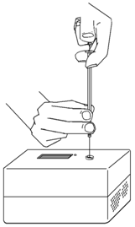
- The Mini GC should now have reached the correct start temperature and pressure, and the LED should be green.
Figure 3
- To insert the needle of the syringe into the injection port of the Mini GC, hold the syringe with one hand and steady the needle with your other hand, as shown in Figure 3. Insert the needle into the injection port until the needle stop is fully seated. If the needle sticks, rotate it slightly while inserting. Do not move the plunger yet.
- Simultaneously, depress the syringe plunger and select Collect to begin data collection. Pull the needle out of the injection port immediately.

13. While the data collection proceeds, repeat Step 9 to thoroughly clean the syringe and needle. It may take more than three flushes to feel the syringe plunger move smoothly again, which is your indicator that the syringe and needle are both suitably clean.
14. Data collection will end after 8.5 minutes. Observe the graphed data that characterize an ethyl acetate chromatogram.
15. Analyze your chromatogram.
- Choose Peak Integration from the Analyze menu.
- Select the left-most peak. To do this, drag from a little before the peak to a point far enough to the right so that the entire peak is included. Choose Add.
- Record the retention time and the peak area in your data table.
- Click Cancel to return to the graph.

16. Label and store your run of data:
- In LabQuest App, tap the Table tab. Highlight the heading, Run 1, with your stylus, and replace it with the name of your compound. Tap on the Graph tab to return to the graph. Tap the File Cabinet icon to store the run.
- In Logger Pro, double-click Latest, which is the title of your run of data in the table, to the left of the graph. In the Data Set Options dialog box, type in the name of your compound. Click OK. Choose Store Latest Run from the Experiment menu to store your chromatogram.

17. Prepare the butyl acetate sample.
- Click Collect in Logger Pro, or tap ► in LabQuest, to bring up the Temperature-Pressure profile. This profile will be the same as for your previous run. If you are satisfied with these values, click Done.
- While the Mini GC adjusts to its Temperature-Pressure profile, repeat Steps 10 and 11 with the butyl acetate sample.
- After the Mini GC is ready, repeat Steps 12–16.

18. Repeat Step 17 for the ethyl acetate/butyl acetate mixture and the five fractions you collected from the fractional distillation in Part I.
19. After you have completed the test of the mixture, save your file for use at a later time. Save the file as directed by your instructor.
20. Flush and clean the syringe with acetone.
21. Turn off the Mini GC. Keep your test results open in Logger Pro or the LabQuest App; you will need to refer to the various chromatograms to answer the Data Analysis questions.

DATA TABLE
Part I Results
Compound | Retention time (min) | Peak area
Ethyl acetate (EtOAc)
Butyl acetate (BuOAc)
EtOAc/BuOAc mixture

Part II Results
Fraction | Temperature range  (°C) | Volume collected (drops or mL)
1
2
3
4
5

Analysis of the Chromatograms
 | Peak area EtOAc | Peak area BuOAc | Area EtOAc:  Area BuOAc
Acetate Mixture
1st fraction
2nd fraction
3rd fraction
4th fraction
5th fraction

DATA ANALYSIS
1. Based on the distillation and GC data, what was the ethyl acetate:butyl acetate ratio for each fraction?
2. How well did your fractionating column separate the chemicals? What could you change to achieve better separation?

