Relative Velocities
Suppose you are on a train. You are at the front end of the train car, and the restroom is at the back end of the train car. The train is moving at 10 m/s (a little over 20 mph) as it passes through a town. If you walk at 2 m/s toward the back of the train, how fast are you moving relative to the ground?
The above paragraph might have come from the end-of-chapter questions in a standard high school physics textbook. You can easily calculate that your velocity relative to the ground is 8 m/s in the direction the train is moving. You might even know that Olympic-level sprinters could probably momentarily have a velocity of 0 m/s relative to the ground. In this experiment, you will explore relative velocities using two Go Direct Sensor Carts and a Go Direct Motion Detector.
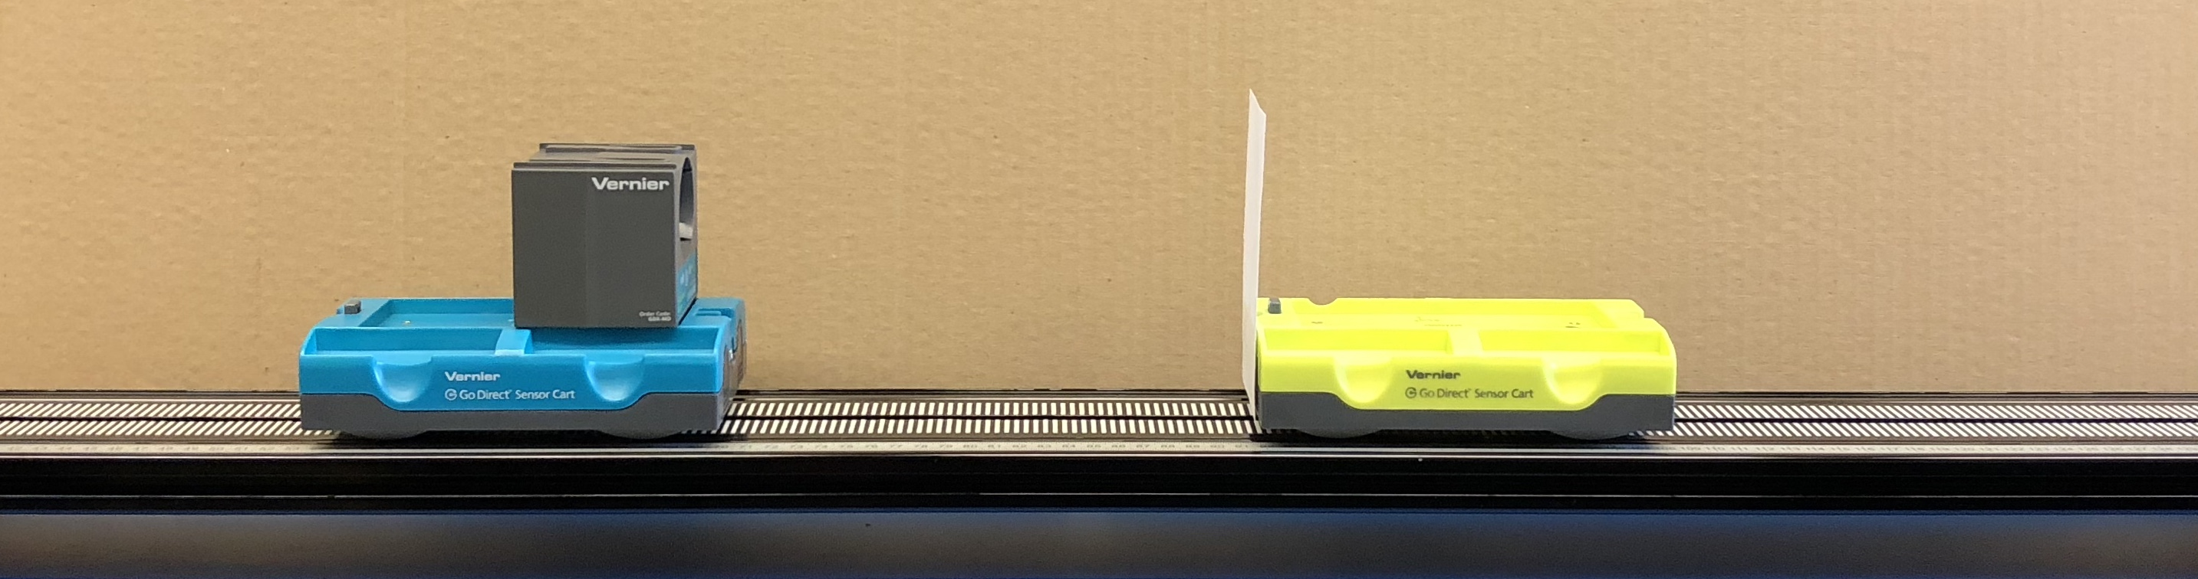
Figure 1
OBJECTIVES
- Collect position and velocity data from two carts on a track
- Analyze position vs. time and velocity vs. time graphs
- Evaluate the equation of relative velocities for 1-dimensional motion

MATERIALS
Graphical Analysis 4 app | Track
computer, Chromebook, or mobile device | index card
Go Direct Sensor Carts (1 green, 1 yellow) | tape
Go Direct Motion Detector

PReliminary questions
1. On a position vs. time graph, sketch a line representing the motion of a train in the positive direction. Sketch a second line representing a horseback rider ahead of the train, moving slower than the train. Describe in words how the position of the horseback rider changes relative to the front of the train. If it helps, imagine you are in the train engine, watching the rider.
2. In a different color on the same position vs. time graph, sketch a line representing the position of the horse and rider relative to the train. How could the equation for this line be determined by knowing the equations for the original two lines on the graph?
PROCEDURE
1. Set up the equipment as in Figure 1, placing the carts on the track such that the +x arrows printed on the carts point in the same direction.
Place the motion detector on the green cart.
Attach an index card to the back of the yellow cart with tape.
Level the track if the carts move without being pushed.

2. Turn on the carts and the motion detector, and launch Graphical Analysis on your device. Connect your carts and motion detector to Graphical Analysis.
3. Zero the cart positions
- Move both carts to the end of the ramp, touching each other, with the +x arrows pointing to the length of the track.
- For each cart, click or tap the Position meter and choose Zero.

Part I Motion in the same direction
4. Move the yellow cart ahead to the center of the track by rolling it along the track. This will set its starting position as greater than zero.

5. Collect data.
- Click or tap collect.
- Start the yellow cart by giving it a light push in the +x direction.
- Start the green cart by giving it a stronger push in the +x direction.

6. Choose a time when both carts are moving and click on the velocity vs. time graph at that time to examine your data.
Determine the velocity of the yellow cart relative to the track, and record this value in the data table.
Determine the velocity of the green cart relative to the track, and record this value in the data table.
Determine the velocity of the yellow cart relative to the green cart, and record this value in the data table.
Sketch or print your velocity vs. time graph, or copy a graph image to a report document.

7. Repeat steps 3–6 with varying pushes.

Part II Motion in opposing directions
8. Set up the carts as in step 3. Then move the yellow cart ahead to the end of the track by rolling it along the track. This will set its starting position at the far end of the track.
9. Collect data.
- Click or tap collect.
- Start the yellow cart by giving it a light push toward the green cart.
- Start the green cart by giving it a push in the +x direction.

10. Choose a time when both carts are moving and click on the velocity vs. time graph at that time to examine your data.
Determine the velocity of the yellow cart relative to the track, and record this value in the data table.
Determine the velocity of the green cart relative to the track, and record this value in the data table.
Determine the velocity of the yellow cart relative to the green cart, and record this value in the data table.
Sketch or print your velocity vs. time graph, or copy a graph image to a report document.

11. Repeat steps 8–10 with varying pushes.

DATA
Part I Motion in the same direction
Run | velocity of yellow cart relative to track  v_{Y,T} (m/s) | velocity of green cart relative to track  v_{G,T}(m/s) | velocity of yellow cart relative to green cart  v_{Y,G} (m/s) | relate the velocities with an equation
1
2
3

Part II Motion in opposite directions
Run | velocity of yellow cart relative to track v_{Y,T} (m/s) | velocity of green cart relative to track  v_{G,T} (m/s) | velocity of yellow cart relative to green cart  v_{Y,G} (m/s) | relate the velocities with an equation
1
2
3

DATA ANALYSIS
1. For each run, note the relationship between the three velocities you recorded.
2. If the equation you wrote is not in terms of the velocity of the yellow cart relative to the track, re-write the equation in the form
v_{Y,T} = v?,? + v?,?

ANALYSIS Questions
1. Does the equation you wrote in step 2 work for every instance you tested? What about the person-on-train question from the very beginning of this handout? Show this.
2. Represent the velocities in the equation with hand-drawn vectors, to scale, for one trial in each part of the experiment.

Extensions
1. Place the motion detector on the yellow cart facing backwards, and place the index card on the front of the green cart. “Reverse” the motion detector readings so that the positive direction for the motion detector is the same as the positive direction for the carts. Repeat both parts of the experiment.
2. Explore additional different scenarios of relative motion with the carts, motion detector, and track.

