Relative Velocities
OverView
This experiment uses the wireless connection capability of the Go Direct Sensor Cart and Go Direct Motion Detector to enable experimentation with relative velocities.
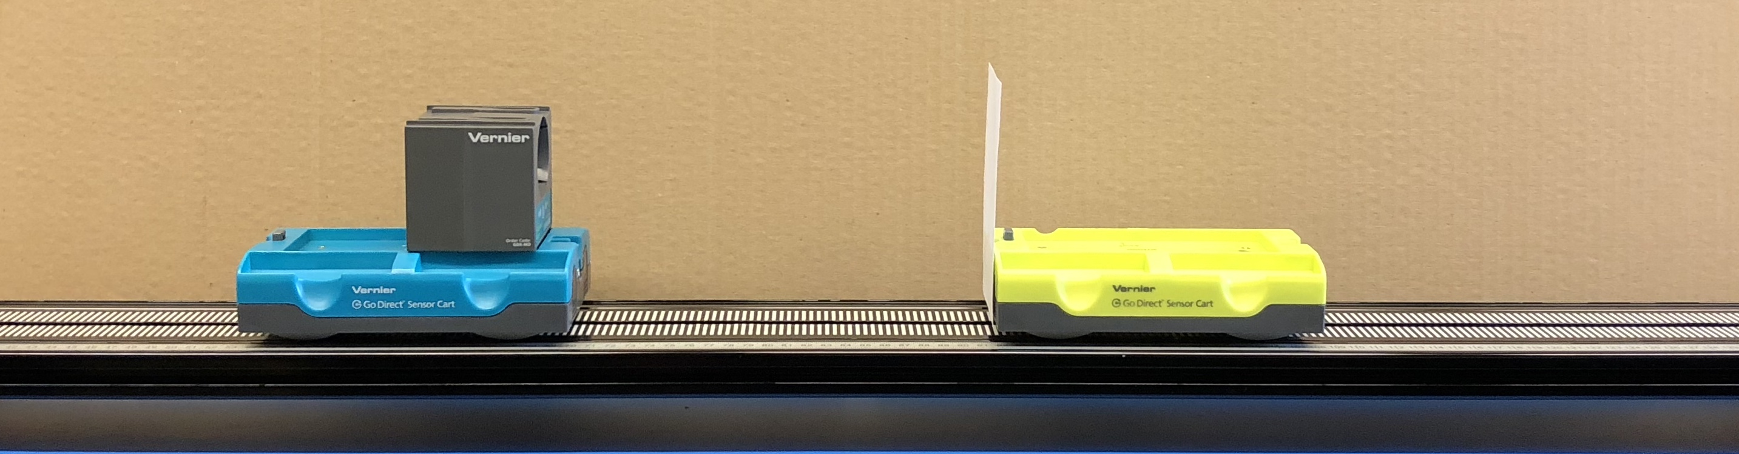
Figure 1
RELATED SKILLS
- View different graphs
- Add curve fits to data.

Estimated Time
It is estimated that data collection and analysis can be completed in one 45-minute class period.

Next Generation Science Standards (NGSS)
Disciplinary Core Ideas | Crosscutting Concepts | Science and Engineering Practices
PS2.A Forces and Motion | Patterns  Systems and system models | Developing and using models  Planning and carrying out investigations  Analyzing and interpreting data  Using mathematics and computational thinking  Obtaining, evaluating, and communicating information

EQUIPMENT TIPS
1. Tips for obtaining useful data with a motion detector
Go Direct Motion will detect objects as close as 0.15 m. Ideally, an experiment is set up so that the target is nearly this close at the point of closest approach, giving the best possible data.
Ultrasound is emitted from the Motion Detector in a cone about 15° off the axis (30° wide); this includes downward. Anything within the ultrasound cone can cause a reflection and possibly an accidental measurement. A common problem is getting unintentional reflections from a desk, chair, or computer.
If the velocity and acceleration graphs are noisy, try to increase the strength of the ultrasonic reflection from the target by increasing the target’s area and ensuring the target creates a strong reflection of the ultrasound.

2. Charge the carts and motion detector overnight before using this experiment with your classes.
Data-Collection and Analysis Tips
1. Click on the vertical axis menu to see which color line is associated with each cart and the motion detector’s measurements.

Answers to Pre-Lab Activity
The position of the horseback rider gets closer and closer to the train. Imagining the train to be stationary, the horseback rider would be moving backwards toward the train, and have a negative velocity.
SAMPLE RESULTS
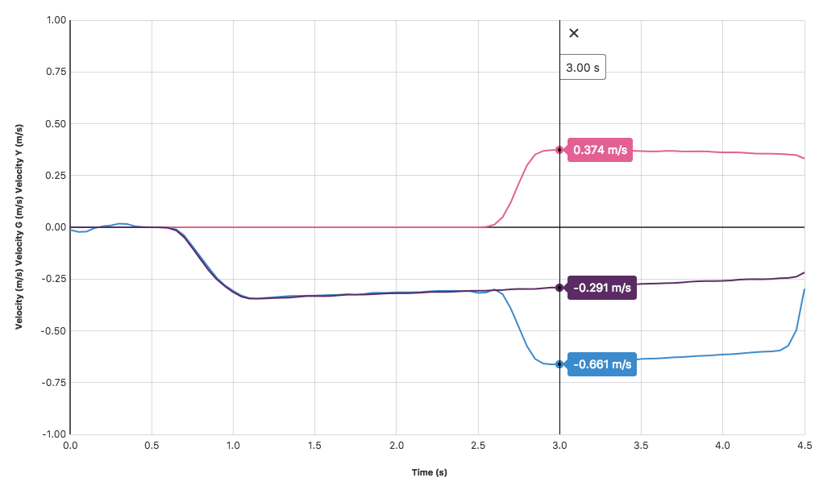
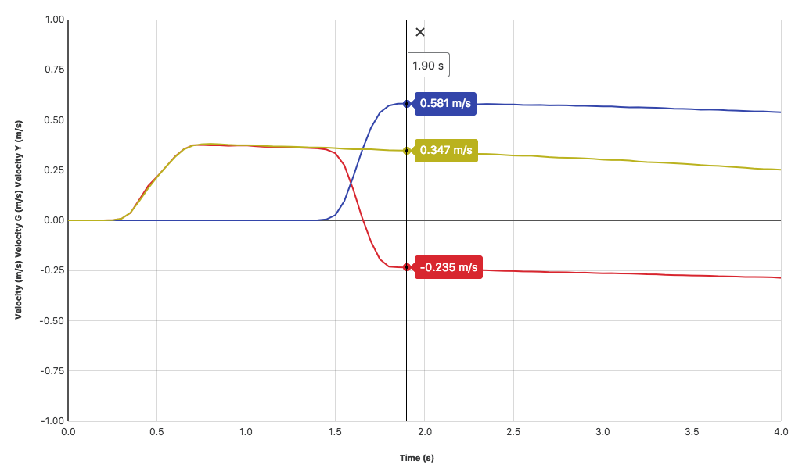
Figure 2 A possible velocity vs. time graph for two carts moving in the same direction at different speeds
Figure 3 A possible velocity vs. time graph for two carts moving toward each other at different speeds
Part I Motion in the same direction
Run | velocity of yellow cart relative to track  v_{Y,T} (m/s) | velocity of green cart relative to track  v_{G,T}(m/s) | velocity of yellow cart relative to green cart  v_{Y,G} (m/s) | relate the velocities with an equation
1 | 0.348 | 0.581 | -0.233 | v_{Y,T -} v_{G,T =} v_{Y,G}
2 | 0.402 | 0.355 | 0.044 | v_{Y,T -} v_{G,T =} v_{Y,G}
3 | 0.226 | 0.487 | -0.260 | v_{Y,T -} v_{G,T =} v_{Y,G}

Part II Motion in opposing directions
Run | velocity of yellow cart relative to track  v_{Y,T} (m/s) | velocity of green cart relative to track  v_{G,T}(m/s) | velocity of yellow cart relative to green cart  v_{Y,G} (m/s) | relate the velocities with an equation
1 | -0.289 | 0.371 | -0.655 | v_{Y,T -} v_{G,T =} v_{Y,G}
2 | -0.262 | 0.378 | -0.632 | v_{Y,T -} v_{G,T =} v_{Y,G}
3 | -0.325 | 0.416 | -0.742 | v_{Y,T -} v_{G,T =} v_{Y,G}

DATA ANALYSIS

Students should re-write their equation as
v_{Y,T =} v_{Y,G +} v_{G,T}

Answers to ANALYSIS Questions
1. The answers should be yes. Students should show an example from their data and from the train example.
2. A vector addition diagram for this equation might look like this:
v_{Y,T}
v_{Y,G}
v_{G,T}

