A Guided Inquiry Approach to Understanding Fluorescence Spectroscopy
This experiment requires the most recent version of the data-collection software. Updates can be found at www.vernier.com/downloads
This experiment is designed with four parts where each section builds on the previous part. This allows the instructor to decide what level is right for their students. It also helps break it down for students so that they can get passed the intimidation of operating an instrument first and then focus on learning the science.
The experiment starts off with exploring the instrument and the data collection parameters. Students learn how these data collection parameters play off of each other to generate a spectrum.
Then students explore the fluorescence data collection part. Once the students start investigating samples, they’ll determine the optimum wavelength for excitation by looking at the absorbance spectrum and various LED excitation wavelengths, manipulating the data collection parameters, and manipulating the LED intensity with a known sample. The goal of this is to get a strong, clear spectrum while manipulating the parameters they just learned about, plus a few more.
Part three has them prepare serial dilutions from a stock solution to investigate the most vital, and perhaps trickiest part of fluorescence spectroscopy, the effect of concentration on fluorescence emission. This will allow them to explore photobleaching, or the inner filter effect.
Finally, they can start to learn about the properties of molecules through fluorescence spectroscopy. This is for the most advanced undergraduates in upper division classes such as biochemistry and physical chemistry. Several parameters can be investigated here; this particular experiment looks at how changes in pH and halide concentration modify fluorescence emission. Based on time and curriculum constraints, it is best to only pick one of these topics for part four.
The experiment can be used with the SpectroVis Plus or the Go Direct SpectroVis Plus Spectrophotometer. This experiment was originally written and performed with the Vernier Fluorescence/UV-VIS Spectrophotometer. In that version quinine is used instead of fluorescein to take advantage of the UV light source and detection. Download the entire experiment for the Vernier Fluorescence/UV-VIS Spectrophotometer at http://www.vernier.com/vsp-fuv/
before you begin
- It is recommended that you read the Go Direct SpectroVis Plus Spectrophotometer user guide before beginning this, or any, experiment with the instrument.
- Logger Pro version 3.15 or newer, or LabQuest 2 App version 2.8.2 or newer is required for this experiment.

Instructor Notes
Part I Operating a Spectrometer: Exploring the Instrument
- The first part is designed for all students in any science class just wanting to understand how a spectrometer works. The easiest way to play around with spectrometer settings is to simply look at the raw output from the lamp, independent of a liquid sample. In Logger Pro or LabQuest App, this is referred to as Uncalibrated Data mode and it displays the raw lamp output which typically looks like Figure 1.
- Students adjust the various settings to explore what affect they might have on their spectrum. There are multiple parameters than can be adjusted on a spectrometer. The first, and most commonly manipulated parameter, is the Sample Time. The Sample Time is the time that the individual diodes (pixels) in the array are allowed to respond to light before they are “read out” and reset to zero. They respond linearly to light until they approach saturation. When students increase and decrease this value, the signal will get larger and smaller proportionally.
- Once they’ve explored how the sample time affects the intensity and saturation of the lamp signal, they might notice that the spectrum looks quite noisy. The noise consists of random fluctuations. To reduce this, spectrometer software uses mathematical signal to noise enhancement techniques. Two options are available in Logger Pro and LabQuest App: wavelength smoothing and samples to average. Learning the balance between all these parameters is important for working with any spectrometer. It is especially important for fluorescence since it is such a sensitive technique.
  - The first is Wavelength Smoothing, which performs a boxcar average over adjacent detector elements. A value of 5, for example, averages each data point with 5 points to its left and 5 points to its right. The greater this value, the smoother the data and the higher the signal to noise ratio. If the value entered is too high, a loss in spectral resolution will result. This can result in the peak maxima being shifted and inaccurate. Students will have to play with this value enough to learn that, while it makes the data prettier, it also makes your data less accurate. Therefore, it should be used sparingly.
  - The second is Samples to Average. This command sets the number of discrete spectral acquisitions that are accumulated before a spectrum is displayed. The higher the value, the better the signal to noise ratio. The draw back here is that the more samples your students are averaging, the longer they are going to have to wait for a stable spectrum.
Part II Obtaining an Fluorescence Spectrum
- The second part is intended for students who need to learn how to take fluorescence spectrometer data properly. This starts typically in organic chemistry, and extends into upper division courses such as inorganic, analytical, physical, biochemistry, molecular biology, and several others.
- Students will start with a sample of known concentration. This is important because fluorescence is very sensitive to concentration (as students will explore in Part III) and we want them to be successful with this part first. Prepare the fluorescein solution (1.2x10⁻⁵ M in 0.1 M NaOH). This solution is light sensitive, it is best to store it in a brown bottle away from light.
- The student instructions guide the students through taking an absorbance spectrum in order to determine which wavelength is appropriate to excite the sample first. Then it sets them up for taking a fluorescence spectrum. Students may not understand why they are taking an absorbance spectrum first. An alternate approach is to have the students use the convenient LED-based excitation method to excite the sample with all available wavelengths.
Part III Conducting a Fluorescence Experiment: Concentration
- In this part of the experiment, students will have to prepare serial dilutions from a highly concentrated stock solution, 6.0x10⁻⁴ M fluorescein in 0.1 M NaOH. This solution is light sensitive, it is best to store it in a brown bottle away from light. You can also prepare the serial dilutions for the students prior to the lab in order to save time, depending on the curriculum goal.
- Once they have set up their standards and determined the spectrometer parameters, they perform a gross calibration curve and observe the inner filter effect. Students should identify the linear region of the graph as having very low concentration samples.
- You can also have students verify that these very low concentrations do not result in an accurate absorbance spectrum, thus illustrating the immense sensitivity of a fluorescence spectrometer.
- Since fluorescein is a colored solution, it will be obvious to students that only clear samples result in fluorescence emission in the linear region of concentration. While a clear sample is inadequate for giving an absorbance measurement, a clear sample can still have a fluorescence measurement.
Part IV Learning about Molecules with Fluorescence Spectroscopy
- The next two extensions are designed for students that are ready to learn about molecules using fluorescence spectroscopy.
- The first example is pH dependent fluorescence. This is incredibly important in biological studies. Students need to be able to pick fluorescent probes that will work at the pH of their biological system. So they need to understand that fluorescence emission can vary with pH. To simplify the process, you can have buffers available for the students to make their samples. Also, titrating the sample while it is in the instrument and measuring the pH afterwards is an easy and illustrative way to collect this data quickly.
- The second is heavy atom quenching studies. These are most appropriate for a physical chemistry level curriculum where you discuss excited state dynamics and radiative decay. Heavy atom quenching experiments along with the Stern-Volmer plot can allow you to calculate the binding constant for the quencher and the fluorophore in the excited state. To simplify the halide dependence of quinine extension, have available 0.1 M KBr for the students to make their samples.
MATERIALS
Part I Operating a Spectrometer: Exploring the Instrument
LabQuest or computer
LabQuest App or Logger Pro
Go Direct SpectroVis Plus Spectrophotometer
Part II Obtaining an Fluorescence Spectrum
materials from Part I
cuvette
fluorescein solution (1.2x10⁻⁵ M in 0.1 M NaOH)
NaOH (0.1 M)
Part III Conducting a Fluorescence Experiment: Concentration
materials from Part II
fluorescein solution (6.0x10⁻⁴ M in 0.1 M NaOH)
Part IV Learning about Molecules with Fluorescence Spectroscopy
materials from Part II
0.1 M H₂SO₄
0.1 M KBr

HAZARD ALERTS
The chemical safety signal words used in this experiment (DANGER, WARNING, and N/A) are part of the Globally Harmonized System of Classification and labeling of Chemicals (GHS). Refer to the Safety Data Sheet (SDS) that came with the chemical for proper handling, storage, and disposal information. The SDS can also be found online from the manufacturer.
Sodium hydroxide, 0.1 M, NaOH: WARNING: Causes skin and eye irritation.
ANALYZING RESULTS
Part I Operating a Spectrometer: Exploring the Instrument
- As this value is increased, the signal increases. As this value is decreased, the signal decreases. The Sample Time is the time that the individual diodes (pixels) in the array are allowed to respond to light before they are “read out” and reset to zero. They respond linearly to light until they approach saturation.
- This command sets the number of discrete spectral acquisitions that are accumulated before a spectrum is displayed. The higher the value, the better the signal to noise ratio. The draw back here is that the more samples your students are averaging, the longer they are going to have to wait for a stable spectrum.
- Wavelength Smoothing performs a boxcar average over adjacent detector elements. A value of 5, for example, average each data point with 5 points to its left and 5 points to its right. The greater this value, the smoother the data and the higher the signal to noise ratio. If the value entered is too high, a loss in spectral resolution will result. This can result in the peak maxima being shifted and inaccurate. Students will have to play with this value enough to learn that, while it makes your data prettier, it also makes your data less accurate. Therefore, it should be used sparingly.
Part II Obtaining an Fluorescence Spectrum
- There will be two common answers for this question. First, the absorbance spectrum was used to determine the wavelength of maximum absorbance. Exciting the sample at this wavelength will result in the most efficient fluorescence emission. Second, utilizing the various LEDs available, it was determined that only one LED produced an adequate fluorescence emission. In comparing this information to the absorbance spectrum, I determined that this LED wavelength is closest to the wavelength of maximum absorbance. These two factors are related via the Jablonski diagram and result in a value distinct to a compound, the Stokes shift.
- It is a quick way to observe the Stokes shift.
- Yes, the 405nm excitation did result in a fluorescence spectrum. This excitation wavelength overlaps with the absorbance spectrum of fluorescein and so it should give a fluorescence emission. However, the fluorescence amplitude was lower, with the same settings, compared to the emission amplitude from the 500 nm excitation. This is because 405 nm has less overlap with the absorbance spectrum compared to the 500 nm LED.
Part III Conducting a Fluorescence Experiment: Concentration
- At higher concentrations, the fluorescence stopped increasing and eventually started to go back down. This is due to the inner filter effect. The inner filter effect results in an apparent decrease in emission quantum yield and/or distortion of bandshape as a result of reabsorption of emitted radiation. To avoid this, it is best to perform fluorescence measurements on samples that have an absorbance below 0.1.
- 1.2x10⁻⁵ M allowed the most versatility in spectrometer settings for the different experiment types we explored.
Part IV Learning about Molecules with Fluorescence Spectroscopy
- The strongest emission was given at pH 10, this is not unexpected since we are diluting the sample in 0.1 M NaOH. As we decreased the pH, the fluorescence emission decreased until there was none left at pH 2. This is an important observation because biological samples are highly pH dependent and it is common to measure fluorescence of biological samples.
- As the halide concentration increased, the fluorescence emission decreased. This is a common phenomenon known as heavy atom quenching. It is a useful tool when studying excited state dynamics. If I graph the intensity versus the concentration in a Stern-Volmer plot, the linear fit can give me the excited state binding constant which can be used to calculate the excited state lifetime of the fluorophore.

Sample Data
Part I Operating a Spectrometer: Exploring the Instrument
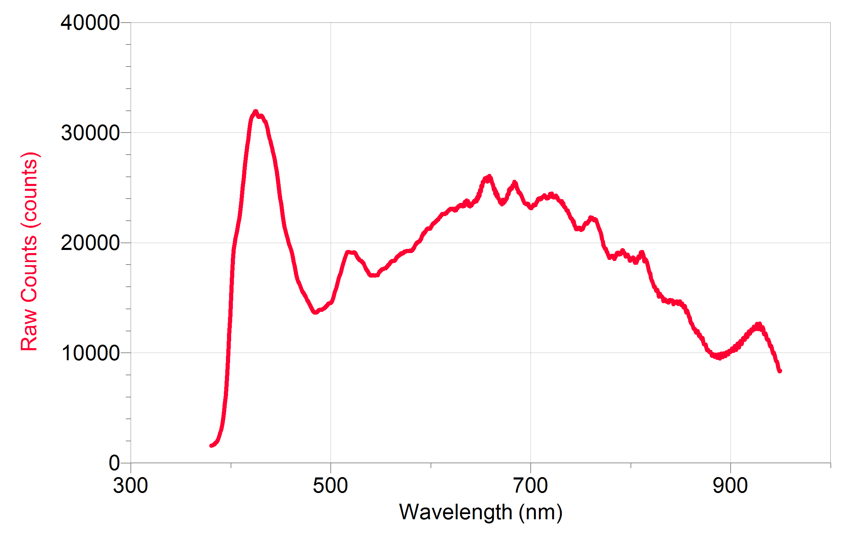
Figure 1 Raw lamp output from Go Direct SpectroVis Plus Spectrophotometer with
30 ms sample time, 1 wavelength smoothing, 6 samples to average
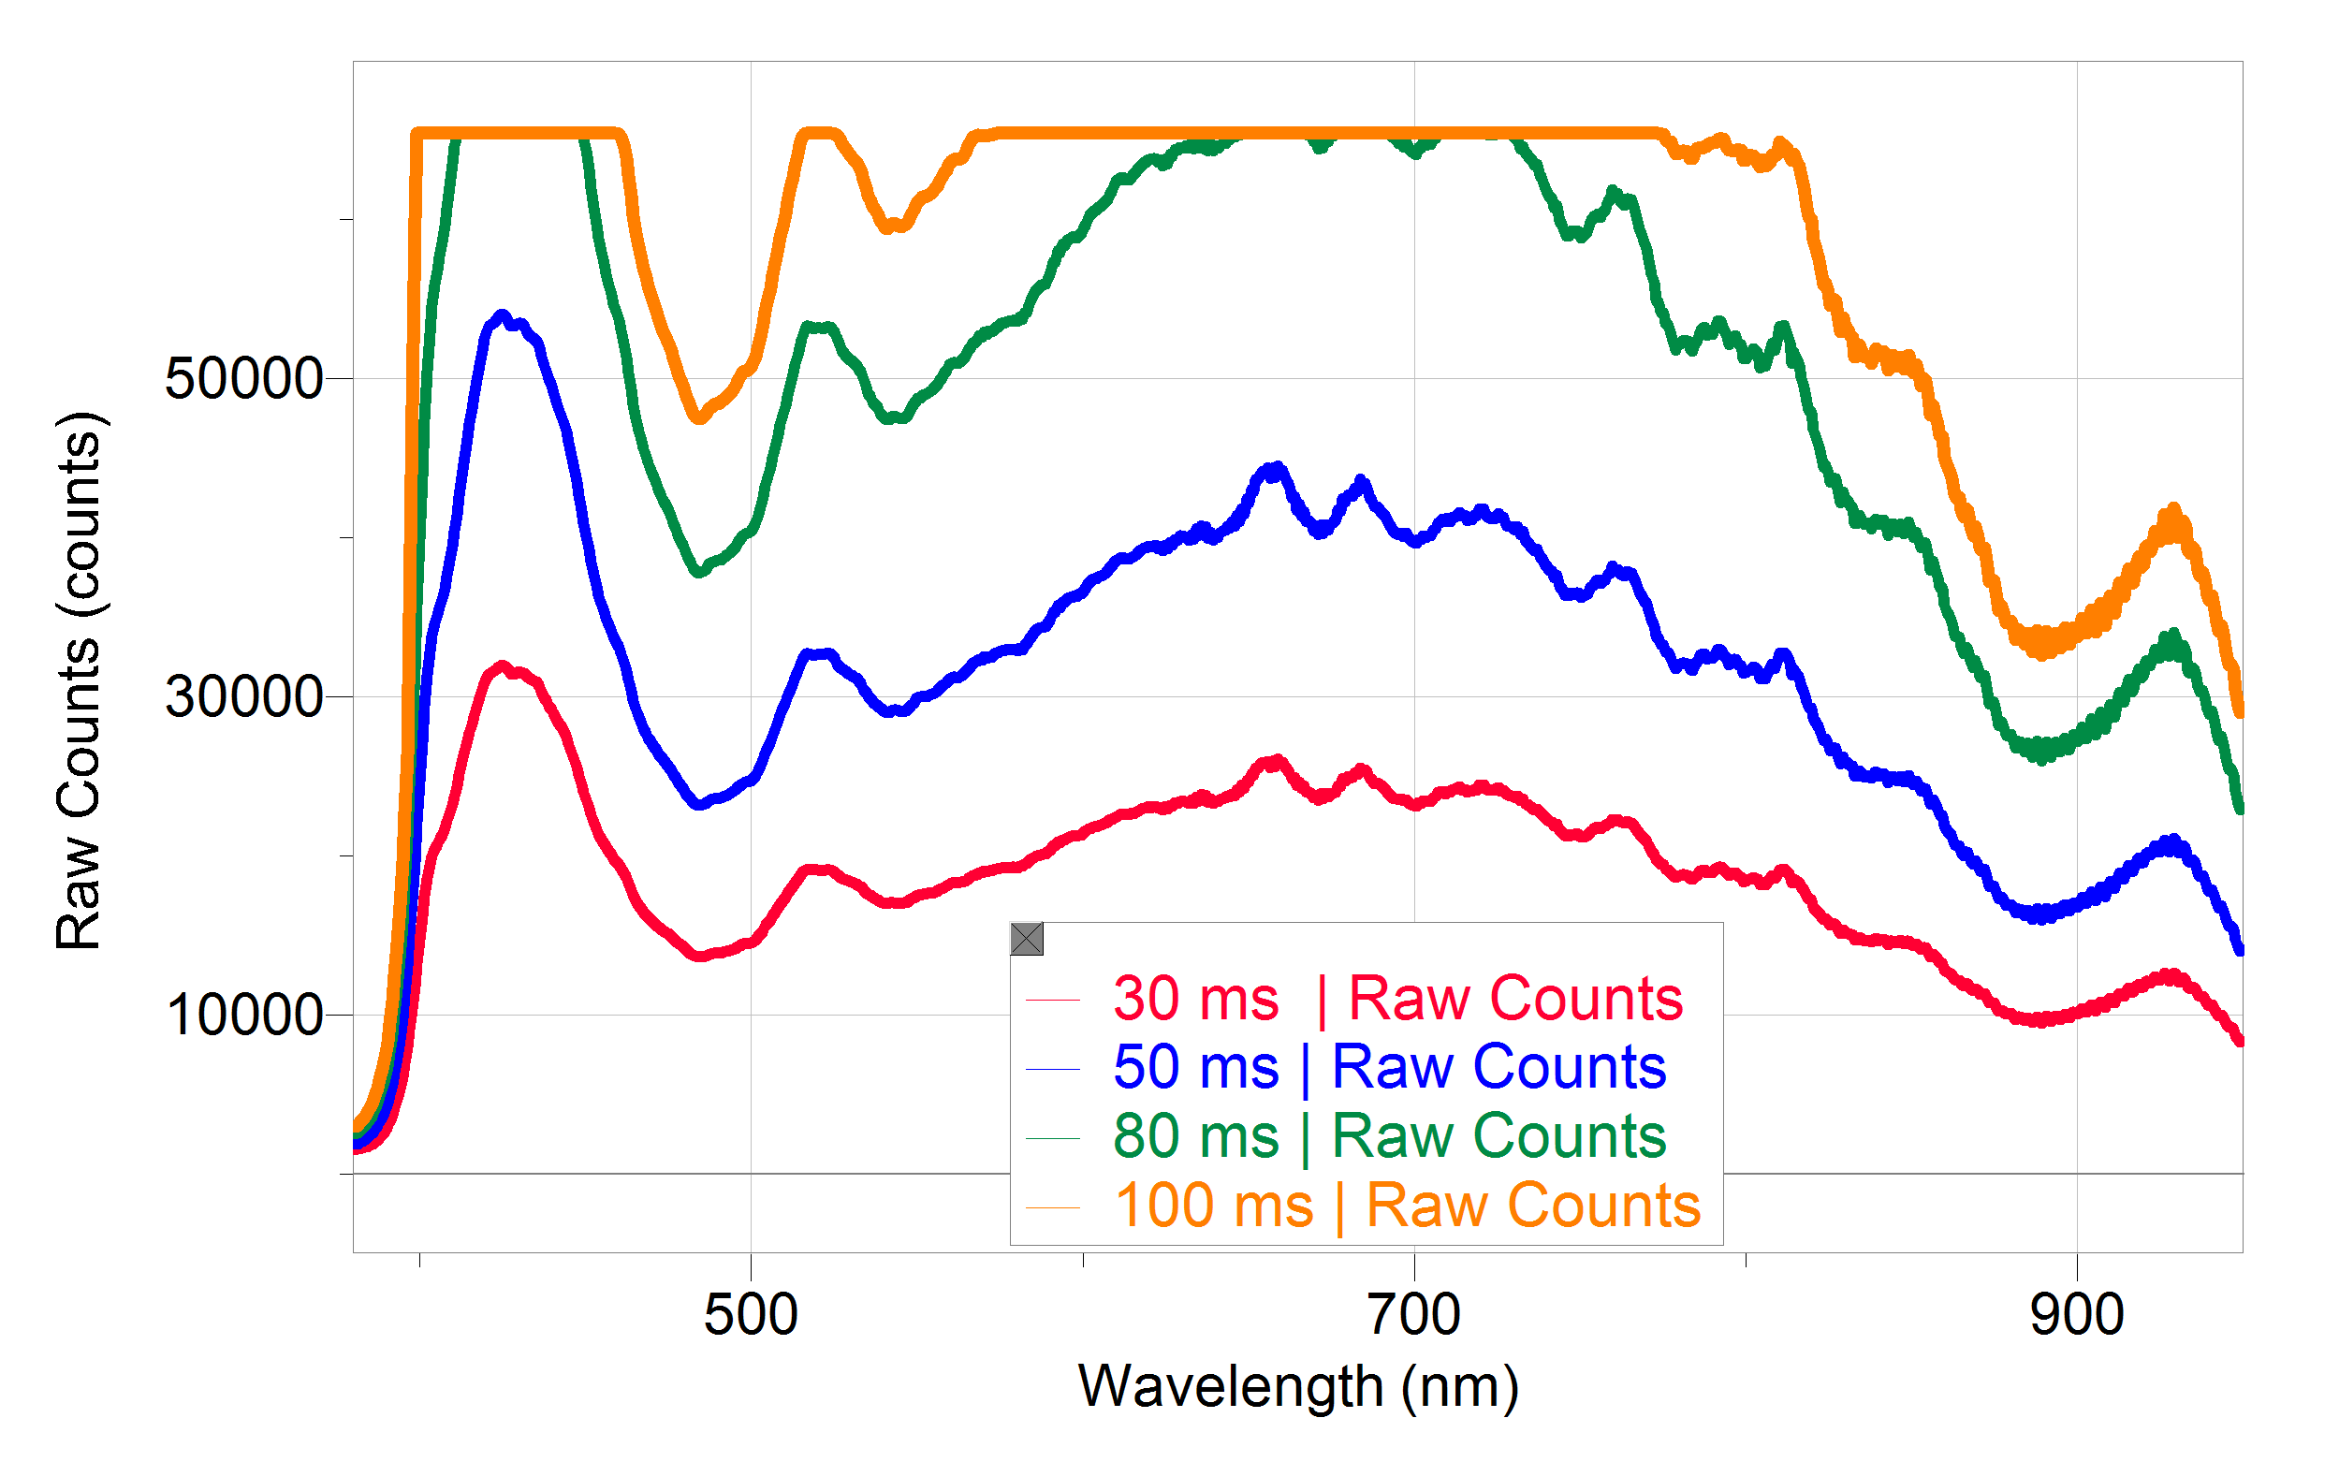
Figure 2 Raw lamp output at various sample times showing detector saturation

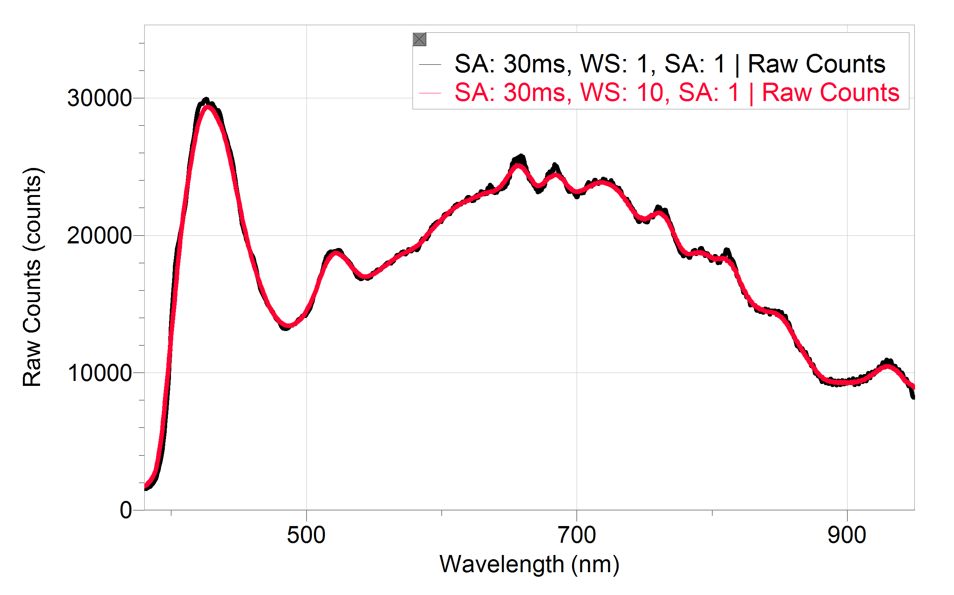
Figure 3 Raw lamp output with adjusted wavelength smoothing
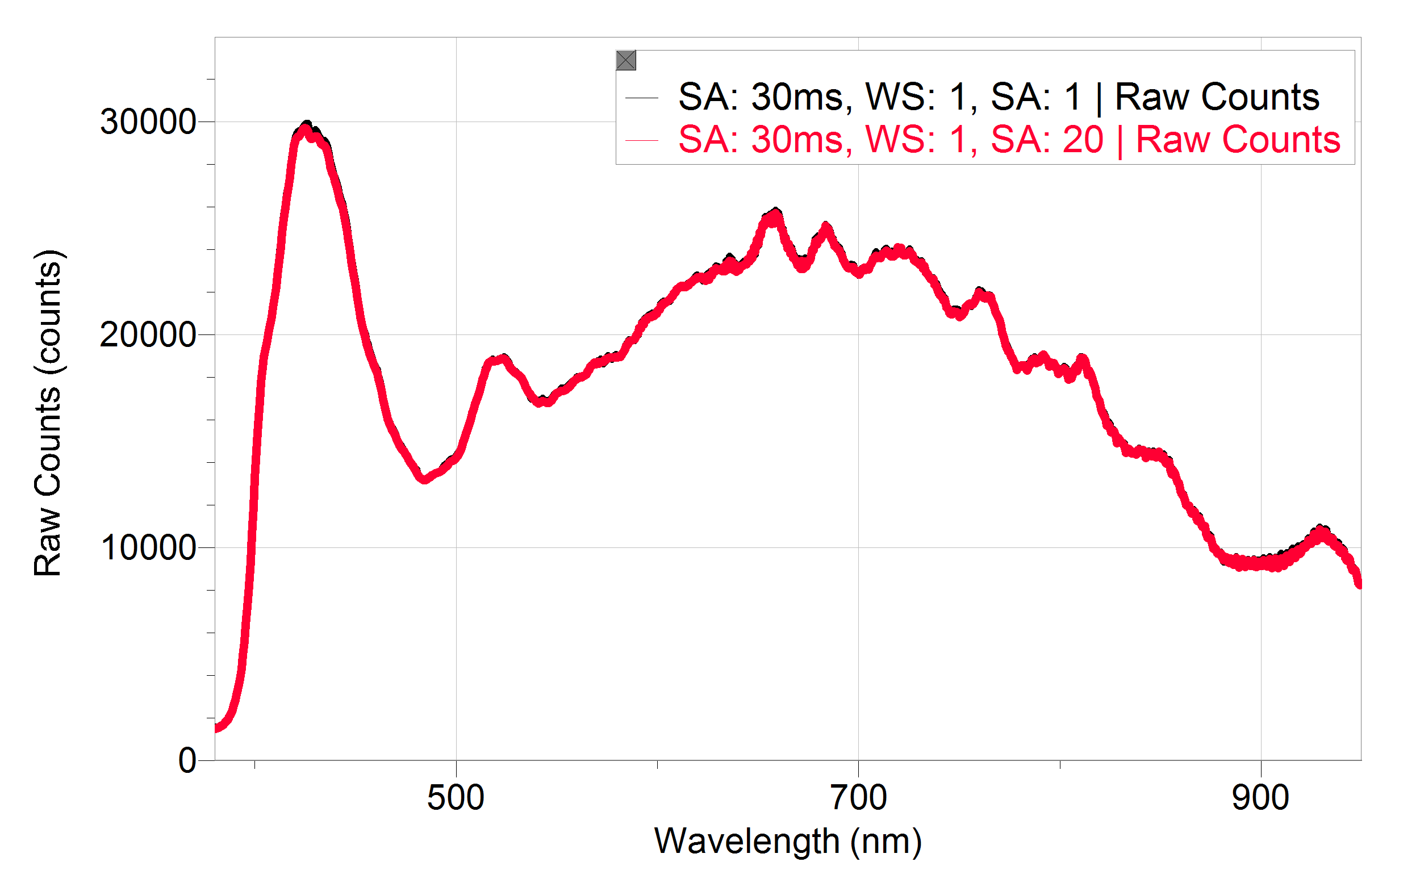
Figure 4 Raw lamp output with adjusted samples to average

Part II Obtaining an Accurate Fluorescence Spectrum
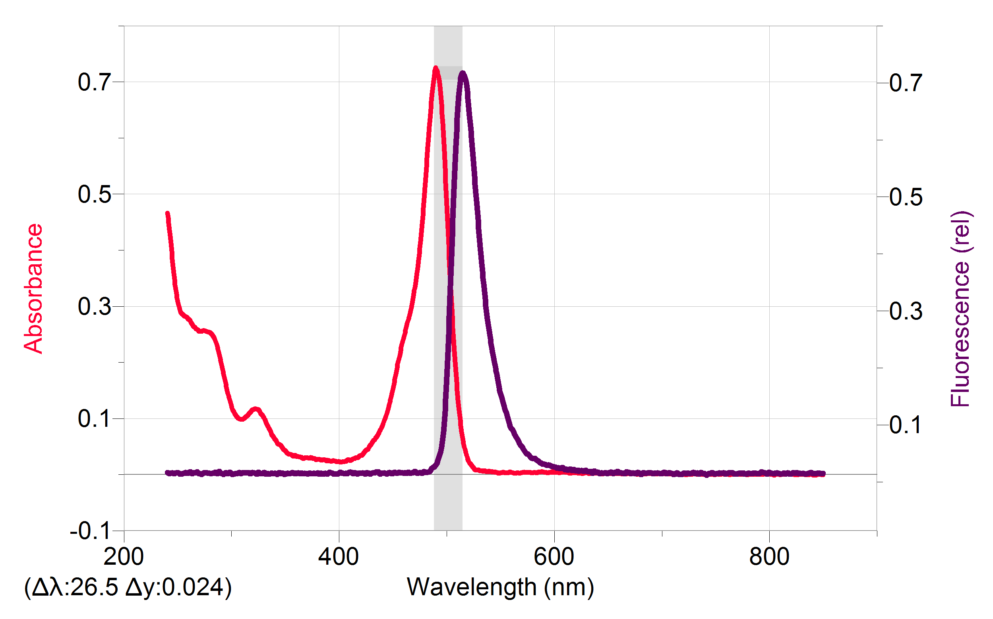
Figure 5 Stokes shift of fluorescein
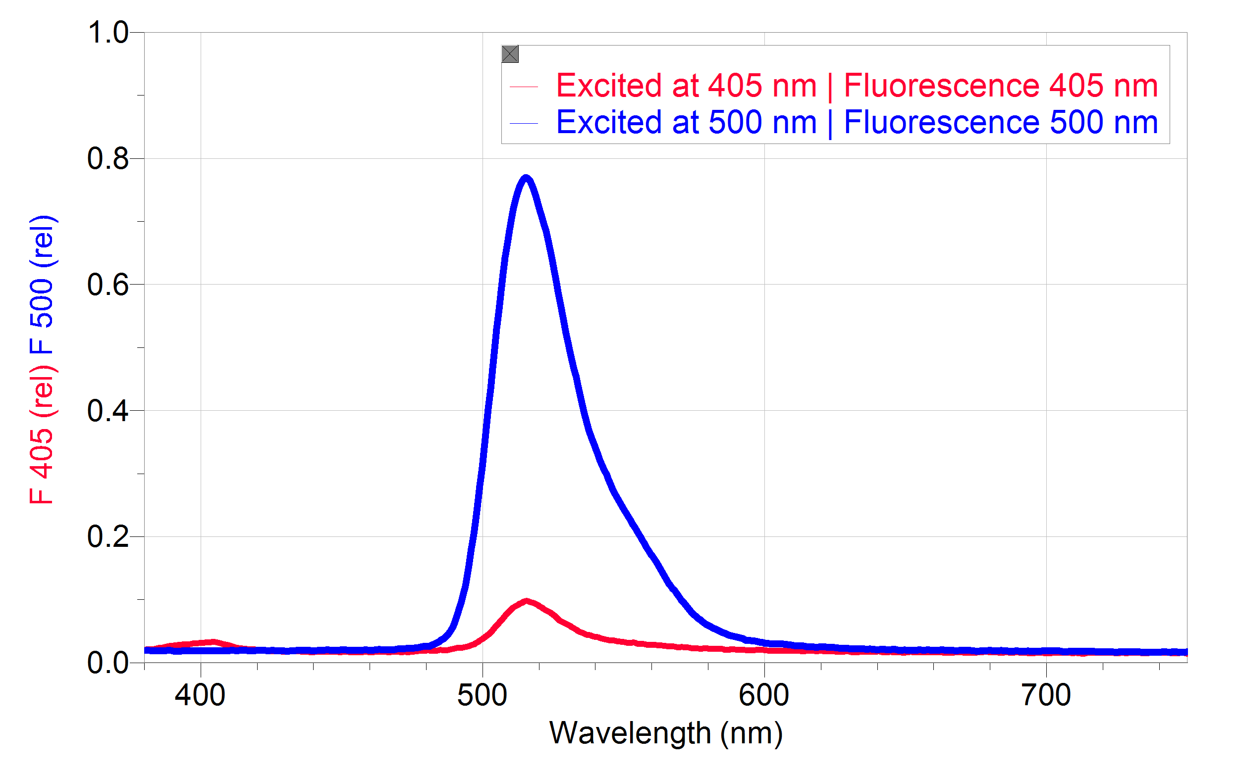
Figure 6 Fluorescence spectra of fluorescein at 500 nm excitation and 405 nm excitation

Part III Conducting a Proper Fluorescence Experiment: Concentration
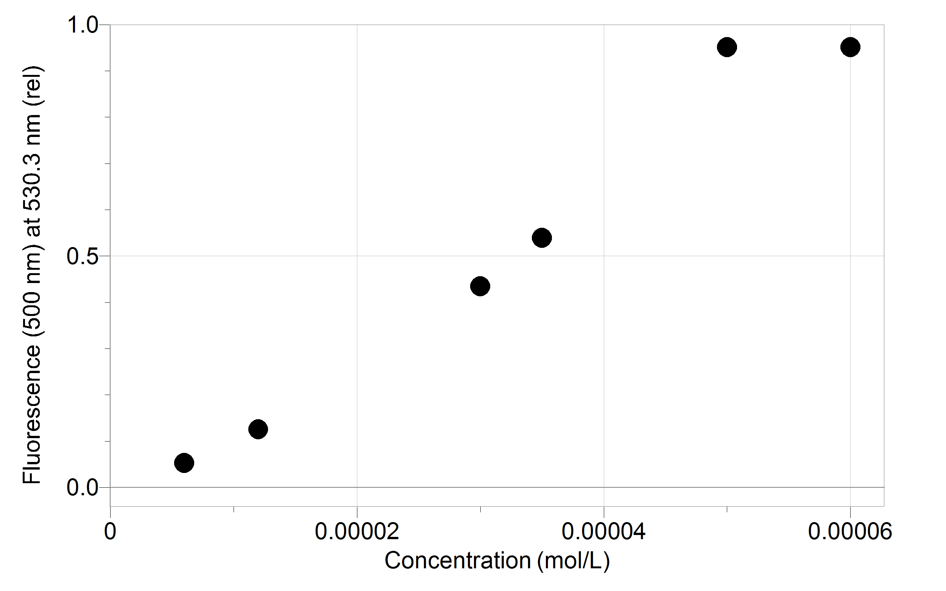
Figure 7 Gross calibration curve for fluorescein
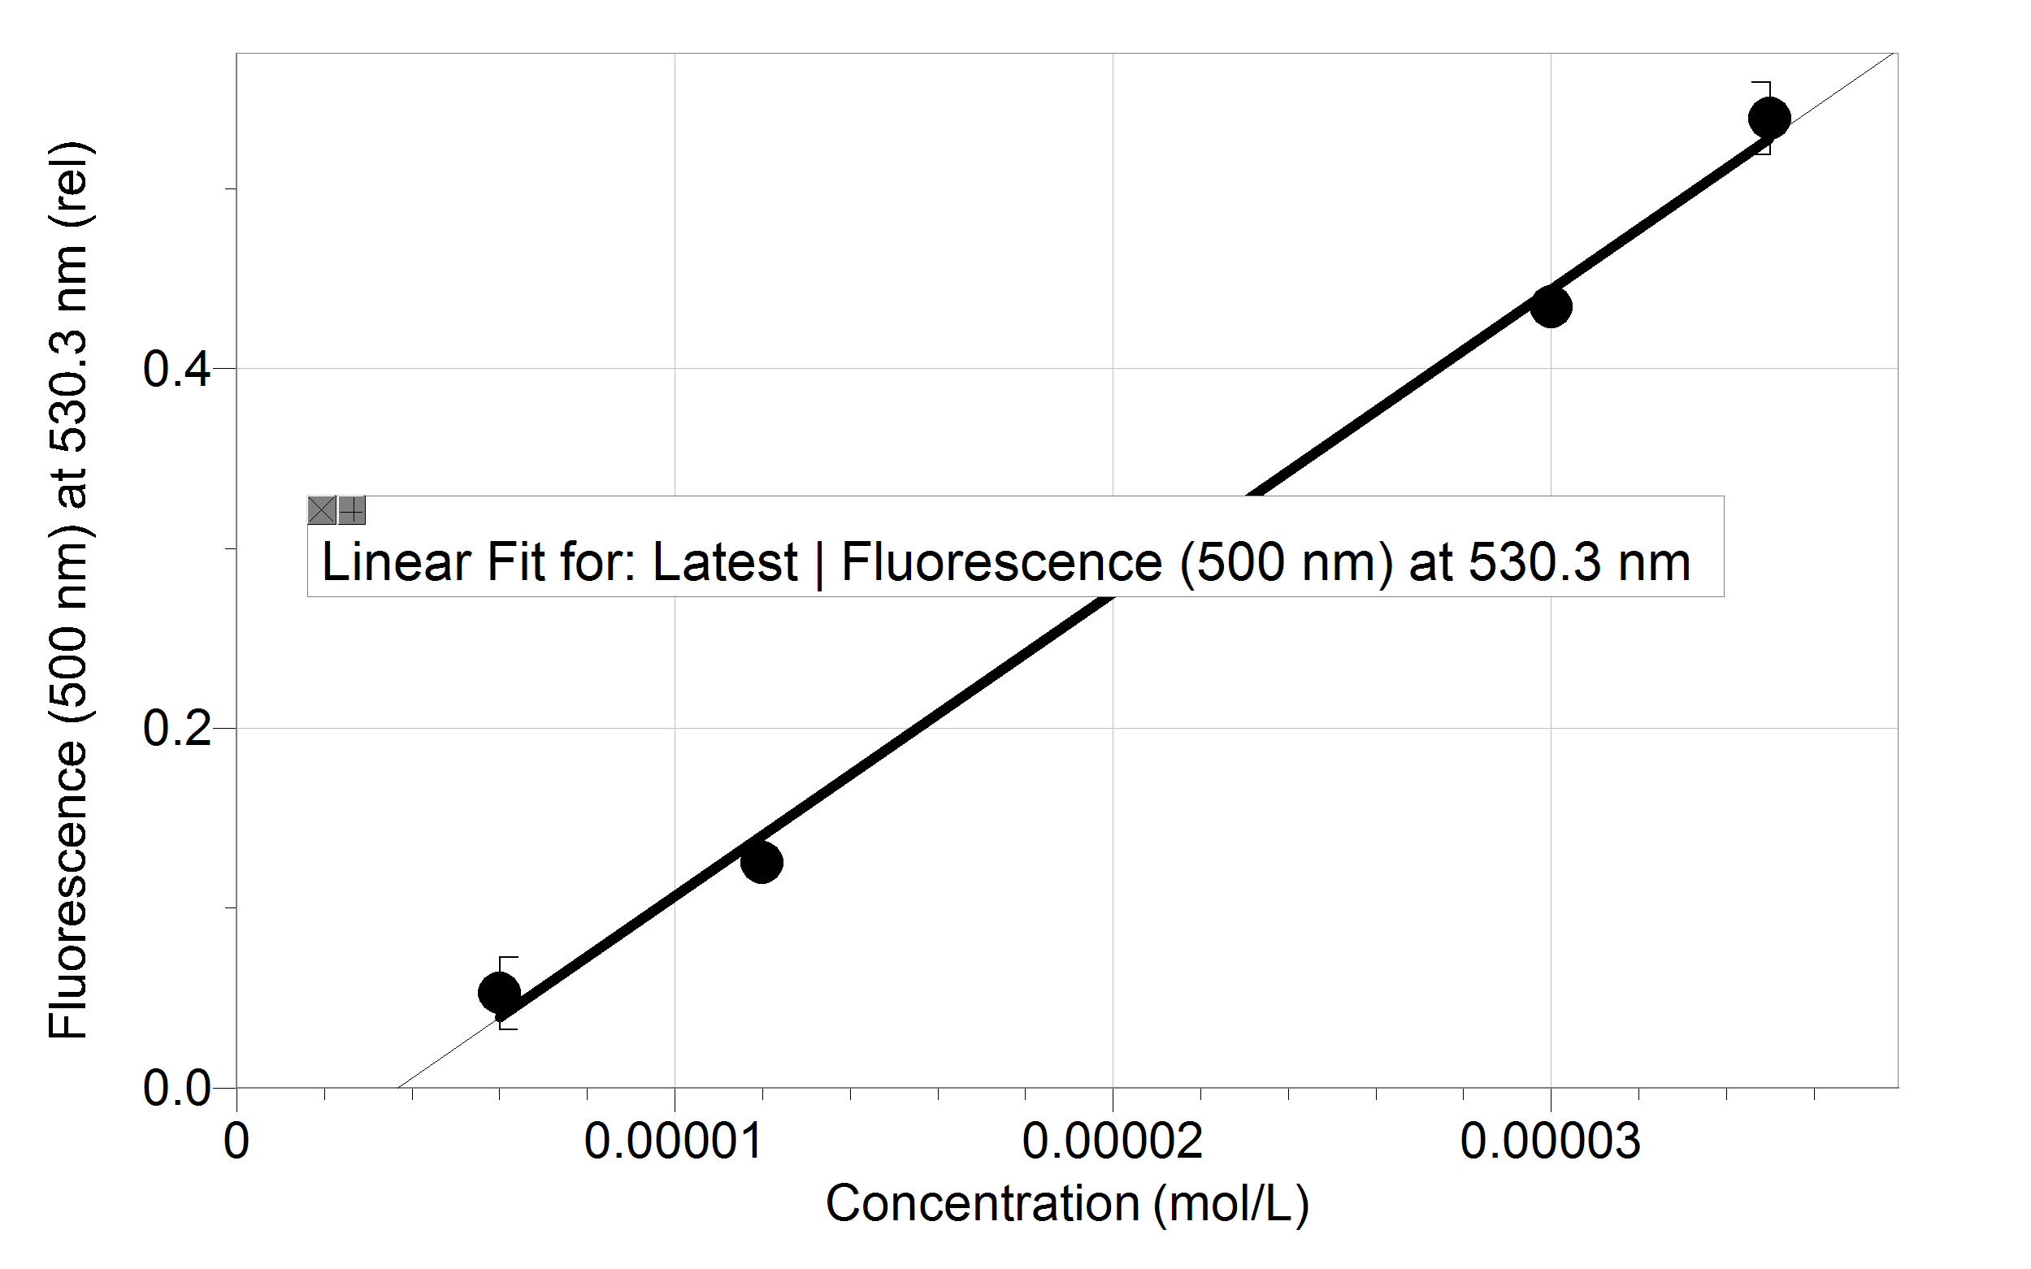
Figure 8 Linear region of fluorescence vs concentration data for fluorescein

Part IV Learning about Molecules with Fluorescence Spectroscopy
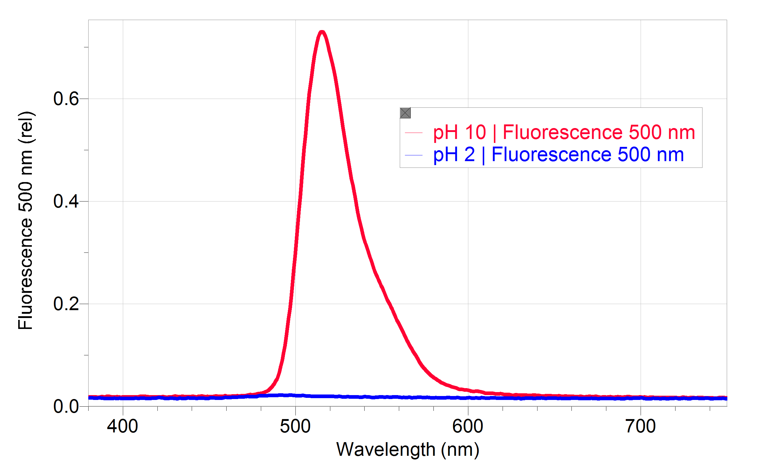
Figure 9 Fluorescence Spectra of 10 mg/L quinine at various pH values
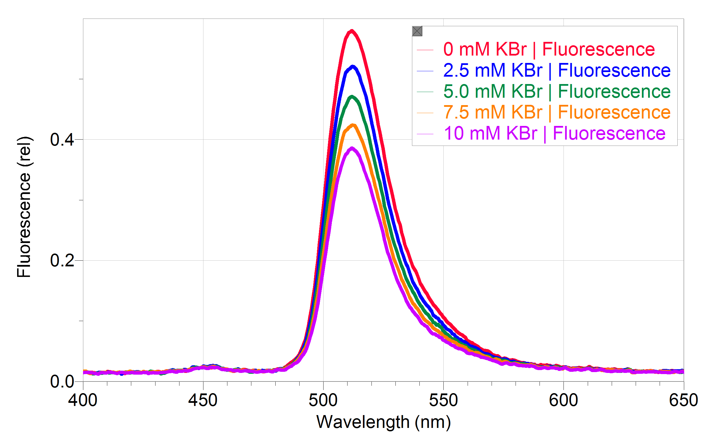
Figure 10 Fluorescence Spectra of 1.2x10⁻⁵ M fluorescein at various KBr Concentrations

