How does insolation change with latitude?
In the seasons lab with the temperature probes, you built a model using a globe and a light bulb to explore the effect of Earth’s tilt on the amount of insolation. This activity models the effect of latitude only without accounting for the tilt. Not only is this a simplified approach to the concept of the sun’s angle in the sky as observed from Earth but it is also a more abstract conceptual model because it does not use a globe to represent Earth. The simulated sun is a light source shining on sensors held at different angles to measure incoming light. You will be gathering and analyzing data to relate the angle (latitude) to insolation.
OBJECTIVES
In this experiment, you will
- Monitor simulated insolation as measured with a Light Sensor.
- Monitor simulated insolation as measured with a Voltage Probe connected to a photovoltaic cell.
- Analyze and Interpret your results.
MATERIALS
Computer | Lamp, 40 watt incandescent
Vernier interface | metric ruler
Voltage Probe | Lamp, LED 3-Watt or greater
Physics stand and utility clamp | Protractor
Foamboard or Cardboard (~24” x 36”) | Paper, (~18 x 24)
Light Sensor | String (1 meter)
Solar cell

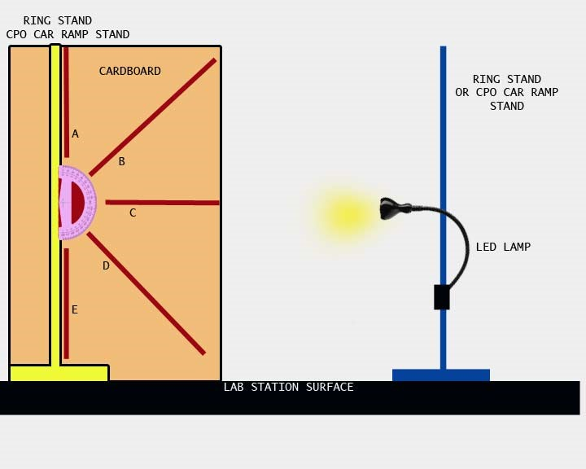

Figure 1
PROCEDURE A: COLLECTING VOLTAGE DATA
- Assemble the protractor panel and the incandescent lamp to the lab stand as shown in Figure 1. It is important to adjust the panel so the light travels freely from the lamp to the solar cell without shadows affecting the data collection.
- Attach the Voltage Probe to the solar cell.
  - Attach the solar cell to the end of a meter stick or dowel.
  - Tape the cord of the Voltage Probe to the meter stick or dowel.
  - Cover the solar cell with a dark paper or hold it inside a darkened container (paper bag, dark cloth bag, etc.)
  - Zero the Voltage Probe. This completes the Voltage Probe assembly.
- Measure the voltage at various angles.
  - Position the Voltage Probe assembly so it is at the 0° mark on the protractor panel. This will show as parallel to the lab surface and 90° on the protractor.
  - Measure a 1 meter separation from the lamp to the solar cell using the string.
  - Adjust the height of the lamp to match the centerline of the protractor so they are the same distance from the lab surface.
  - Make sure the lights are turned off in the classroom as overhead lighting and light from windows will affect your readings.
  - Turn on the lamp and record the data for Voltage.
  - Move the Voltage Probe assembly away from the lamp and repeat the data collection for a total of 3 trials at each angle. For each new angle, reposition the lamp so that it is at the same height as the center of the solar cell and 1 meter separation.
  - Turn off the incandescent lamp when you are done and allow the reflector to cool down before attempting to remove the lamp from the lab stand.
  - Calculate and record only the average (mean) on your data table.
- Repeat Step 3, parts a–d using the LED lamp.
PROCEDURE B: COLLECTING ILLUMINATION DATA
- Hold the Light Sensor and cover the end with a dark paper or hold it inside a darkened container (paper bag, dark cloth bag, etc.)
  - Select the detection range for 0–600 Lux.
  - Zero the Light Sensor. This completes the preparation of the Light Sensor.
- Measure illumination at various angles.
  - Position the Light Sensor so it is at the 0° mark on the protractor panel. This will show as parallel to the lab surface and 90° on the protractor.
  - Measure a 1 meter separation from the lamp to the rip of the Light Sensor using the string.
  - Adjust the height of the lamp to match the centerline of the protractor so they are the same distance from the lab surface.
  - Make sure the lights are turned off in the classroom as overhead lighting and light from windows will affect your readings.
  - Turn on the lamp and record the data.
  - Move the Light Sensor away from the panel, position it correctly again, and repeat the data collection for a total of 3 trials at each angle. For each new angle, reposition the lamp so that it is at the same height as the center of the solar cell and 1 meter separation.
  - Turn off the incandescent lamp when you are done and allow the reflector to cool down before attempting to remove the lamp from the lab stand.
  - Calculate and record only the average (mean) on your data table.
- Repeat Step 6, parts a–d using the LED lamp.

DATA
 | INCANDESCENT LAMP |  |  | LED  LAMP |  | DATA NOTES
ANGLE | VOLTS (DC) | LUX  (0-600) |  | VOLTS (DC) | LUX  (0-600)
90 N
60 N
30 N
0
30 S
60 S
90 S

On the graphs below, you’ll be translating the data into a visual representation or model. What we’re trying to show is the relationship between latitude (angular distance away from Earth’s equator) and the amount of illumination coming from the Sun. On Earth, we normally think in terms of tropical, temperate, polar and so on to describe climate regions. We might also think of how the position of the sun in the sky changes depending on how far north or south we travel. Ultimately, these are ways we try to make sense of how we experience changes in temperature over time and place. Let’s see what we can come up with.

VOLTAGE DATA
VOLTS
(DC)
LATITUDE (degrees North and South)

□ LED LAMP □ INCANDESCENT LAMP
ILLUMINATION
(Lux)
LATITUDE (degrees North and South)

PROCESSING THE DATA
- How might this model’s limitations over-represent certain features of the Earth-Sun relationship?
- In what way(s) might this model not show certain important features related to incoming solar energy?
- At which latitude(s) on the model is the sunlight more direct?

- Where in the United States would you market the installation of solar panels based on this data? Be sure to explain your answer.

- As you move the light sensor from the north polar latitudes towards the equator, the Lux readings change. Describe those changes.

- What other factors affect the amount of insolation in a region?

- In 2012, the United States National Renewable Energy Laboratory published a map showing solar energy as a resource to be managed similarly to soil, water, and minerals. Why doesn’t the map show constant amounts of solar energy going across the United States? In other words, why don’t places with the same latitude get the same amount of solar energy? Make a claim (thesis statement), provide evidence from the map and/or your lab (use numerical data), and use logical reasoning (make connections to the concepts).
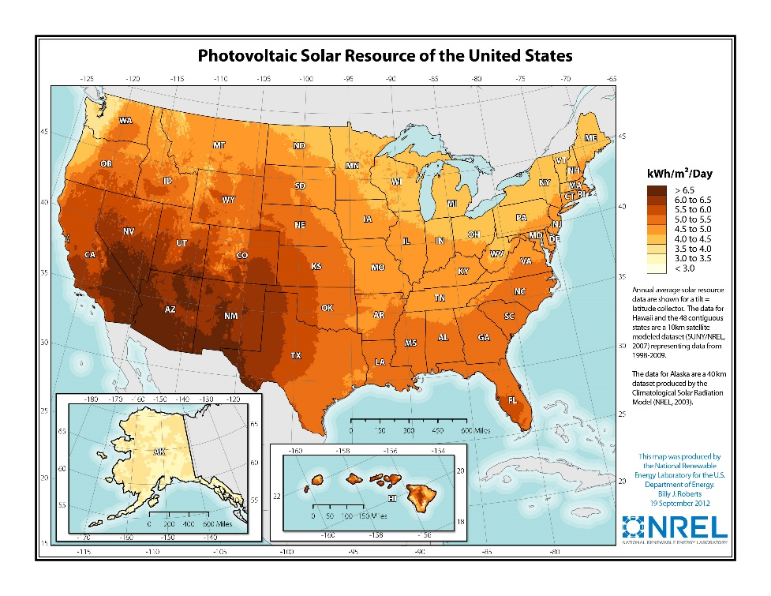
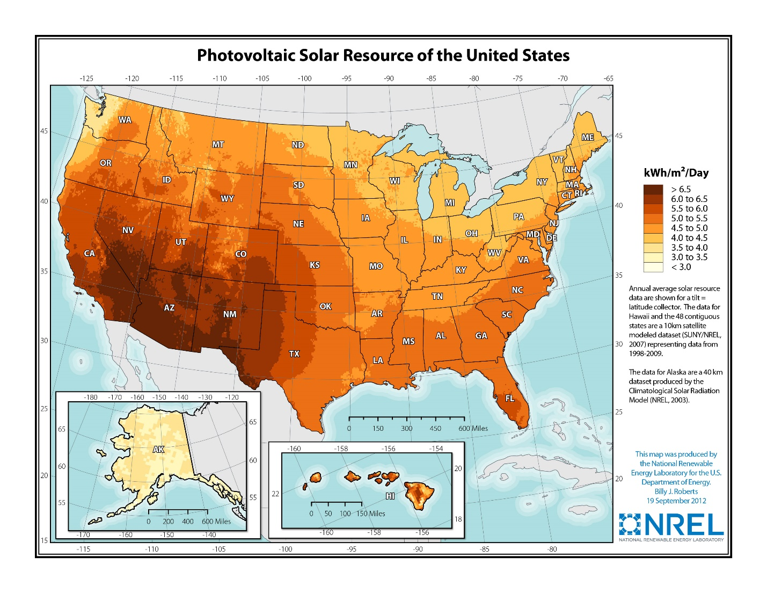
The Sample Set below was compiled using mean calculations from 10 trials and is representative of the data ranges that can be collected.

DATA COLLECTION WITH VERNIER VOLTAGE SENSOR AND LIGHT SENSOR
 | INCANDESCENT LAMP |  |  | LED LAMP |  | DATA NOTES
ANGLE | VOLTS (DC) | LUX  (0-600) |  | VOLTS (DC) | LUX  (0-600)
90 N | .25 | 23 |  | .06 | 4
60 N | .29 | 31 |  | .07 | 7
30 N | .37 | 301 |  | .11 | 100
0 | .42 | 415 |  | .29 | 137
30 S | .38 | 309 |  | .16 | 82
60 S | .27 | 28 |  | .03 | 6
90 S | .26 | 16 |  | .01 | 3

Comments and Observations
- Ambient light and uncontrolled light falling onto the sensors will introduce error to the data.
- NGSS standards are not included here specifically but this activity falls into the Earth and Space Science (ESS) Performance Expectations and also into NGSS Engineering Performance Expectations addressing the building, use, and limitations of models to represent natural phenomena. Additionally, this model may be introduced in the Human Activity or Natural Resources units or storylines of NGSS.
- The construction of the panel board has a few things to address.
  - Using the drawing or white construction paper on the materials list requires it to be taped to the foam board (steps not described herein). It also requires the use of a taped protractor.
  - This construction can be more expedient if pre-printed ‘posters’ with an enlarged representation of a protractor is used.
  - The panel board can be attached to the lab stand using good quality spring clamps available at most hardware vendors.
- The centering of the lamp with the equatorial latitude on the model is pretty critical. If the lamp is tilted vertically or not at the same height as the equator on the model, inaccurate data will be generated.
- Avoidance of obstructions or misalignments is important because these can create shadows that skew the data.
- SAFETY ISSUES: None specific to this lab. Basic electrical safety, hot items (lamp) safety, trip hazards, and falling objects safety rules apply.
- The original proposal described the setup with the sensors attached to the panel.
  - I think that for elementary school students, it would be best to attach the sensors with Velcro or some other semi-permanent system to protect the sensors and also for expediency in the data collection.
  - This document shows the data collection with hand-held sensors that require attention to alignment of the sensors. Grade 8 students were able to do this easily.
- The photovoltaic cell used is a cheapie from ‘CPO’ and I have used two other brands. One medium ‘toy’ quality for solar car challenge and some very high quality ‘hobbyist’ PV cells. This one was used for proof of concept.
  - The PV cell attachment can be to a dowel or other extension with a much better system that simple tape. I used tape and a meter stick.
  - The important feature to include on the attachment is that the PV cell be fixed at a perpendicular angle to the axis of the dowel.
- The lab stands are from CPO and are very sturdy using a 1.125 inch laminated wood base with a ¾-inch bolt that comes up into a threaded insert for the metal post. Very good quality with powder coated finish and pre-drilled holes. I’m sure Vernier can source similar quality and design without patent infringement.
- I sourced the format with rough adaptation from the Middle School Vernier labs.
- This lab shows the older LabQuest which I had handy. Our district has thousands (24,000) iPads for students yet only a handful of the wireless Vernier systems. One of these days I’m writing up a grant proposal for some large purchases of the ‘universal platform’ wireless systems…

RESOURCES FOR THE LESSON
