How does insolation change with latitude?
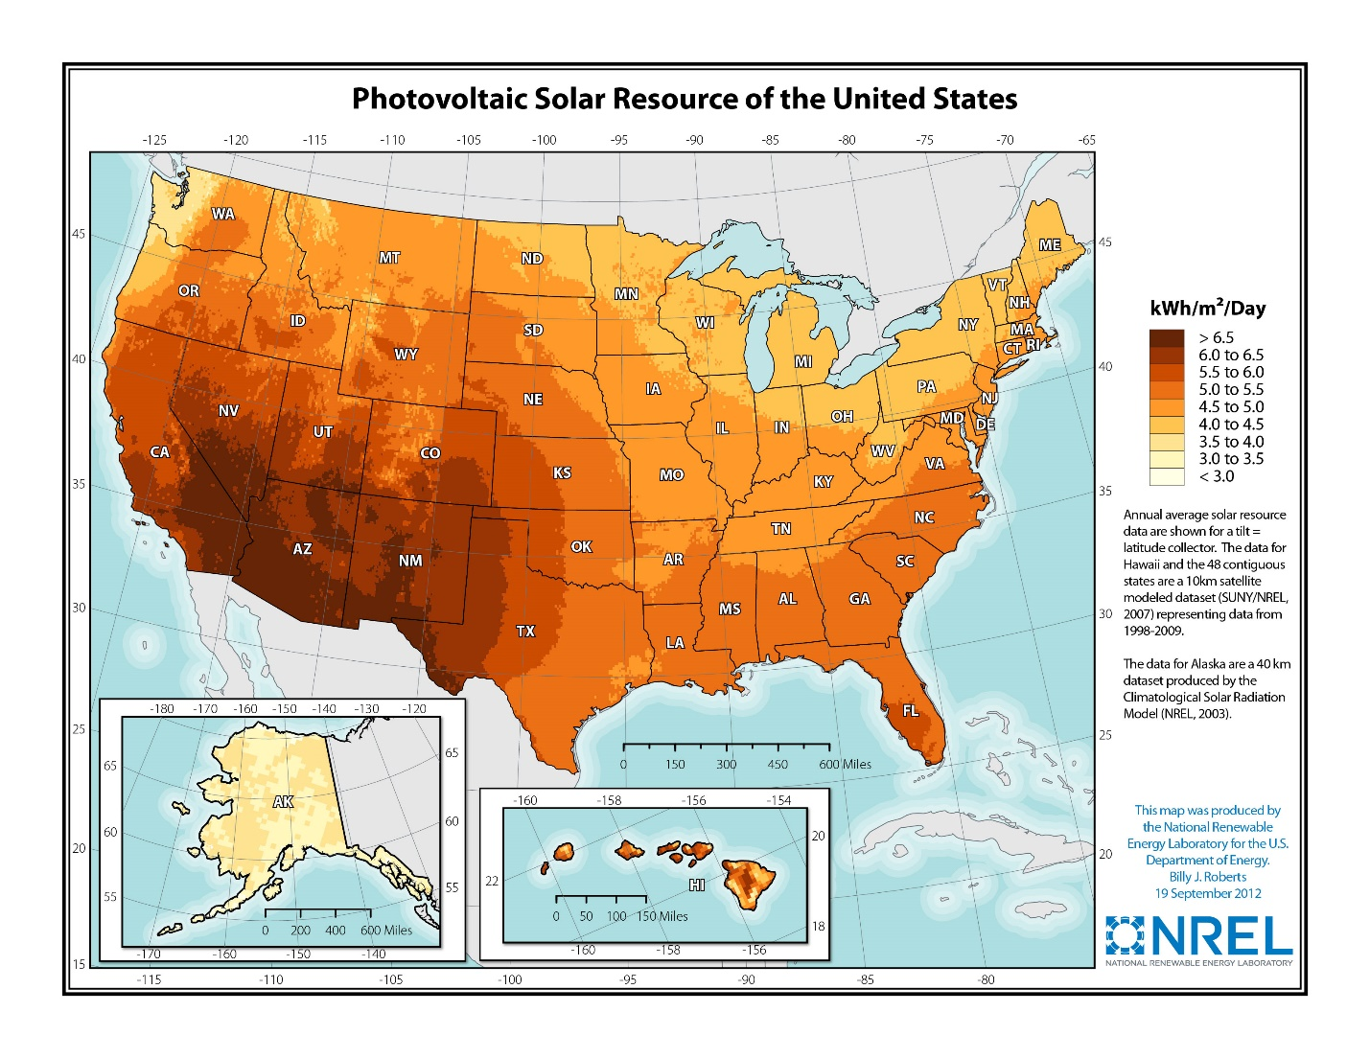
The Sample Set below was compiled using mean calculations from 10 trials and is representative of the data ranges that can be collected.

DATA COLLECTION WITH VERNIER VOLTAGE SENSOR AND LIGHT SENSOR
 | INCANDESCENT LAMP |  |  | LED LAMP |  | DATA NOTES
ANGLE | VOLTS (DC) | LUX  (0-600) |  | VOLTS (DC) | LUX  (0-600)
90 N | .25 | 23 |  | .06 | 4
60 N | .29 | 31 |  | .07 | 7
30 N | .37 | 301 |  | .11 | 100
0 | .42 | 415 |  | .29 | 137
30 S | .38 | 309 |  | .16 | 82
60 S | .27 | 28 |  | .03 | 6
90 S | .26 | 16 |  | .01 | 3

Comments and Observations
- Ambient light and uncontrolled light falling onto the sensors will introduce error to the data.
- NGSS standards are not included here specifically but this activity falls into the Earth and Space Science (ESS) Performance Expectations and also into NGSS Engineering Performance Expectations addressing the building, use, and limitations of models to represent natural phenomena. Additionally, this model may be introduced in the Human Activity or Natural Resources units or storylines of NGSS.
- The construction of the panel board has a few things to address.
  - Using the drawing or white construction paper on the materials list requires it to be taped to the foam board (steps not described herein). It also requires the use of a taped protractor.
  - This construction can be more expedient if pre-printed ‘posters’ with an enlarged representation of a protractor is used.
  - The panel board can be attached to the lab stand using good quality spring clamps available at most hardware vendors.
- The centering of the lamp with the equatorial latitude on the model is pretty critical. If the lamp is tilted vertically or not at the same height as the equator on the model, inaccurate data will be generated.
- Avoidance of obstructions or misalignments is important because these can create shadows that skew the data.
- SAFETY ISSUES: None specific to this lab. Basic electrical safety, hot items (lamp) safety, trip hazards, and falling objects safety rules apply.
- The original proposal described the setup with the sensors attached to the panel.
  - I think that for elementary school students, it would be best to attach the sensors with Velcro or some other semi-permanent system to protect the sensors and also for expediency in the data collection.
  - This document shows the data collection with hand-held sensors that require attention to alignment of the sensors. Grade 8 students were able to do this easily.
- The photovoltaic cell used is a cheapie from ‘CPO’ and I have used two other brands. One medium ‘toy’ quality for solar car challenge and some very high quality ‘hobbyist’ PV cells. This one was used for proof of concept.
  - The PV cell attachment can be to a dowel or other extension with a much better system that simple tape. I used tape and a meter stick.
  - The important feature to include on the attachment is that the PV cell be fixed at a perpendicular angle to the axis of the dowel.
- The lab stands are from CPO and are very sturdy using a 1.125 inch laminated wood base with a ¾-inch bolt that comes up into a threaded insert for the metal post. Very good quality with powder coated finish and pre-drilled holes. I’m sure Vernier can source similar quality and design without patent infringement.
- I sourced the format with rough adaptation from the Middle School Vernier labs.
- This lab shows the older LabQuest which I had handy. Our district has thousands (24,000) iPads for students yet only a handful of the wireless Vernier systems. One of these days I’m writing up a grant proposal for some large purchases of the ‘universal platform’ wireless systems…

RESOURCES FOR THE LESSON
