Virtual Images and the Telescope
The telescope is an example of the usefulness of lenses in producing images. One of the many claims to fame of Galileo Galilei is his work refining the design of a refracting optical telescope. Telescopes use combinations of lenses to produce a magnified image.
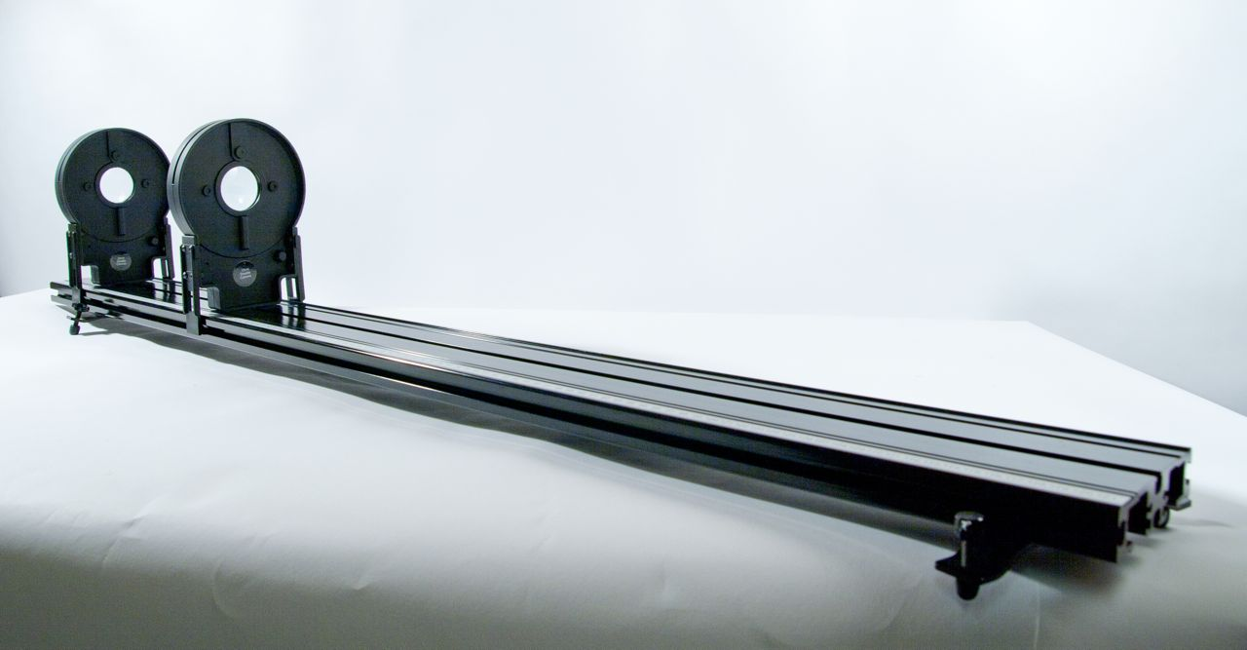
Figure 1

objectives
- Build a refracting optical telescope.
- Discuss the characteristics of real and virtual images.

Materials
Vernier data-collection interface | Vernier Dynamics System track
Logger Pro or LabQuest App | Optics Expansion Kit: 10 and 20 cm double convex lenses,

Preliminary questions
Before performing this activity, you should complete the activity called “Real Images and the Thin Lens Equation.”
1. You’ve learned from the previous activity how to project a real image of a distant object using a double convex lens. How must you arrange an object, lens and screen to produce a real image?
2. What are the characteristics of a real image?
Procedure
Part A: Investigating Virtual Images
1. Investigate the 15 cm double concave lens. Is it possible to project a real image as you did with the convex lenses?
2. Look “into” the lens. Is it possible to see an image this way? This is a virtual image. How does it differ from a real image?
Part B: The Magnifying Lens
Next, we will experiment with the use of a double convex lens as a magnifying glass.
1. Attach the screen to the track.
2. Attach the 10 cm double convex lens to the track.
3. Look through the double convex lens at the screen. Adjust the distance between the two until you clearly see a magnified image of the screen and its scale markers. Continue to adjust the distance to maximize the magnification of the image.
4. Is the image produced by a magnifying glass real or virtual? How do you know?
5. What is special about the position where the image has maximum magnification while remaining in focus?
Part C: The Telescope
Now we will make a telescope. In a previous activity, you projected the image of a distant object (the outdoors) on a screen. A telescope is a combination of this type of projection and a magnifying glass.
1. Set up the 10 cm double convex lens and the screen in the position from Part B that yielded maximum magnification. Be sure to leave space on the opposite side of the screen for steps that follow.
2. Use a 20 cm double convex lens to project the image of a distant object on the “back” side of the screen, as you did in “Real Image Formation.” Adjust the lens position until the projected image is in sharp focus. The final arrangement of the track should be: Window, 20 cm lens, Screen, 10 cm lens.
3. Now remove the screen. You’ve made a telescope. The lens that was a magnifying lens is now the eyepiece, and the lens producing the real image is the objective lens.
4. Describe the image you see when looking through the eyepiece. Is it upright or inverted? Magnified or reduced? Real or virtual? How do you know?
5. What is special about the distance between the two lenses?
6. Look through the lenses from the other direction. How does the image seen through the eyepiece compare?
7. Borrow a lens from a neighboring lab team so you have two lenses of the same focal length. Set up the two lenses at the special distance. Describe your results.
Analysis
In a refracting optical telescope, a real image of a distant object is produced in the space between the lenses. A second lens produces a magnified virtual image. Below is a ray diagram of the two lenses, the real image, and the virtual image.
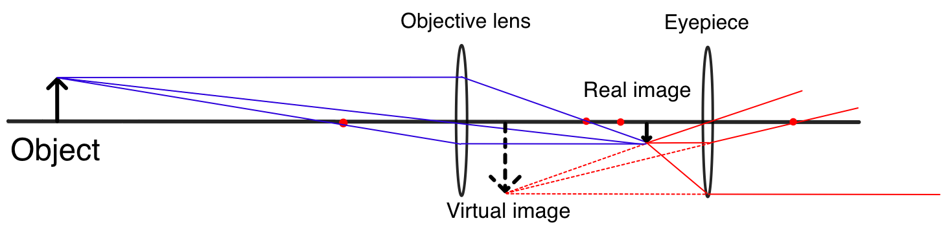
Figure 2: Ray Diagram of a Telescope
Extension
1. Research and sketch a ray diagram of the Galilean telescope.
instructor information
The telescope is an example of the usefulness of lenses in producing images. One of the many claims to fame of Galileo Galilei is his work refining the design of a refracting optical telescope. Telescopes use combinations of lenses to produce a magnified image.

objectives
- Build a refracting optical telescope.
- Discuss the characteristics of real and virtual images.

Materials
Vernier data-collection interface | Vernier Dynamics System track
Logger Pro or LabQuest App | Optics Expansion Kit: 10 and 20 cm double convex lenses,

Preliminary questions
Before performing this activity, you should complete the activity called “Real Images and the Thin Lens Equation.”
1. You’ve learned from the previous activity how to project a real image of a distant object using a double convex lens. How must you arrange an object, lens and screen to produce a real image?
[The lens must be between the object and the screen.]
2. What are the characteristics of a real image?
[Real images can be projected onto a screen or a card, and rays of light pass through the location of a real image. See the investigation, “Real Images and the Thin Lens Equation”]
Procedure
Part A: Investigating Virtual Images
1. Investigate the 15 cm double concave lens. Is it possible to project a real image as you did with the convex lenses?
[No, it is not possible to produce a real image with the concave lens.]
2. Look “into” the lens. Is it possible to see an image this way? This is a virtual image. How does it differ from a real image?
[Virtual images appear to be behind the lens. The light rays don’t actually diverge from a point behind the lens, but our brains interpret the image this way because of the angle between the rays that enter the eye.]
Part B: The Magnifying Lens
Next, we will experiment with the use of a double convex lens as a magnifying glass.
1. Attach the screen to the track.
2. Attach the 10 cm double convex lens to the track.
3. Look through the double convex lens at the screen. Adjust the distance between the two until you clearly see a magnified image of the screen and its scale markers. Continue to adjust the distance to maximize the magnification of the image.
4. Is the image produced by a magnifying glass real or virtual? How do you know?
[It is a virtual image. Virtual images appear to be behind the lens. They appear to occur in a location through which the light rays don’t actually pass. Virtual images cannot be projected on a screen or card.]
5. What is special about the position where the image has maximum magnification while remaining in focus?
[It is at the focal length.]
Part C: The Telescope
Now we will make a telescope. In a previous activity, you projected the image of a distant object (the outdoors) on a screen. A telescope is a combination of this type of projection and the virtual image produced by a magnifying glass.
1. Set up the 10 cm double convex lens and the screen in the position from Part B that yielded maximum magnification. Be sure to leave some space on the opposite side of the screen for steps that follow.
2. Use a 20 cm double convex lens to project the image of a distant object on the “back” side of the screen, as you did in “Real Image Formation.” Adjust the lens position until the projected image is in sharp focus. The final arrangement of the track should be: Window, 20 cm lens, Screen, 10 cm lens.
3. Now remove the screen. You’ve made a telescope. The lens that was a magnifying lens is now the eyepiece, and the lens producing the real image is the objective lens.
4. Describe the image you see when looking through the eyepiece. Is it upright or inverted? Magnified or reduced? Real or virtual? How do you know?
[The image is inverted, magnified, and virtual.]
5. What is special about the distance between the two lenses?
[It is the sum of the focal lengths.]
6. Look through the lenses from the other direction. How does the image seen through the eyepiece compare when viewed from the other direction?
[The image is inverted, reduced and virtual.]
7. Borrow a lens from a neighboring lab team so you have two lenses of the same focal length. Set the two lenses up at the special distance. Describe your results.
[The image is the inverted, the same size, and virtual.]
Analysis
In a refracting optical telescope, a real image of a distant object is produced in the space between the lenses. A second lens produces a magnified virtual image. Below is a ray diagram of the two lenses, the real image, and the virtual image.
Figure 2: Ray Diagram of a Telescope
Extension
1. Research and sketch a ray diagram of the Galilean telescope.
[A good reference is the Wikipedia article on the Galilean telescope:
http://en.wikipedia.org/wiki/Galilean_telescope#Galileo.27s_telescope]

