Aperture, Light Intensity, and F-stops
Lenses are used in a variety of everyday applications. In a camera, a real image is produced when light from a source passes through a lens and an opening, called the aperture, before striking film or a sensor. The size and shape of the aperture affect how much light strikes the film or sensor, and also affect some characteristics of the image. In this activity, you will investigate the role of aperture size and the resultant light intensity as it relates to what are known as “f-stops” in the world of photography.
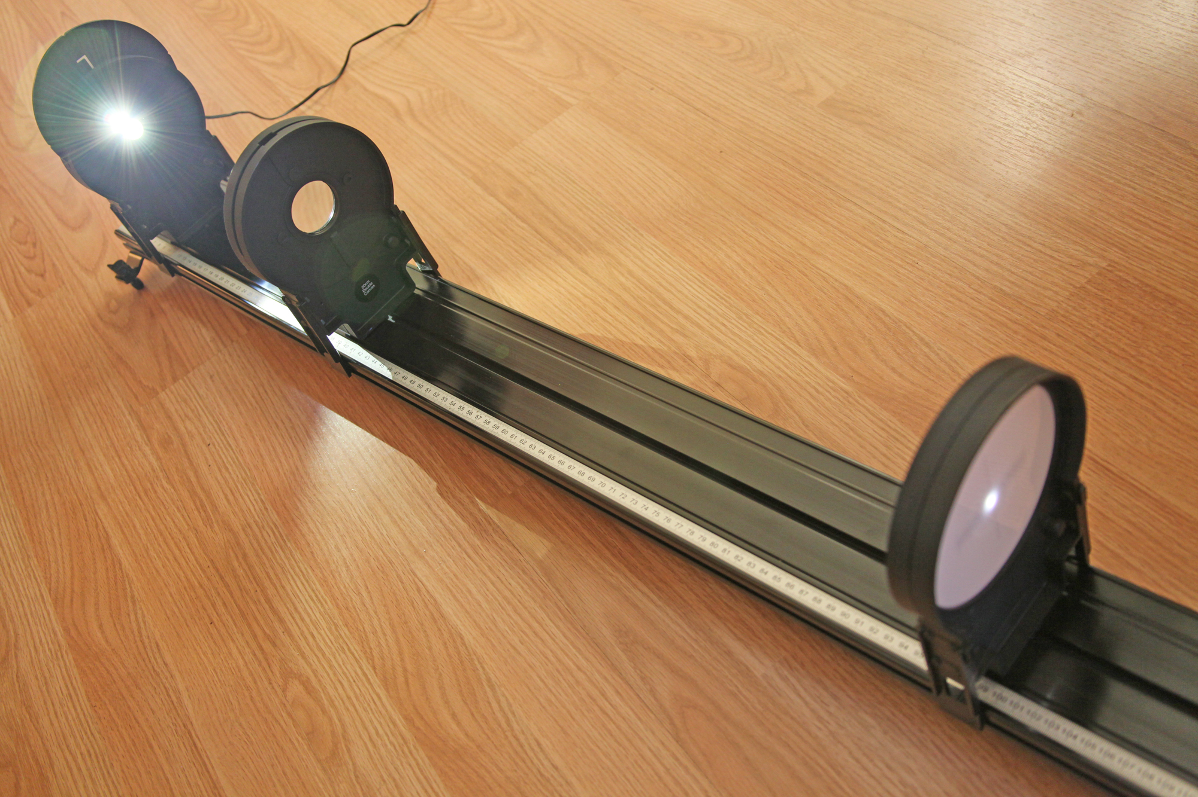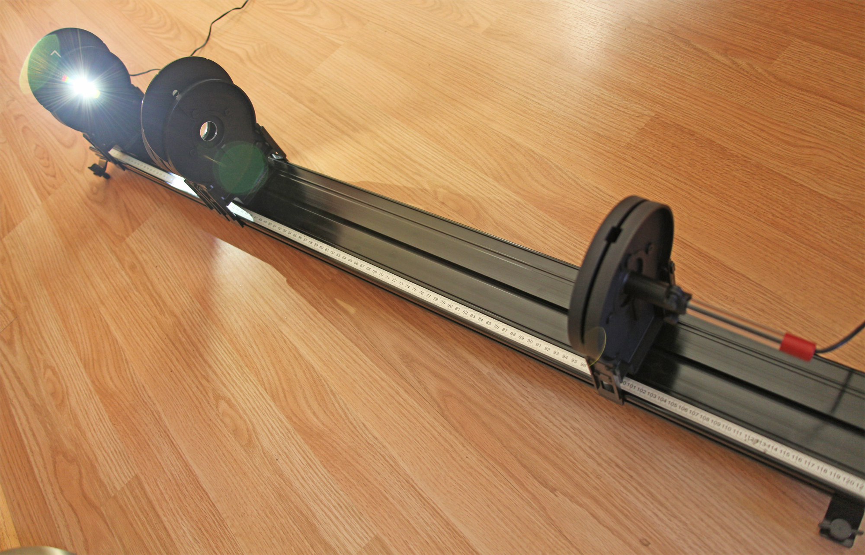
Figure 1 Figure 2

objectives
- Quantitatively determine the relationship between aperture size and the amount of light intensity of an image.
- Study the relationship between the focal length of the lens, diameter of the aperture, and the f-stop value.

Materials
Vernier data-collection interface | Vernier Dynamics System Track
Logger Pro 3 or LabQuest App  Vernier Light Sensor | Vernier Optics Expansion Kit: Light  Source, Aperture Assembly, 20 cm  Converging Lens, Screen, Light  Sensor Holder, Power Supply

Part A: APERTURES AND LIGHT INTENSITY
1. Set up the Optics Expansion Kit on the Vernier Dynamics System Track with the Light Source positioned at 10 cm, the 20 cm Converging Lens positioned at 40 cm, and the Screen positioned at 110 cm, as shown in Figure 1.
2. Connect the Light Source to the Power Supply, turn on the Light Source, and allow it to stabilize for 15 minutes before collecting data. The intensity falls slightly as the LED warms, so for this experiment, warm-up time is required.

3. Turn the disc on the Light Source to select the open hole which exposes the white LED light source. Adjust the position of the Screen until a real image of the LED is projected in sharp focus on the Screen.
4. Connect the Light Sensor to the interface. If your sensor has a range switch, set it to the
0-6000 lux range.
5. Mount the Light Sensor in the holder, then replace the Screen with the Light Sensor assembly. Make sure that the Light Source is directed toward the Light Sensor. The real image of the LED should now be visible on Light Sensor.
6. Prepare the Aperture Assembly by turning it to the largest opening.
7. Place the Aperture Assembly on the Track, immediately adjacent to the lens, on the side of the lens closest to the light sensor, as shown in Figure 2. Read the light intensity reading in lux on your Vernier data collection interface and record the value in the data table. Gather readings for the remaining four apertures and record them in the data table.

data table 1
Aperture | Light intensity
 | (lux)
5 (largest)
4
3
2
1 (smallest)

8. What seems to be happening, quantitatively, to the light intensity each time you move from one aperture to the next smaller aperture?
9. What does your answer to the above question suggest about how the surface area of the aperture changes as you move from one aperture to the next smaller aperture?
10. To test your prediction, determine the surface area of each aperture and record your results in the data table. You will need to measure the diameter of each of the apertures (in cm, estimating to the nearest hundredth of a cm), and then use the formula for the area of a circle, A = πR² =πD²/4, where R is the radius and D is the diameter.
data table 2
Aperture | Aperture diameter (cm) | Area
 |  | (cm²)
5 (largest)
4
3
2
1 (smallest)

11. Based upon the area column of Data Table 2, what quantitatively happens to the area each time you move from one aperture to the next smallest aperture? Does this agree with your answer to Question 9?

Part B: Aperture and f-sTOPS
As you determined in Part A, the five circular apertures in the Aperture Assembly have been carefully designed such that moving from one aperture to the next smallest aperture will cut the aperture area in half. As a result, the light intensity is cut in half. Accordingly, moving from one aperture to the next larger aperture will double the aperture area and double the light intensity.
In photography, there is a concept known as the f-stop. F-stops indicate relative aperture, and are defined as the ratio of the focal length (f) of the lens to the diameter (D) of the aperture:
f-stop = focal length / aperture diameter = f / D
Most cameras with variable aperture size will have settings including a subset of the following:
f-2, f-2.8, f-4, f-5.6, f-8, f-11, f-16, f-22, f-32
Contrary to intuition, the larger the f-stop value, the smaller the opening of the aperture. This is reflected by the equation shown above, since the f-stop is found by dividing by the aperture diameter. Thus, a larger diameter yields a smaller f-stop, and vice versa.
In this part of the experiment, you will determine the f-stop value for each of the apertures. The f-stop value depends upon both the focal length of the lens used, and the diameter of the aperture. You will recall that the lens used in this experiment has a focal length of 20 cm.
1. Copy the diameter data from Data Table 2 to the diameter column in Data Table 3.
2. Compute the f-stop column of Data Table 3, by dividing the focal length (20 cm) of the lens used by the diameter of the aperture.
3. Which f-stops from the list of common camera f-stops given at the beginning of Part B are closest to the calculated f-stop values in Data Table 3? Record your answer in the “Closest Camera f-stop” column of Data Table 3.

data table 3
Aperture | Aperture diameter | F-stop value | Closest camera f-stop
 | (cm) | = f / D
5 (largest)
4
3
2
1 (smallest)

4. What happens to the light intensity when one jumps from a given f-stop to the next higher-numbered f-stop in the list of camera f-stops? What happens to the light intensity when jumping from a given f-stop to the next lower-numbered f-stop in the list of camera f-stops?
5. What would happen to each of the f-stop values in Data Table 3 if the lens used was the 10 cm Converging Lens instead of the 20 cm Converging Lens?

Extensions
1. A lens for a particular camera has a focal length of 50 mm. What diameter would be required for an aperture whose f-stop is f-2.8?
2. A telephoto lens (a camera lens used for focusing in on distant objects) has an aperture of diameter 40 mm. What focal length lens would be needed if this aperture has an f-stop value of f-5.6?
3. Compute the ratio of each of the common camera f-stop values to the value of the preceding f-stop value. Do these ratios seem to be close to a constant? Compare this constant to √2.

Instructor Information
Lenses are used in a variety of everyday applications. In a camera, a real image is produced when light from a source passes through a lens and an opening, called the aperture, before striking film or a sensor. The size and shape of the aperture affect how much light strikes the film or sensor, and also affect some characteristics of the image. In this activity, you will investigate the role of aperture size and the resultant light intensity as it relates to what are known as “f-stops” in the world of photography.

objectives
- Quantitatively determine the relationship between aperture size and the amount of light intensity of an image.
- Study the relationship between the focal length of the lens, diameter of the aperture, and the f-stop value.

Materials
Vernier data-collection interface | Vernier Dynamics System Track
Logger Pro 3 or LabQuest App  Vernier Light Sensor | Vernier Optics Expansion Kit: Light  Source, Aperture Assembly, 20 cm  Converging Lens, Screen, Light  Sensor Holder, Power Supply

Part A: APERTURES AND LIGHT INTENSITY
1. Set up the Optics Expansion Kit on the Vernier Dynamics System Track with the Light Source positioned at 10 cm, the 20 cm Converging Lens positioned at 40 cm, and the Screen positioned at 110 cm, as shown in Figure 1.
2. Connect the Light Source to the Power Supply, turn on the Light Source, and allow it to stabilize for 15 minutes before collecting data. The intensity falls slightly as the LED warms, so for this experiment, warm-up time is required.
3. Turn the disc on the Light Source to select the open hole which exposes the white LED light source. Adjust the position of the Screen until a real image of the LED is projected in sharp focus on the Screen.
4. Connect the Light Sensor to the interface. If your sensor has a range switch, set it to the
0-6000 lux range.
5. Mount the Light Sensor in the holder, then replace the Screen with the Light Sensor assembly. Make sure that the Light Source is directed toward the Light Sensor. The real image of the LED should now be visible on Light Sensor.
6. Prepare the Aperture Assembly by turning it to the largest opening.
7. Place the Aperture Assembly on the Track, immediately adjacent to the lens, on the side of the lens closest to the light sensor, as shown in Figure 2. Read the light intensity reading in lux on your Vernier data collection interface and record the value in the data table. Gather readings for the remaining four apertures and record them in the data table.
data table 1
Aperture | Light intensity
 | (lux)
5 (largest) | 5828
4 | 2906
3 | 1448
2 | 711
1 (smallest) | 354

8. What seems to be happening, quantitatively, to the light intensity each time you move from one aperture to the next smaller aperture?
[The light intensity is half its previous value.]
9. What does your answer to the above question suggest about how the surface area of the aperture changes as you move from one aperture to the next smaller aperture?
[The surface area is also reduced to half of its previous value, letting only half the amount of light through.]
10. To test your prediction, determine the surface area of each aperture and record your results in the data table. You will need to measure the diameter of each of the apertures (in cm, estimating to the nearest hundredth of a cm), and then use the formula for the area of a circle, A = πR² =πD²/4, where R is the radius and D is the diameter.

data table 2
Aperture | Aperture diameter (cm) | Area
 |  | (cm²)
5 (largest) | 2.54 | 5.06
4 | 1.83 | 2.63
3 | 1.27 | 1.26
2 | 0.873 | 0.60
1 (smallest) | 0.635 | 0.32

11. Based upon the area column of Data Table 2, what quantitatively happens to the area each time you move from one aperture to the next smallest aperture? Does this agree with your answer to Question 9?
[The area seems to be close to half its previous value each time, in agreement with the guess from item 9.]
Part B: Aperture and f-sTOPS
As you determined in Part A, the five circular apertures in the Aperture Assembly have been carefully designed such that moving from one aperture to the next smallest aperture will cut the aperture area in half. As a result, the light intensity is cut in half. Accordingly, moving from one aperture to the next larger aperture will double the aperture area and double the light intensity.
In photography, there is a concept known as the f-stop. F-stops indicate relative aperture, and are defined as the ratio of the focal length (f) of the lens to the diameter (D) of the aperture:
f-stop = focal length / aperture diameter = f / D
Most cameras with variable aperture size will have settings including a subset of the following:
f-2, f-2.8, f-4, f-5.6, f-8, f-11, f-16, f-22, f-32
Contrary to intuition, the larger the f-stop value, the smaller the opening of the aperture. This is reflected by the equation shown above, since the f-stop is found by dividing by the aperture diameter. Thus, a larger diameter yields a smaller f-stop, and vice versa.
In this part of the experiment, you will determine the f-stop value for each of the apertures. The f-stop value depends upon both the focal length of the lens used, and the diameter of the aperture. You will recall that the lens used in this experiment has a focal length of 20 cm.
1. Copy the diameter data from Data Table 2 to the diameter column in Data Table 3.
2. Compute the f-stop column of Data Table 3, by dividing the focal length (20 cm) of the lens used by the diameter of the aperture.
3. Which f-stops from the list of common camera f-stops given at the beginning of Part B are closest to the calculated f-stop values in Data Table 3? Record your answer in the “Closest Camera f-stop” column of Data Table 3.

Data table 3
Aperture | Aperture diameter | F-stop value | Closest camera f-stop
 | (cm) | = f / D
5 (largest) | 2.54 | 20/2.54 = 7.87 | f-8
4 | 1.83 | 10.93 | f-11
3 | 1.27 | 15.75 | f-16
2 | 0.873 | 22.91 | f-22
1 (smallest) | 0.635 | 31.50 | f-32

4. What happens to the light intensity when one jumps from a given f-stop to the next higher-numbered f-stop in the list of camera f-stops? What happens to the light intensity when jumping from a given f-stop to the next lower-numbered f-stop in the list of camera f-stops?
[Going from one f-stop to the next highest f-stop reduced the light intensity by half. Going from one f-stop down to the next lowest f-stop doubles the light intensity.]
5. What would happen to each of the f-stop values in Data Table 3 if the lens used was the 10 cm Converging Lens instead of the 20 cm Converging Lens?
[The f-stops would vary from f-4 through f-16. 10/2.54 = 3.94 ~ f-4, etc.]
Extensions
1. A lens for a particular camera has a focal length of 50 mm. What diameter would be required for an aperture whose f-stop is f-2.8?
[Using f-stop = f/D, where f-stop is 2.8 and f=50mm, we get D = 50mm / 2.8 ~ 17.9 mm.]
2. A telephoto lens (a camera lens used for focusing in on distant objects) has an aperture of diameter 40 mm. What focal length lens would be needed if this aperture has an f-stop value of f-5.6?
[f = D ∙ f-stop = 40 mm · 5.6 = 224 mm]
3. Compute the ratio of each of the common camera f-stop values to the value of the preceding f-stop value. Do these ratios seem to be close to a constant? Compare this constant to √2.
[The ratios are close to 1.41, which is approximately √2.]

Thanks to Richard Born, professor emeritus at Northern Illinois University, for contributing this experiment.

