Inquiry Activity: Deflection of a Rectangular, Center-Loaded Beam
Learning Objectives
- The student will engage in an inquiry activity to develop a mathematical model based on observations (of their own devising) from the physical world.
- The student will understand the factors that affect the deflection of a rectangular-cross-sectioned, center-loaded beam, supported on both ends.
- The student will construct a model representing the relationship of various factors affecting the deflection of center-loaded rectangular beams.

Recommended Grades/Subjects
Grades 9–12 or college level physical science, physics, or engineering
This activity can easily be modified for middle school students.

Time needed
The project should be able to be completed in two 45 minute periods. If you break the activity into individual assignments for investigation, and then bring the parts together in a class discussion (Jigsaw), it may take less time. In the latter approach, plan on a single 45 minute period, with the potential need for an additional 20 minutes on a following day to integrate all the elements with your students.

Related Next Generation Science Standards
Disciplinary Core Ideas | Crosscutting Concepts | Science and Engineering Practices
ETS1.A. Defining and Delimiting Engineering Problems  ETS1.B. Developing Possible Solutions  ETS1.C. Optimizing the Design Solution | Patterns  Cause and effect  Scale, proportion, and quantity  Systems and system models | Asking questions and defining problems  Developing and using models  Planning and carrying out investigations  Analyzing and interpreting data  Using mathematics and computational thinking  Constructing explanations and designing solutions  Engaging in argument from evidence  Obtaining, evaluating, and communicating information

Information for the Instructor
The Vernier Structures and Materials Tester (VSMT) has been designed as a platform to easily test the strength of bridges, trusses, beams, and other structures. This series of activities explores the equation for a center-loaded beam that is supported at both ends:
$$\text{∆ = }\frac{\text{FL}\text{3}}{\text{48}\text{EI}}$$
Where ∆ is the beam’s elastic, vertical displacement at mid-span, F is the load, L is the span length, E is the modulus of elasticity, and I is the area moment of inertia. If we consider a solid rectangular beam of base b and height h, then the area moment of inertia is bh³/12, and the equation becomes
$$\text{∆ = }\frac{\text{FL}\text{3}}{\text{4}\text{Ebh}\text{3}}$$

Approach to Inquiry of Factors Affecting the Deflection of a Rectangular Beam
Students should have an intuitive grasp of the individual factors that affect a beam of this nature. A class discussion should reveal the general nature of the individual relationship. For example, under a given load, a greater span between the supports results in a greater beam deflection. Students may not be familiar with the modulus of elasticity, E, but will readily recognize that a wooden beam will deflect more than a steel beam. Providing students with the knowledge that the general flexibility of a material is captured by the modulus of elasticity, and that a larger E value represents a stiffer material, should help them fill in the blanks. If students express uncertainty relating to the general nature (direct or inverse) of the factors, a discussion of extremes may help. For example, compare the amount of bending that occurs when you stand on a piece of lumber that spans a short length versus one that spans 10 times the initial length. This should allow them to derive the relative relationships as shown in this (incorrect) proportionality:
$$\text{∆ ∝ }\frac{\text{FL}}{\text{Ebh}}$$

The students will conduct experiments to determine if their factors are correct and to determine the correct proportionality. A successful investigation will show that the elastic displacement is directly proportional to the load, directly proportional to the cube of the beam’s span length, inversely proportional to the beam’s base, and inversely proportional to the cube of the beam’s height.
Although this activity contains excellent opportunity for high school and college students to engage in designing experiments to develop mathematical models, it has relevance to middle school students as well. Remove the expectation of a strict mathematical model and focus on relative trends and graphing techniques to modify this activity for middle school or a conceptual physics course.

General Considerations
The most challenging aspect of designing this investigation is to recognize that for each physical setup you need to collect data over a range of force data. Students will need to extract specific data from these data sets to evaluate, for example, the effect of beam width on the flex of the beam. Figure 1 is intended to illustrate one approach to collecting meaningful data.
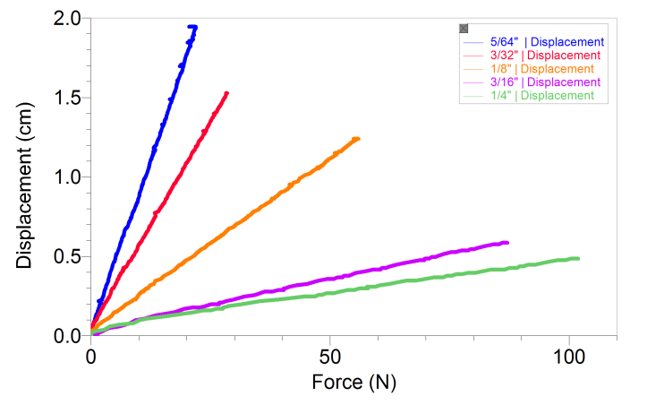
Figure 1
As you consider Figure 1, realize that each plot on the graph represents a new data set; in this case a series of planks that increase in height. In order to develop a mathematical model, students will need to pull deflection data from each run at a specific force (in this example, 20 N) and plot this data as a new graph of displacement versus height (see Figure 2). Students can use the curve fit feature in Logger Pro to determine the best-fit relationship.
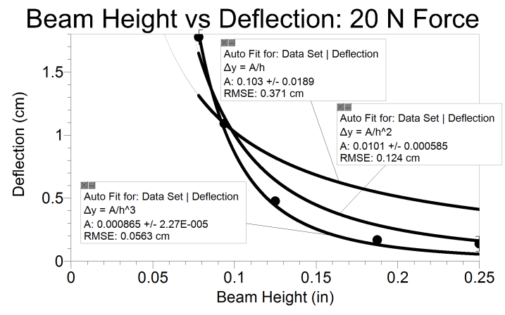
Figure 2
Consider again the data presented in Figure 1. The test for the 5/64 in. plank was stopped at about 20 N due to the amount of bending that was occurring. For this reason, students will find it most useful to start collecting data on the sample that is most flexible. Then they can limit data collection for the remaining runs to match with the limitations of the first data set.
There are a number of additional items that are useful to keep in mind when doing the beam experiments discussed in this activity:
1. Follow the safety recommendations found in the VSMT User Manual:
Wear safety glasses.
Tackle using threaded parts should be attached so that a sufficient amount of the threaded component is engaged.
Quick links should be secured and not left open.

2. Basswood is much preferred over balsa wood. Balsa wood tends to be soft and brittle, can break under relatively small forces, and contains a large degree of species variation.
3. Thin pieces of wood work best. All experiments can be done with wood with a thickness of 5 mm (one-quarter of an inch) or less. Using thin pieces will also allow you to keep the load forces smaller so that not as much energy is released in the event of beam failure.
4. A precision measurement device, such as a Vernier caliper or micrometer, is useful for more accurate measurement of beam dimensions.
5. There is no need to apply forces that will bend the beams to the breaking point.
6. The experiments described here make use of a U-bolt and quick link (found in the VSMT Tackle Kit) to securely connect the beams to the VSMT. It is not necessary to consider the weight of this tackle in the calculations of force. The added weight will affect the intercept of the equation, but not the power relationship.

Answers to Follow-Up Questions
1. The height of the beam has the greatest influence. If you double the height the deflection will decrease by a factor of 8, in theory.
2. By doing this you double the height but cut the width in half. Doubling the height decreases the deflection by a factor of 8; halving the width doubles the deflection. Therefore, you should expect the deflection to be one fourth of the original deflection.
3. Yes. The beam, in theory, acts as a spring and must flex in response to any force.
4. Students should find that stacking individual beams stacked actually gives an inverse squared relationship rather than an inverse cubed. This points to the importance of the internal forces acting on the beam in this investigation.

Challenge Activities
If we start with the idea that students will identify the various factors and identify trends (e.g., if the span length is increased then a given force will result in a larger deflection) then a progression of difficulty may be
- Determine the actual power relationship between deflection and the various factors.
- Calculate the modulus of elasticity for the wood being used.
- Have students make a prediction of deflection for a given force on a piece of wood that is outside the limits of those tested in the development of their model. Can they defend why the model should (or should not) be valid outside the tested range?
- Using published values of the modulus of elasticity, have the students test their model with other materials, such as hard plastics, metals, and other easily obtainable materials.
- Introduce the students to stress-strain curves and have them evaluate the appropriateness of a given material for a particular use. When is flexibility acceptable or even desirable?

Supplemental Student Instructions
You may find that starting the investigation as a class (versus individual lab groups) will help students gain the needed traction to get started.
You can decrease the time required by having different lab groups investigate different factors and then construct the overall mathematical model together as part of a whole-class discussion.
We feel that there are engaging challenges in the student version of the investigation. However, depending on your emphasis for this project and the level of your students, you may wish to provide them with more detailed instructions on various aspects of the software and logic setup as included below. We have provided this as example text of what a student may actually have to do to perform this activity. We do not anticipate that your students will create such detailed instructions.
Equipment Setup Suggestions
- The experiment file "Rectangular Beam Inquiry" or "VSMT Basic" can be used for this investigation. Both can be found by choosing Open►Experiments►Probes & Sensors►Structures & Materials Tester from the File menu.
- To measure force and displacement of rectangular beams, connect the beam to the load cell using two quick links, a u-bolt, and a threaded eye bolt. This hardware is included in the VSMT Tackle Kit (order code: VSMT-TK).
- Select beam sizes that will allow students to use the same tackle for each test.
- Collect data of force vs. displacement starting with a beam that will deflect the most.
  - Store this (and subsequent) data run(s) by choosing Store Latest Run from the Experiment menu (Logger Pro) or choosing Store Run from the Graph menu (LabQuest App). We recommend renaming the run with the variable parameter value (e.g., "2 in. beam").
  - When all data have been collected, turn on the Examine Tool (using the toolbar button or choosing Examine from the Analyze menu). Use this to analyze all of the data runs at the same force. Select a force that allows all data runs to return data that appear to be representative. Record the force and displacement data by selecting it in the data table or copying it down.
  - Open a new file in Logger Pro and copy this data and enter the beam's dimension data associated with each run. Graphing the displacement versus the test variable will provide a data set that can be analyzed using curve fitting to determine the best fit power relationship (see Figure 2).

Investigation Design (Example Text)
Investigation of the effect of beam span length on deflection
Select a beam with a width of 25 mm (1 in.), a height of 1.5 mm (1/16 in.), and a length of 30 cm (12 in.).
The beam will flex the most at the longest span length. In order to be certain we will collect data for each length, we'll start with the longest length/most flex.
We will start with a 26 cm span. We will decrease the length of the span by 1 cm for each trial until we reach a span of 18 cm. That will be nine data points, which should be sufficient to evaluate the relationship between length and deflection.
We will record the displacement that occurs for each span length when loaded with the same amount of force.
Procedure (Example Text)
1. Set span to 26 cm.
2. Attach beam using the small u-bolt.
3. Connect VSMT to Logger Pro using a LabQuest Mini.
4. Zero the sensors and collect data while applying a force.
5. Save the run (Experiment►Store Latest Run). Rename the runs so it is clear which run is which (Data►Data Set Options).
6. Reverse the wheel to take the force off.
7. Move the crossbeams closer by 1 cm.
8. Repeat Steps 4–7 for each of the remaining lengths.
9. Select a force value that all of the runs achieved and pull the displacement and length data for each run.
10. Graph this data in a new Logger Pro file and use curve fitting to determine the best-fit relationship.
Questions (Example Text)
1. Will we need to cut the beam to length or will moving the crossbars be enough?
2. Do we need to account for the weight of the u-bolt?
3. Do we need to do this investigation for other sizes of beams?

troubleshooting
The most common confusion related to using the VSMT is that the Displacement Sensor will not auto-ID. Be sure to select the Displacement Sensor as explained in the VSMT User Manual.
If you try to increase beam height by stacking beams you will get misleading results. Either use solid beams or fasten them securely at the ends if you stack them. This is an engaging investigation in itself (see Follow-up Question 4).

