Bridge Competition

Learning Objectives

Analyze data to identify design features or characteristics of the truss components to optimize the strength of a bridge.

Recommended Grades/ Subjects

Grades 9–12 or college-level physical science, physics, or engineering

The activity can also be modified for middle school students.

Time needed

A single 45-minute class period can be devoted to explaining the constraints and design criteria, distributing building supplies and offering guidance. Bridge construction itself can take considerable amount of time, depending on how much work is done in class. This can be assigned as home work if no class time is available for this activity. An additional 45-minute class period is needed for testing the bridges.

related activitieS

This activity can be used as a standalone project, or it can be used as a culminating activity after exploring strengths of materials, truss strength, and other related activities.

Related Next Generation Science Standards

|  |  |  |
| --- | --- | --- |
| Disciplinary Core Ideas | Crosscutting Concepts | Science and Engineering Practices |
| ETS1.A. Defining and Delimiting Engineering Problems  ETS1.B. Developing Possible Solutions  ETS1.C. Optimizing the Design Solution | Patterns  Cause and effect  Scale, proportion, and quantity  Systems and system models | Asking questions and defining problems  Developing and using models  Planning and carrying out investigations  Analyzing and interpreting data  Using mathematics and computational thinking  Constructing explanations and designing solutions  Engaging in argument from evidence  Obtaining, evaluating, and communicating information |

Information for the Instructor

Bridge building contests are great fun and are an excellent platform for practicing good engineering principles. Often, activities that are fun for students, such as bridge building contests, can leave a teacher wondering if there was any significant learning that took place. We designed this activity to emphasize the engineering design process and to provide a framework to harness student creativity.

We developed this activity for use with the Vernier Structures and Materials Tester (VSMT). It is, however, readily adaptable to any platform for data collection and evaluation a teacher might have available. Some of the benefits of using the VSMT include:

By applying the force themselves (through a series of simple machines) the students gain a tangible sense of the force being applied to their structure.

Integrating data-collection technology for data collection and analysis allows the student to determine the maximum force (and displacement) a bridge supports with an accuracy and certainty.

The student is able to apply force until a single element of the structure fails ("weakest link") rather than destroy the bridge completely. This allows the student the opportunity to effectively redesign that portion of the bridge that failed without having to rebuild it from scratch. This makes it practical for a student to engage in the process of evaluating their design and improving it in the next design cycle.

Bridge building competitions

There are nearly as many approaches to bridge competitions as there are physics and engineering teachers. The outline provided here is a starting point for you to consider. It is based on past rules from the International Bridge Competition (sponsored by the Illinois Institute of Technology). For more information, see [www.bridgecontest.phys.iit.edu/public/international/index](http://www.bridgecontest.phys.iit.edu/public/international/index)  
We encourage you to modify these to fit the needs of your students and the resources you have available.

General Considerations

There are several Vernier interface and software options for this activity. The use of the Displacement Sensor on the VSMT is not specifically required for this activity, so any interface and software combination that can accommodate the VSMT force sensor will work. Refer to the compatibility chart on the VSMT website to determine the best option for your class: www.vernier.com/vsmt

There are a number of things that are useful to keep in mind when using the VSMT:

1. Bridges constructed of 3/32" basswood have been successfully tested. Both basswood and balsa wood are available at hobby stores and online retailers. Other dimension stock and other types of wood can be used, but be careful not to exceed the load limitations of the VSMT (1000 N).

2. Follow these safety recommendations, and see the VSMT *User Manual* for additional safety and use tips:

Wear safety glasses

Tackle using threaded parts should be attached so that a sufficient amount of the threaded component is engaged

Quick links should be secured and not left open

3. We have created an Experiment file in Logger *Pro* to assist in tracking the individual bridge performances in a class competition. To access this file choose Open from the File menu. Then open Probes & Sensors>Structures & Materials Tester>Structure Comparison. The file converts the force applied to the bridge into a ratio of mass held to bridge mass.

Alarms are set for bridges exceeding the 2.5 cm deflection and the 490.5 N (50 kg) mass limit.

Calculations of efficiency are based on the ratio of (weight held):(weight of bridge). Enter bridge mass in grams. If weight held exceeds 490.5 N the efficiency is based on 490.5 N.

4. There are several preliminary studies/investigations that can be integrated into a bridge building competition:

Truss design and strength

Understanding of members being in tension or compression

Combinations of building materials and appropriate adhesives

Joint construction and the use of gussets and pins

5. Symmetry in construction is often equally important as the overall design. Tips for students to create symmetrical truss patterns and identical sides will increase the opportunity for a successful effort.

6. The rules found in the student pages of the activity are slightly modified from the 2016 rules for the International Bridge Building Competition run by the Illinois Institute of Technology.

troubleshooting

Note that the Displacement Sensor will not auto-ID when attached to LabQuest or an interface connected to a computer platform. Be sure to select the Displacement Sensor, as explained in the VSMT *User Manual*.

Additional Resources

The following information is provided as background for instructors regarding truss statics.

Truss

A truss is a rigid framework with internal members that are connected in a triangular pattern. Trusses have a very high strength-to-weight ratio, which allows them to span long distances. Historically, trusses were frequently used in bridge design; due to their efficiency and low cost, they are also becoming common elements in homes for roof and floor framing construction. A truss bridge is built from two trusses (one on either side) connected by a horizontal bridge deck. The bridge deck serves as the vehicle navigation surface and can be located at the top or the bottom of the bridge. Additional lateral bracing is applied as necessary to improve stability, but it must not obstruct the travel pathway along the bridge deck.

Pins and gusset plates (the connections that join bridge members together) are critically important to the overall structural integrity of the bridge. Bridges are supported by *abutments*, foundations that support the weight of the bridge and hold back the soil behind it. If additional supports are required in the middle, they are called piers. Abutments and piers are usually made of concrete, while bridge members are made of steel.

Bridges must carry three different kinds of forces: loads, reactions, and internal forces. Loads are the external forces that are applied to the bridge, such as the weight of the cars and trucks that cross it. Loads also include the weight of the bridge itself, the weight of snow and rain, the force of wind, and the forces caused by earthquakes. Reactions are the support forces supplied by the abutments or piers. Internal forces are the tension and compression forces developed along structural members when a load is applied. Members in tension are being pulled or stretched, while members in compression are being pushed together.

One of the most common truss configurations is the Warren truss. The Warren truss is known for its simplicity because no vertical members are used. Two other common designs are the Pratt and Howe trusses.

In the Pratt truss, all inner diagonal members slant down toward the center, while in the Howe truss they slant toward the outside. The Pratt truss is much more economical to build than the Howe truss. Most of its diagonal members are in tension allowing them to be thinner than the compressive diagonals in the Howe truss.

Truss bridges' support forces are equal to the applied load, and the moments about any point are zero. The strength of a bridge is determined by the largest internal force it can withstand before failing, but no internal force can exceed the material strength of the individual member. Tensile and compressive strength depend on the material used in fabrication, as well as the width and thickness of the structural member cross-section. The compressive strength is also dependent upon the length and shape of individual structural members, but length and shape have no influence on tensile strength.



Figure 1

Calculating Forces in a Truss

The basic approach in solving for the forces acting on individual members in a truss follow the general steps of (1) solving for reaction forces where the truss connects to the ground, (2) isolating individual joints and using an equilibrium of forces and trigonometry to determine the forces along each member (either in tension or compression). The following illustrates this process for this simple truss:

1. Draw a free-body diagram of the bridge. A free-body diagram is a sketch of the bridge showing all forces acting on it. The entire applied load should be drawn as a downward force acting on the center of the bridge (50 N in the example shown below). Calculate the upward reaction forces at the outer supports so that the bridge is in equilibrium.

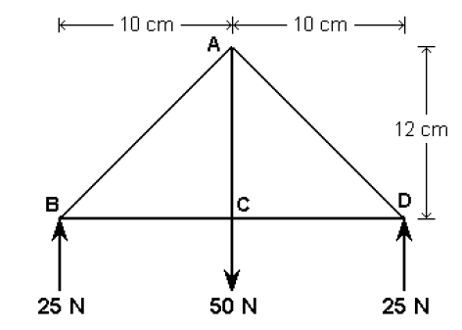

Figure 2

2. Isolate the left-most joint. Use trigonometry to calculate the angle between the diagonal and horizontal members (assume the diagonal member is the hypotenuse of a right triangle).

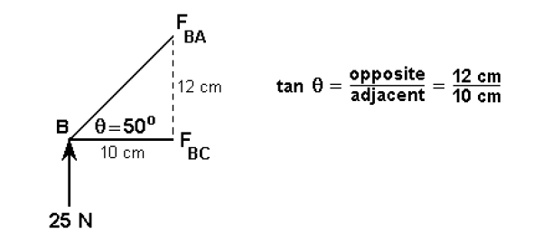

Figure 3

3. Resolve the diagonal member into its horizontal and vertical components. For the joint to be in equilibrium, the sum of all forces in the vertical direction must equal zero. Since there is only one vertical force of 25 N acting in an upward direction, the vertical component of FBA must also equal 25 N, but it must be acting in a downward direction. Notice that both vertical components are “pushing” on joint B, so the force in member BA must be a compressive force.

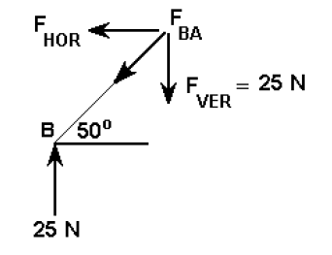

Figure 4

4. Use trig twice more to calculate the horizontal component and the magnitude of the resultant force for FBA.

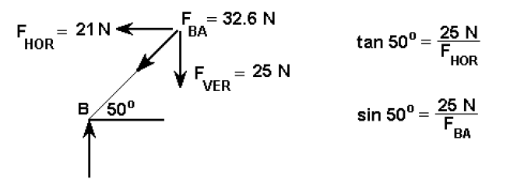

Figure 5

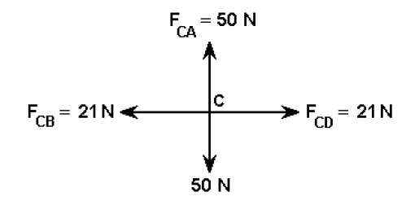5. For the joint to be in equilibrium, the sum of all forces in the horizontal direction must also equal zero. Since there are only two horizontal forces, FBC is "pulling" on joint B, so the force in member BC must be a tension force.

Figure 6

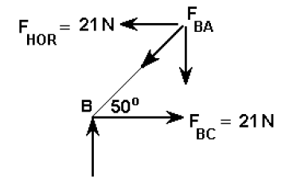6. Repeat Steps 2–5 to calculate the forces acting on joint C. When transferring the value of any known forces (in this case the force in member BC), be sure to apply it in the opposite direction.

Figure 7