Absorbance and Fluorescence Characterization of Quinine
This experiment requires the most recent version of the data-collection software. Updates can be found at www.vernier.com/downloads

Related Skills
It is important to read the Vernier Fluorescence/UV-VIS Spectrophotometer user guide before beginning this, or any, experiment with the instrument.

Instructor Notes
- Quinine stock solution (100.0 mg/L) is prepared by weighing out 120.7 mg quinine sulfate dehydrate or 100.0 mg quinine. Transfer this to a 1 L volumetric flask, fill partially with distilled water, add 50 mL of 1 M sulfuric acid (H₂SO₄), and dilute to mark with additional distilled water. This solution is light sensitive; it is best to store it in a brown bottle.
- To prepare the tonic water (with quinine) sample in 0.05 M H₂SO₄, pipet 5.00 mL of tonic water into a 250 mL volumetric flask and dilute to the mark with 0.05 M H₂SO₄. Then, pipet 5.00 mL of this solution into a 25 mL volumetric flask and dilute to volume with 0.05 M H₂SO₄.
- To simplify the pH dependence of quinine, make buffers available to the students so they can make their samples. Also, titrating the sample while it is in the instrument, and measuring the pH afterwards, is an easy and illustrative way to collect this data quickly.
- To simplify the halide dependence of quinine extension, have 0.1 M KBr available for the students to make their samples.
Sample Data
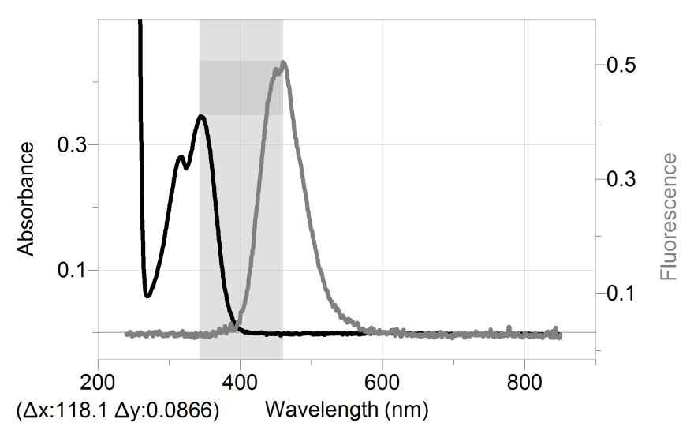
Figure 1 Stokes shift of quinine
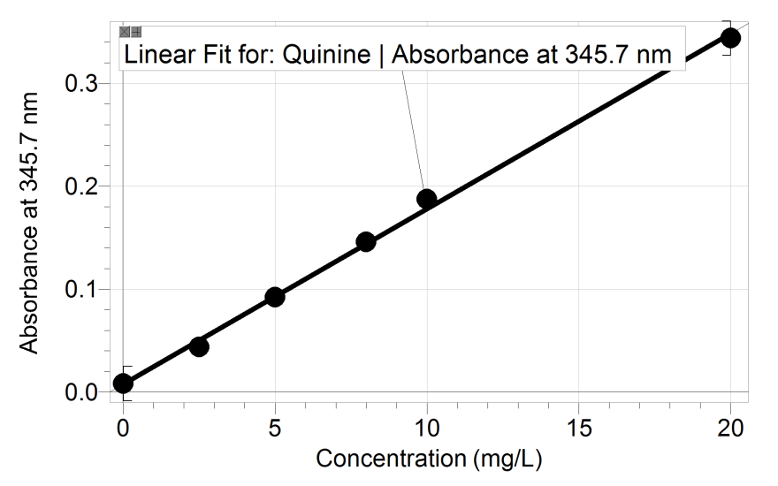
Figure 2 Absorbance vs. concentration data for quinine
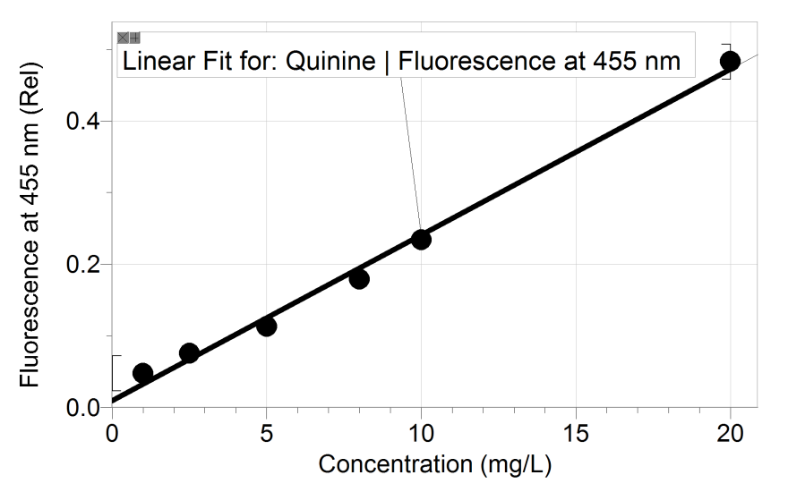
Figure 3 Fluorescence vs. concentration data for quinine
Hazard Alerts
The chemical safety signal words used in this experiment (DANGER, WARNING, and N/A) are part of the Globally Harmonized System of Classification and labeling of Chemicals (GHS). Refer to the Safety Data Sheet (SDS) that came with the chemical for proper handling, storage, and disposal information. SDS can also be found online from the manufacturer.
Sulfuric acid, 0.05 M, H₂SO₄: WARNING: Sulfuric acid solution, H₂SO₄: Causes skin and serious eye irritation.

Discussion
- The concentration of quinine in tonic water was 10 mg/L.
- As shown in Figure 1, the Stokes shift should be close to 118 nm.
- The tonic water spectrum was non-existent in absorbance mode. Fluorescence analysis allowed for calculation of the concentration.
- At high concentrations, the fluorescence intensity is nonlinear. This is due to the inner filter effect.

EXTENSIONS
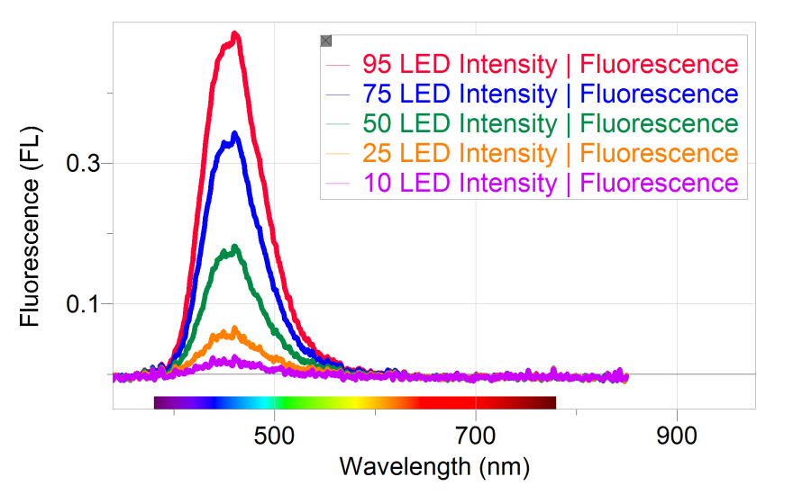
Figure 4 Fluorescence spectra of 20 mg/L quinine at various LED intensities

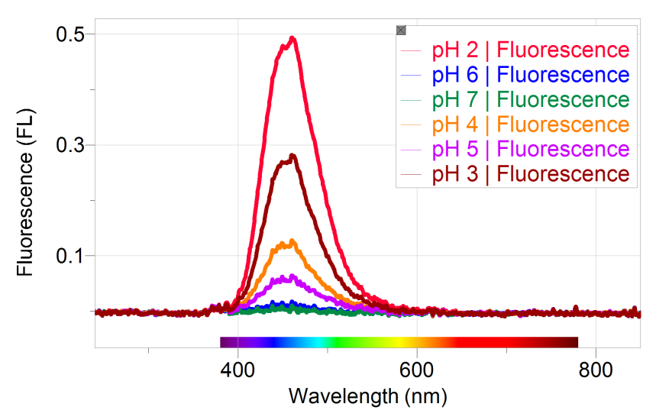
Figure 5 Fluorescence spectra of 20 mg/L quinine at various pH values

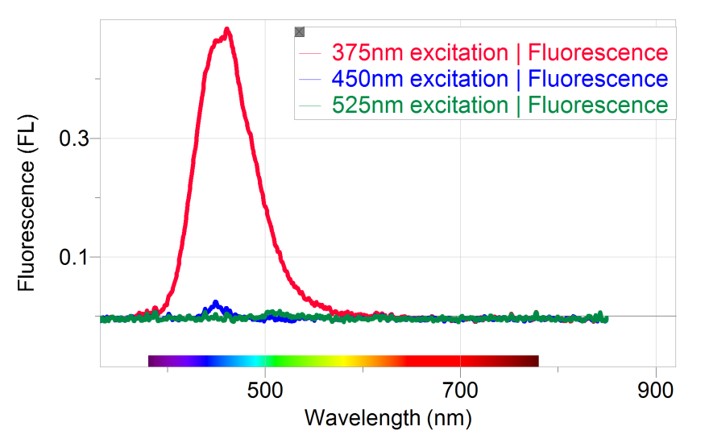
Figure 6 Fluorescence spectra of 20 mg/L quinine at various excitation wavelengths

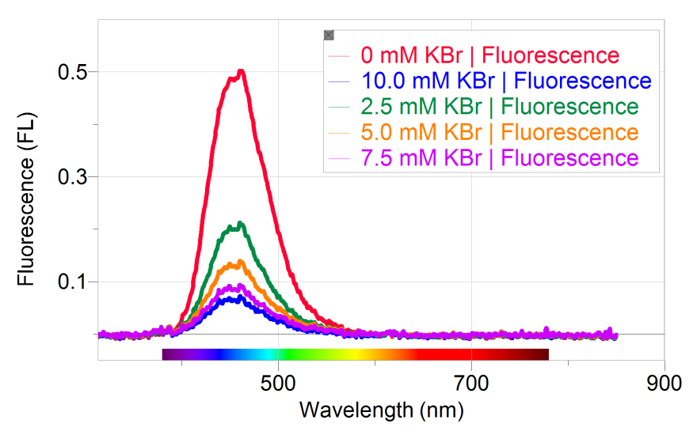
Figure 7 Fluorescence spectra of 20 mg/L quinine at various NaBr concentrations

