Nucleic Acid Quantitation
1. If using computers, the Vernier UV-VIS Spectrophotometer requires Logger Pro version 3.8.6.2 or newer. LabQuest App version 2.1, or newer, is required if you are using LabQuest 2. LabQuest App 1.7, or newer, is required if you are using the original LabQuest. Visit the downloads section of www.vernier.com to update your software.
2. It is recommended that you read the Vernier UV-VIS Spectrophotometer user guide before beginning this, or any, experiment with the instrument.
3. Biological samples can be unstable. They should be prepared freshly for this experiment or stored properly.
4. This experiment is designed only to analyze a biological sample. The preparation and concentrations your students use are up to you. You may want to do a trial run to confirm the absorbance values at 260 nm and 280 nm are less than 1.0. Absorbance values higher than 1.0 begin to lose linearity and could therefore generate erroneous results.
5. A value of 340 nm is used as a correction factor here because there can be contaminants in your solution that scatter the light and create an absorbance offset throughout this wavelength region. The value in a pure nucleic acid sample should be zero. If you are more concerned about electronic noise, you may want to instruct your students to pick the absorbance value at 800 nm to normalize.
6. Negative values could result if an incorrect solution was used as a blank. Alternatively, these values could arise due to fluorescence of a dye in the solution.

Sample Data
Run | A₂₆₀ | A₂₈₀ | A₃₄₀ | A_{260/280} (corrected)
1 | 0.93 | 0.47 | 0.01 | 2.00
2 | 0.86 | 0.42 | 0.01 | 2.07
3 | 0.88 | 0.47 | 0.01 | 1.89
 |  |  | Average | 1.99

Answers to the DATA Analysis Questions
1. Answers will vary. See table above.
2. Answers will vary. See table above.
3. Answers will vary. For pure DNA, A_{260/280} is 1.8 and for pure RNA, A_{260/280} is 2.0. Industrial samples, such as the DNACON used in the sample data, is prepared to resemble the absorption of pure RNA.
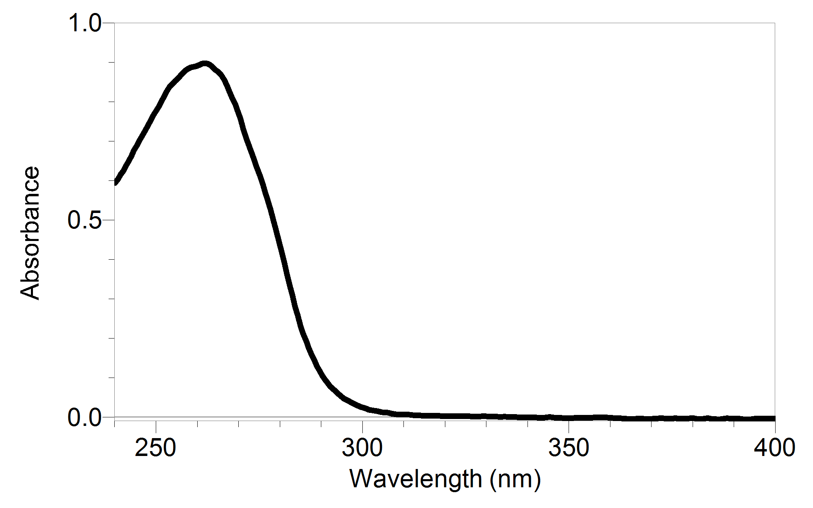
Sample graphs

Absorbance Spectrum of Starna DNACON 260/280

