Base Catalysis of the cis-trans Isomerization of Congo Red
Excitation wavelength: <500 nm
Observation wavelength: 600 nm

Chemicals needed
- Congo red (CR)
- Sodium hydroxide
- Ethanol, commercial grade for solvent

Background
Congo red (CR) is a diazo dye that is a derivative of azobenzene. As can be seen from the skeletal structure in Figure 1, CR has two identically substituted azobenzene moieties.

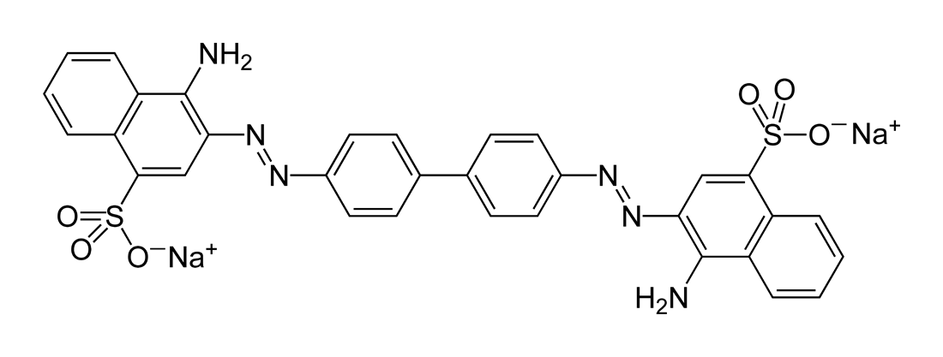
Figure 1: Congo red, MW=696.67

The absorption spectrum of a solution of CR in its trans-ground state (as depicted in Figure 1) in 20% water/ethanol is shown in Figure 2. The dye absorbs strongly throughout the visible range with a maximum near 510 nm. Note that the absorbance is very weak at 600 nm.

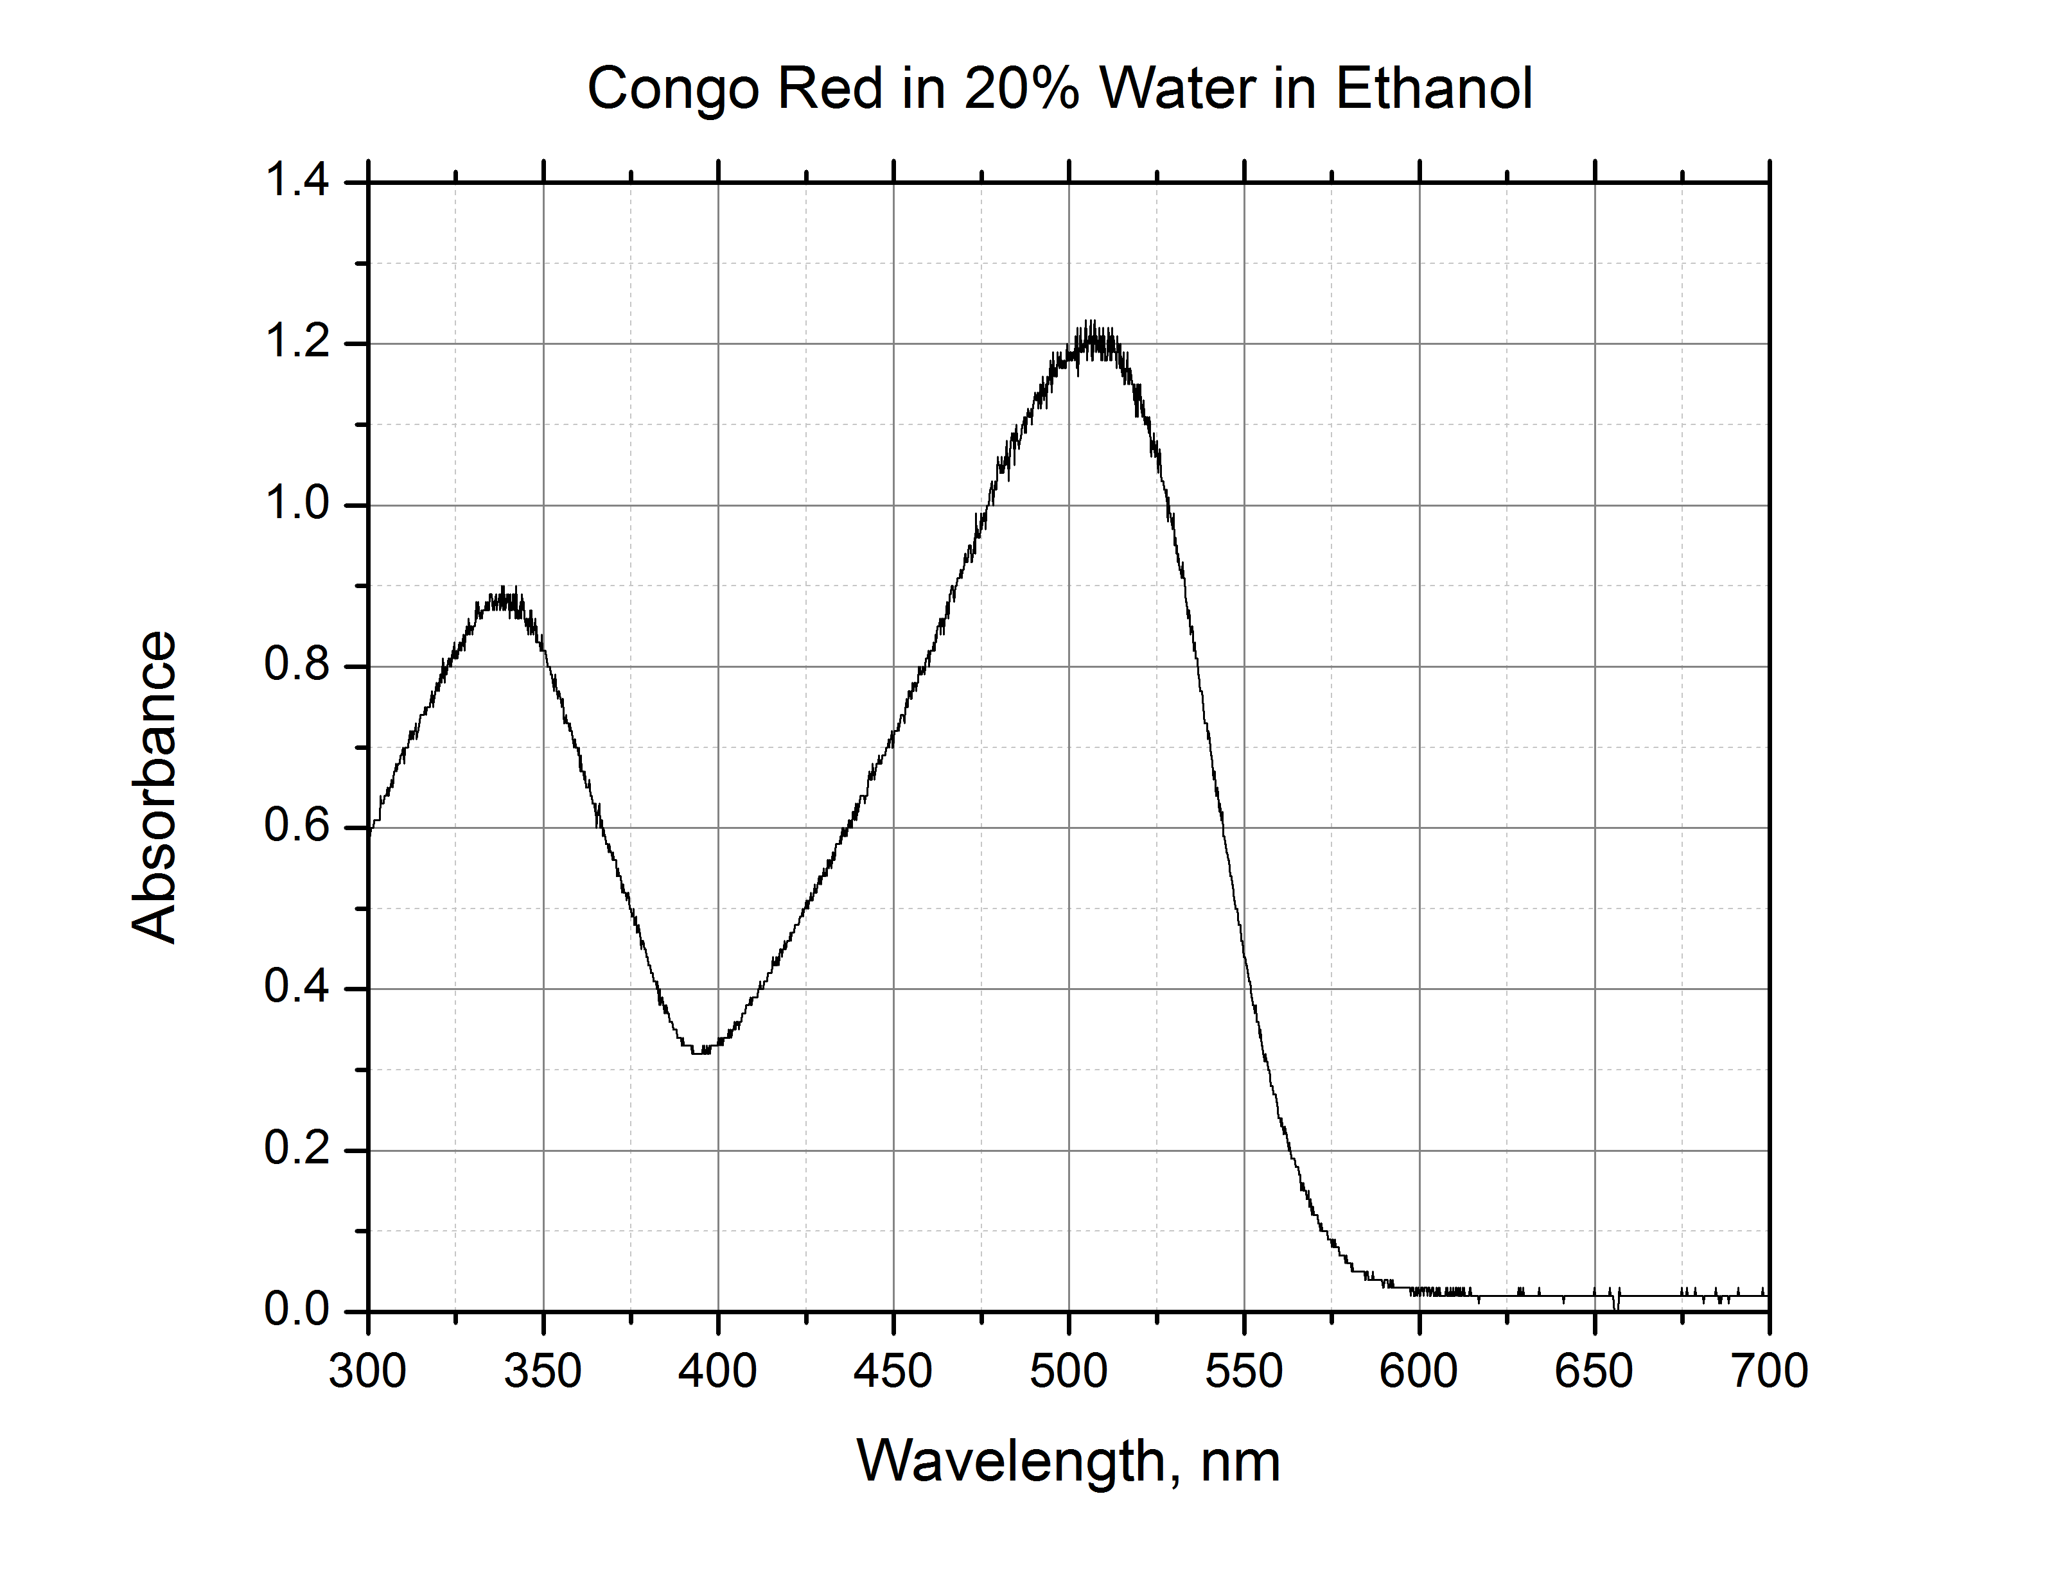
Figure 2: Ground state absorption spectrum of Congo red (trans conf.) in 20% water in ethanol

When light within the broad visible band is absorbed by the dye, some ground state molecules are converted into an excited state in which the electronic structure of the dye is changed. This shift in electron density causes the –N=N- bond to have significantly less double-bond character, and because of this, the molecule becomes torsionally flexible. Thus, in its attempt to rid itself of the energy imparted by the absorption of a photon, CR flips rapidly from a trans-excited state to a cis-ground state that is a higher energy state than the trans-ground state. This cis-state is therefore metastable with respect to the trans-ground state, and in fluid media at room temperature, a cis-trans isomerization will occur with the result that CR in its initial state is regenerated. Overall then, all that happens is that light energy is converted to heat in the solution.
However, this photoreaction provides an opportunity for the student to follow the progress of a thermal cis-trans isomerization and measure its rate on timescales that cannot be achieved by traditional mixing methods. Moreover, the rate is found to be catalyzed by both acids and bases, and the student is required to find the bimolecular rate constant for catalysis by OH⁻ ions.
Procedure
Obtain and wear goggles. Prepare 100 mL of 20% water in ethanol using de-ionized or distilled water. It may be convenient to use 190 proof ethanol, which is 5% in water, and add the requisite volume of water to bring it to 20%. Note that the exact percentage of water is not important, but the water must be
pure. Add small quantities of solid CR to the water-alcohol mixture until the color is a light red. Again the amount of dye is not important; you need to have just enough to generate a quantity of the cis-photoproduct to provide an absorbance that has a good signal-to-noise ratio in the Vernier Flash Photolysis Spectrometer. A useful check is to transfer some of the solution to the 10 mm x 10 mm cuvette and place it in the sample position with the 600 nm band pass filter inserted in front of the detector. If the I₀ reading on the lower-left of the Vernier Flash Photolysis Spectrometer Software is about 20% lower than the value without the cuvette in the sample position (or with an empty cuvette), the solution is adequate for the purpose.
Remove 50 mL of the prepared dye solution and add sufficient 0.1 M NaOH solution in water to bring it to 2 mM in NaOH (the amount of water you add here is not significant in the total).
Now you have two equivalent solutions of dye in the solvent mixture, one of which is 2 mM in OH⁻ ions.
By mixing appropriate amounts of the two solutions, prepare 5 mL amounts that range from 0 to 0.1 mM in OH⁻ ions. These solutions all contain the same CR concentration in the same water/ethanol mixture.
Starting with the 0 mM sample, transfer about 3 mL to a clean, dry cuvette. Place the cuvette in the sample position and confirm that Averages is set to 1. Then, click the Start button. You should see a time profile similar to that in Figure 3, where the y-axis is Amplitude in mV and the x-axis is in ms.

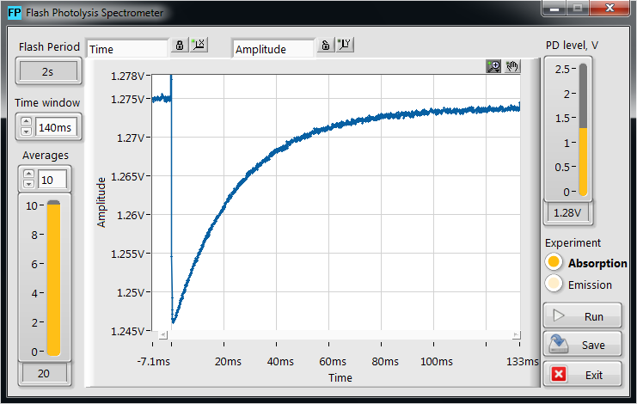
Figure 3: Kinetic profile of Congo red in 20% water in ethanol

In Figure 4, you can see that the flash at t = 0 causes a vertical (on these time scales) drop in the mV reading; it drops from ~1.275 V prior to the flash to ~1.245 V after. Subsequently, the value increases over hundreds of milliseconds. The flash induces the changes outlined earlier, and very quickly, at shorter times than software can follow, the ground state of the cis-form is generated. The ground state of the cis-form absorbs light passing through the 600 nm filter, and the detector registers a drop in transmission. Then, the cis-form returns to the trans-form over many milliseconds, and it is the rate of this process that you are required to extract from the data set.
Repeat data collection with the averages set to 10 (or more) and save the resulting data.
Do the same procedure for the other samples you have prepared, and save their averaged data sets. As you go through the series, you see that the recovery rate increases; to account for this, you will need to adjust the time window setting and the time scale in order to obtain curves that use as much of the time window as possible.
The samples that you have examined have been stored as comma-separated values (CSV) files. Import the data into Logger Pro to evaluate the rate constants for the cis-trans conversion of CR as a function of [OH⁻]. You should find that the decays follow an exponential rate law with a constant that is a linear function of [OH⁻] and the slope of the line (or the best fit of the regression) is the bimolecular rate constant for the catalytic process.

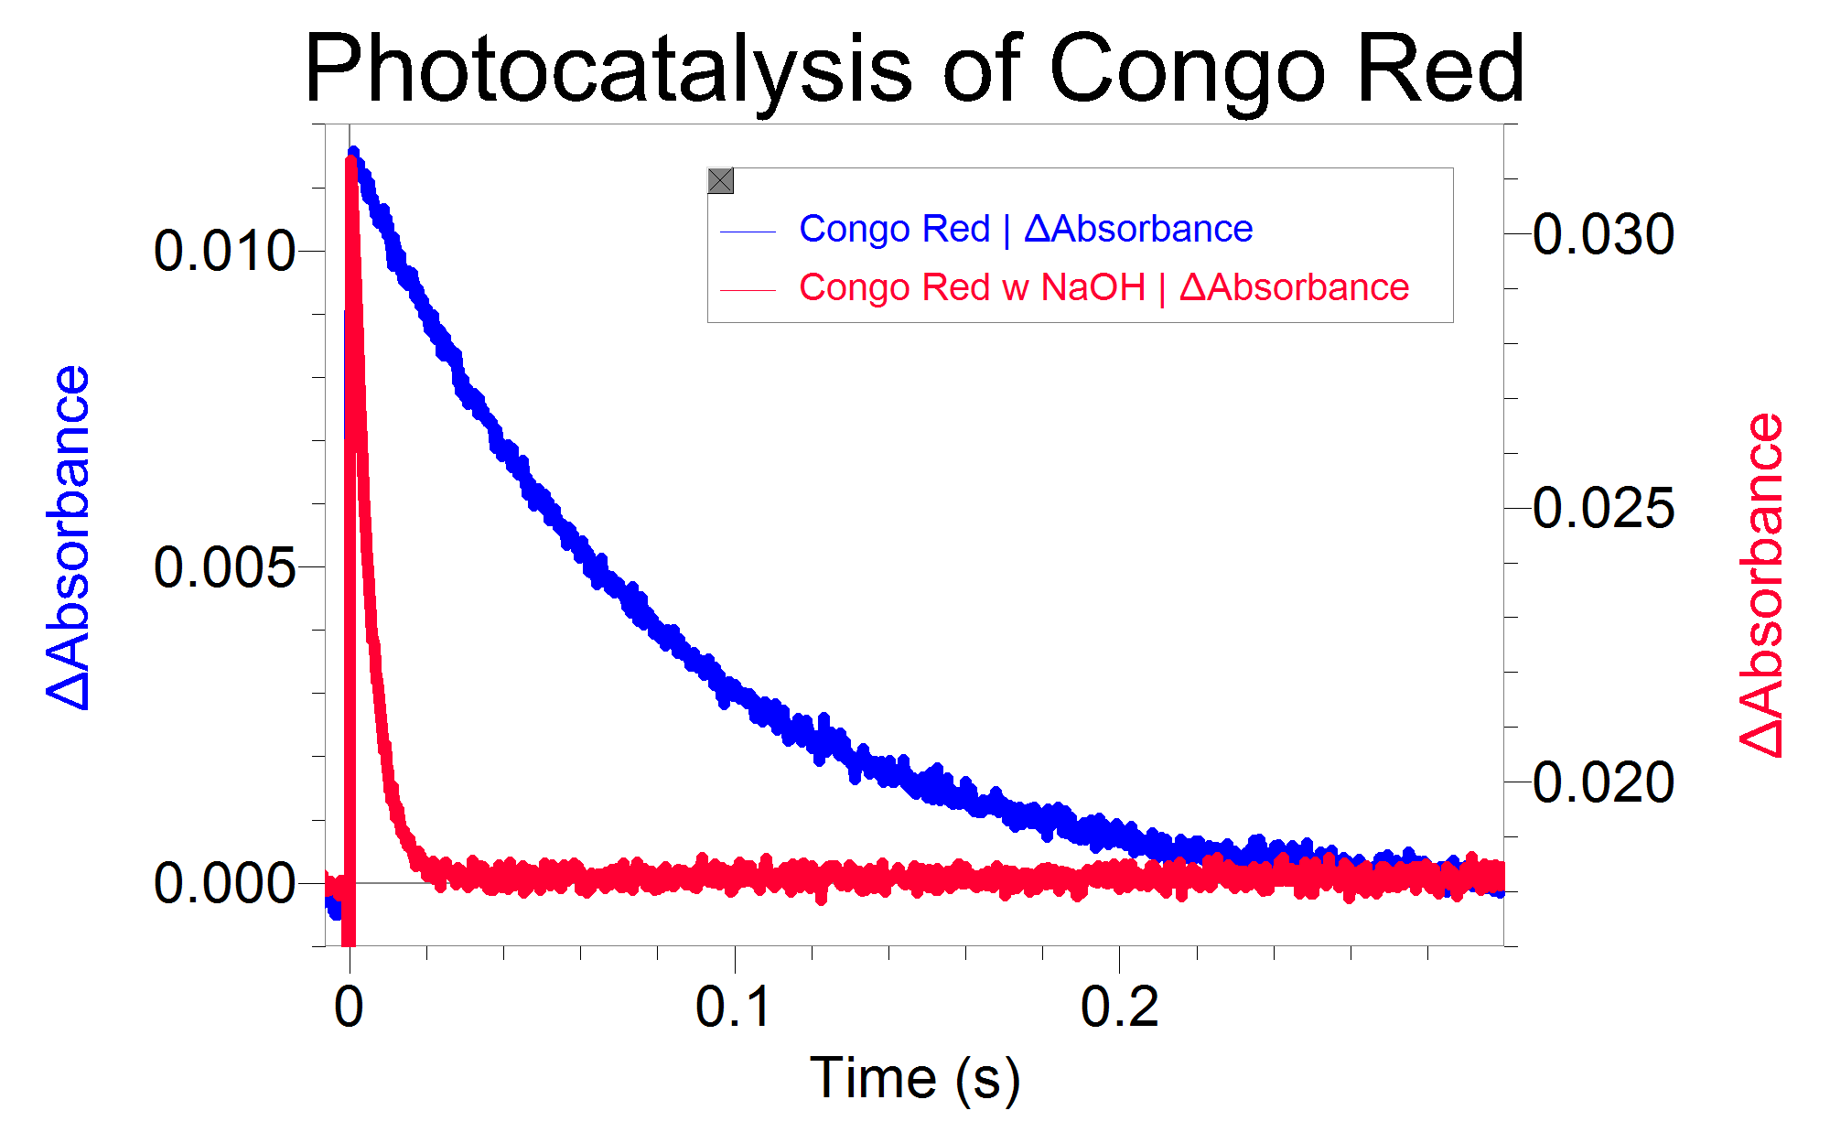

Figure 4: Absorption kinetic profile of Congo red in 20% water in ethanol with 2 mM OH⁻ ions after importing into Logger Pro software

