Isomerization of Mercury Dithizonate

Excitation wavelength: <500 nm

Observation wavelength: 600 nm

Chemicals needed

* Mercury dithizonate (HgDz)
* Trifluoroacetic acid (TFA)
* Ethanol, commercial grade for solvent

Background

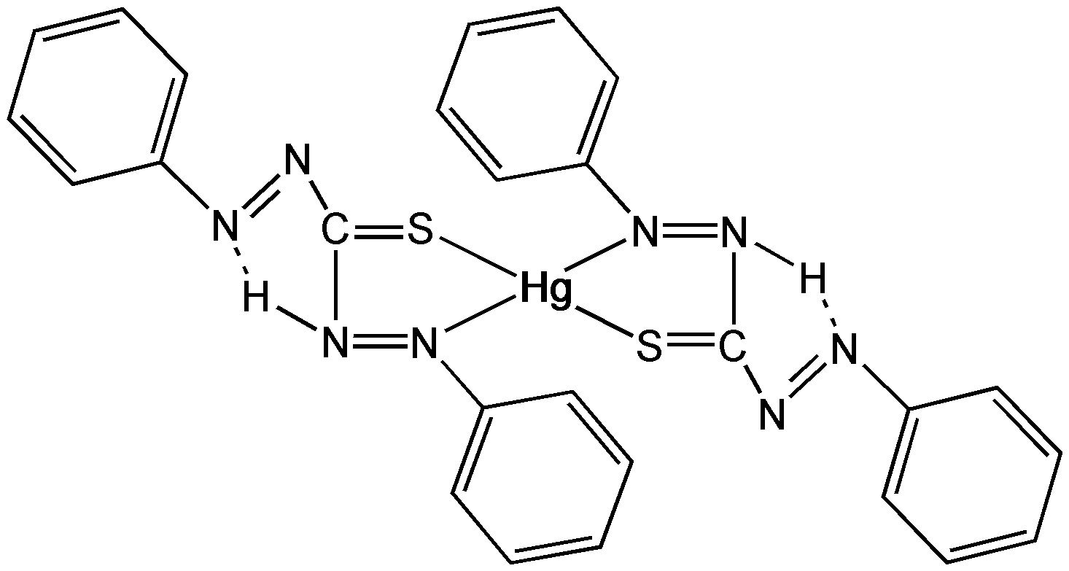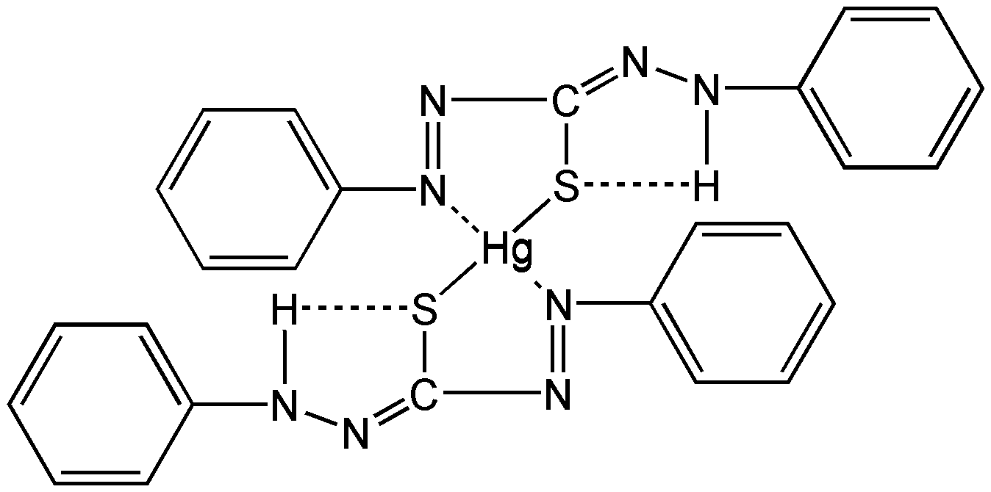

**Figure 1:** Photoinduced isomerization of mercury dithizonate

This photoisomerization event occurs within the flash lamp profile (i.e., “instantaneously” on our time scale). The trans-to-cis back reaction occurs in the dark period following the flash, and the color reverts thermally with a lifetime of ~650 ms. This inversion of color can be catalyzed by acids and bases. In this experiment the solution of the HgDz complex is excited by the flash lamp and the decay of the transient absorption at 600 nm is monitored as a function of time after the flash.

The decay is exponential in time with a rate that is first order in the concentration of an acid such as trifluoroacetic acid (TFA). The experimental conditions are such that the TFA is at a much higher concentration than the photo-produced trans-isomer of the complex and so the conditions correspond to the pseudo-order situation as described in the kinetics theory section (Section 5.7 of the reference manual). A plot of the observed rate constant as a function of acid concentration is linear with a slope that provides the bimolecular rate constant for the catalysis process.

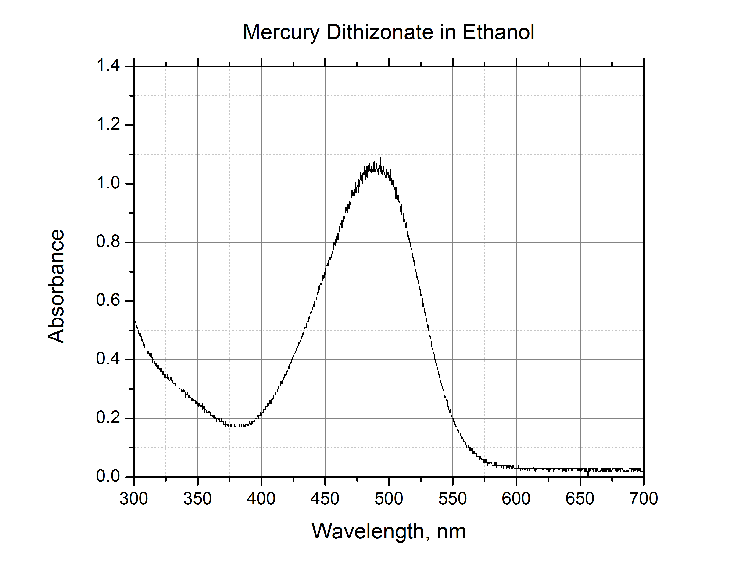

**Figure 2:** Ground state absorption spectrum of mercury dithizonate (trans conf.) in ethanol

Procedure

Obtain and wear goggles. Prepare a 25 mL stock solution of HgDz in ethanol with sufficient solute to provide absorbance of ~1/cm at 500 nm (roughly 10-5 M). Prepare 25 mL of 0.01 M stock solution of TFA in ethanol. Prepare at least 5 sample solutions, each containing 3 mL of HgDz stock, aliquots of TFA stock in the range of 0–1 mL and sufficient ethanol to bring total volume to 4.0 mL. These sample solutions will all have the same concentration of HgDz and varying concentrations of TFA in the range   
0–0.02 M TFA. Place ~4 mL of the [TFA] = 0 M sample solution in a 10 mm x 25 mm rectangular borosilicate cuvette with all faces polished and proceed to photoexcitation.

Photoexcitation of an air-saturated ethanol solution of the Hg complex with the dithizone ligand in the cis-form induces cis-to-trans isomerization, and the compound changes color from orange to blue (λmax = 605 nm).

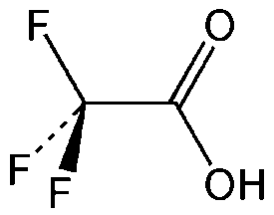

**Figure 3:** Trifluoroacetic acid (TFA); MW = 114.03

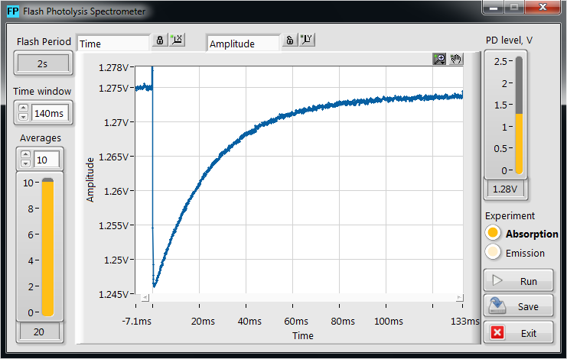

**Figure 4:** Kinetic profile of mercury dithizonate in ethanol