Determination of the Activation Energy of the Thermal Back Reaction of One Spiropyran in Toluene
Excitation wavelength: <400 nm, CG-BG-3
Observation wavelength: 600 nm

Chemicals needed
- 5.0 × 10⁻⁶ M 1’,3’-dihydro-1’,3’,3’-trimethyl-6-nitrospiro(2H-1-benzopyran-2,2’-2H-indole)
(6-NO₂-BIPS) in toluene
- toluene as solvent

Hardware and software needed
- Vernier Flash Photolysis Spectrometer software (available for Windows® only)
- Vernier Logger Pro software (or similar data-analysis software)
- computer
- Vernier Flash Photolysis Spectrometer
- fluorescence cuvette

Background
6-NO₂-BIPS is a type of spiropyran molecule that is colorless in its normal form (N isomer) and undergoes a photochemical ring-opening reaction to yield an isomeric colored merocyanine form (MC isomer) when irradiated with UV light. It has been proposed that the MC isomer is a zwitterion, as shown in Figure 1.
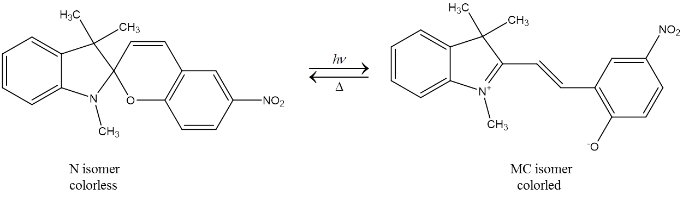
Figure 1: Structure and photochromic reaction of 6-NO₂-BIPS

The N isomer is the thermodynamically more stable isomer and absorbs in the UV region, whereas the MC isomer absorbs in both the UV and visible regions. The MC isomer exhibits a strong and characteristic absorption band between 550 and 650 nm. Upon UV irradiation of 6-NO₂-BIPS, the formation of the MC isomer is induced. The increase in the concentration of the MC isomer results in the increase of absorbance in the visible region of the absorption spectrum. The MC isomer spontaneously returns to the N isomer once the UV irradiation is stopped. The kinetics of this back reaction process can be characterized by measuring the visible absorption at 600 nm of the MC isomer as a function of time. In this experiment, the kinetics of the back reaction will be measured for a range of temperatures in order to determine the activation energy, E_{a}, of the back reaction. The activation energy can be determined from the slope of ln(τ) as a function of 1/T according to the Arrhenius equation:
$$k=\frac{1}{τ}={Ae}^{-(\frac{E_{a}}{RT})}$$
where k is the rate constant, τ is the time constant of the back reaction process, T is the temperature in kelvin, A is the pre-exponential factor in reciprocal time units, and R is the universal gas constant. The literature reported value for E_{a} = 62.5 kJ mol⁻¹.

Procedure
Prepare the solution by taking 0.032 mg of 6-NO₂-BIPS and dissolving it in approximately 20 mL of toluene to give a 5.0 × 10⁻⁶ mol L⁻¹ solution. The concentration was chosen such that the absorbance at λ = 300 nm in a 1 cm cuvette of the UV absorption peak was 0.5 at room temperature (see Figure 2). This avoids any dimerization processes as well as allows the UV irradiation to propagate through the entire sample. If using a common UV-visible spectrometer in an undergraduate laboratory, λ_{max} should not exceed 1.
Ensure you have connected the Vernier Flash Photolysis Spectrometer to your computer using the Vernier Flash Photolysis Spectrometer software. Insert the CG-BG-3 dielectric filter and the 600 nm band pass filter. Fill the provided cuvette with 4 mL of the 6-NO₂-BIPS/toluene solution.
Prepare a hot bath of water that can be temperature controlled, and use a thermometer to monitor the temperature. The bottom half of the cuvette should be placed into the hot bath to allow the solution to come into thermal equilibrium with the water. For five different temperatures between 30°C and 60°C, remove the cuvette once it is in thermal equilibrium and place the cuvette in the Flash Photolysis Spectrometer. Set the time window appropriately and take one measurement, returning the cuvette to the hot bath afterwards. See Figure 3 for an example of measurements done at five varying temperatures. For multiple measurements at the same temperature, return the cuvette to the hot bath in between measurements; this will ensure that the solution is at thermal equilibrium with the warm water for each measurement.
An example of the generated absorbance vs. time profile is shown in Figure 4 for a temperature of 55°C. Also shown in this plot is the fitted exponential decay function (red line) generated using Logger Pro software. This fit will provide the lifetime of the back reaction, which in this example is 1.33 seconds. Once lifetimes at five different temperatures are obtained, a plot like the one in Figure 5 can be generated. Using Logger Pro, a line is fit through the five data points and the slope of this line is used to calculate the activation energy, E_{a}, of the back reaction.
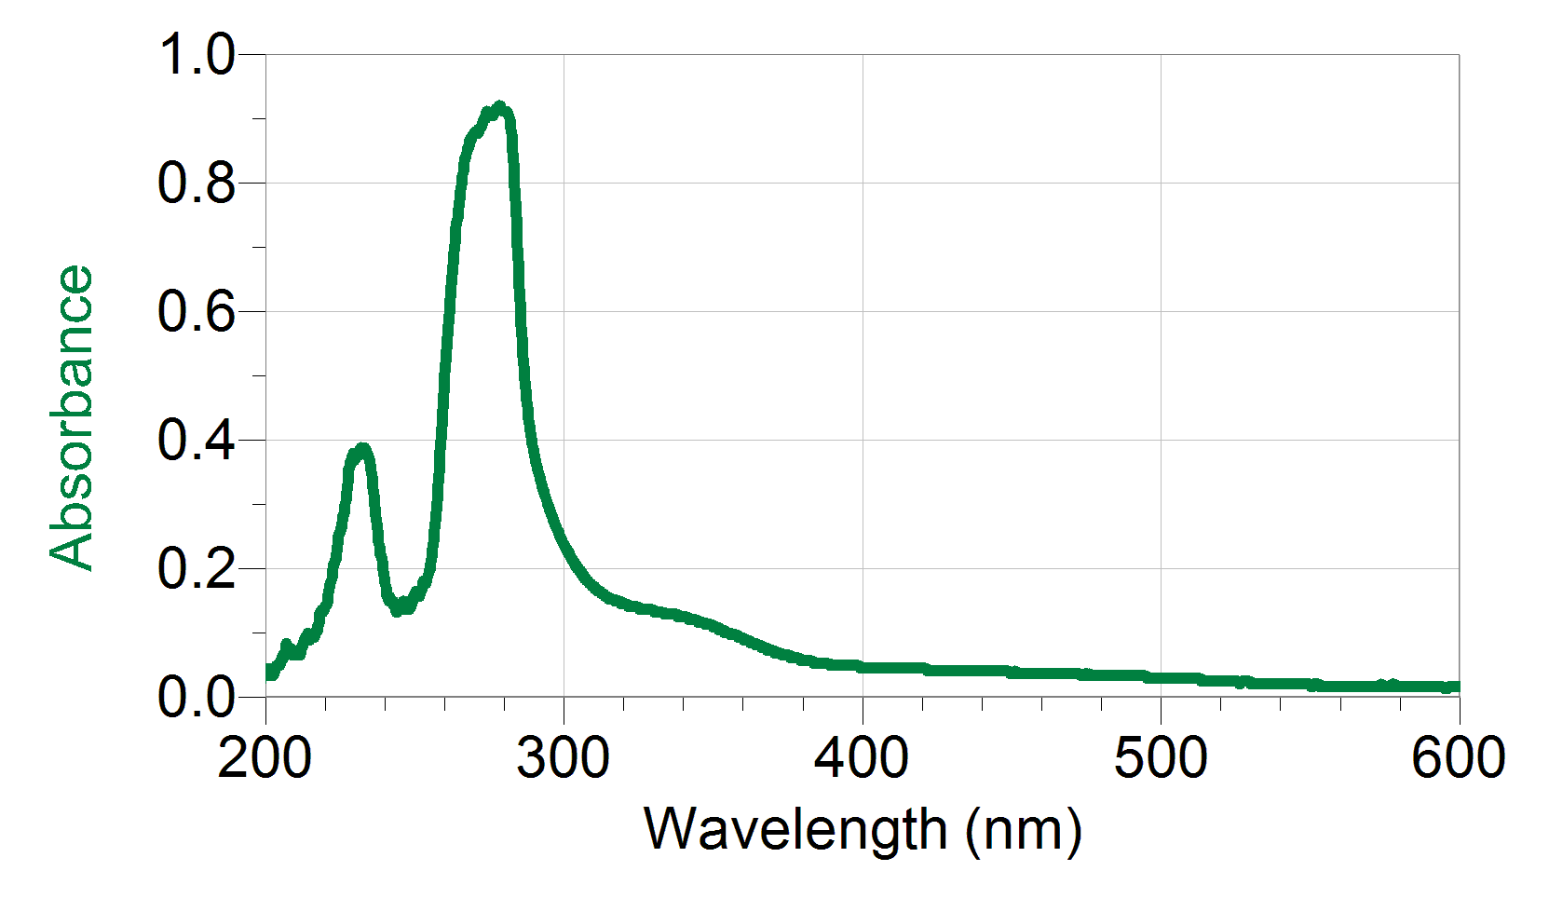
Figure 2: Ground state absorption spectrum of one spiropyran in toluene

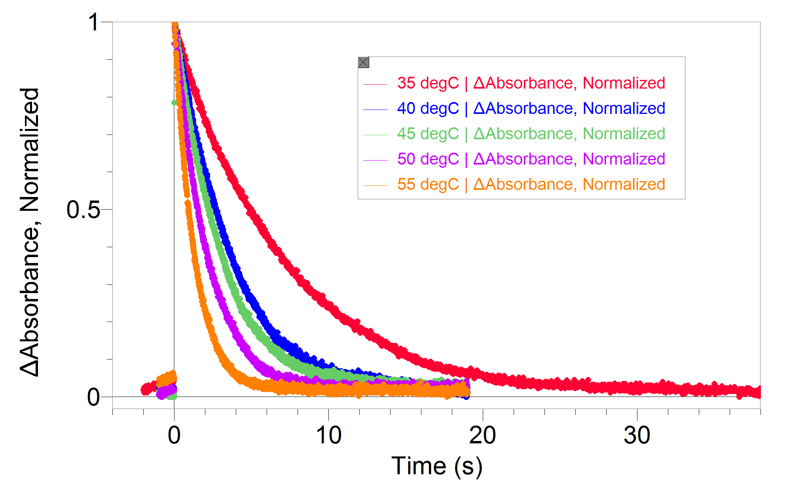
Figure 3: Transient absorption at 600 nm of spiropyran in toluene
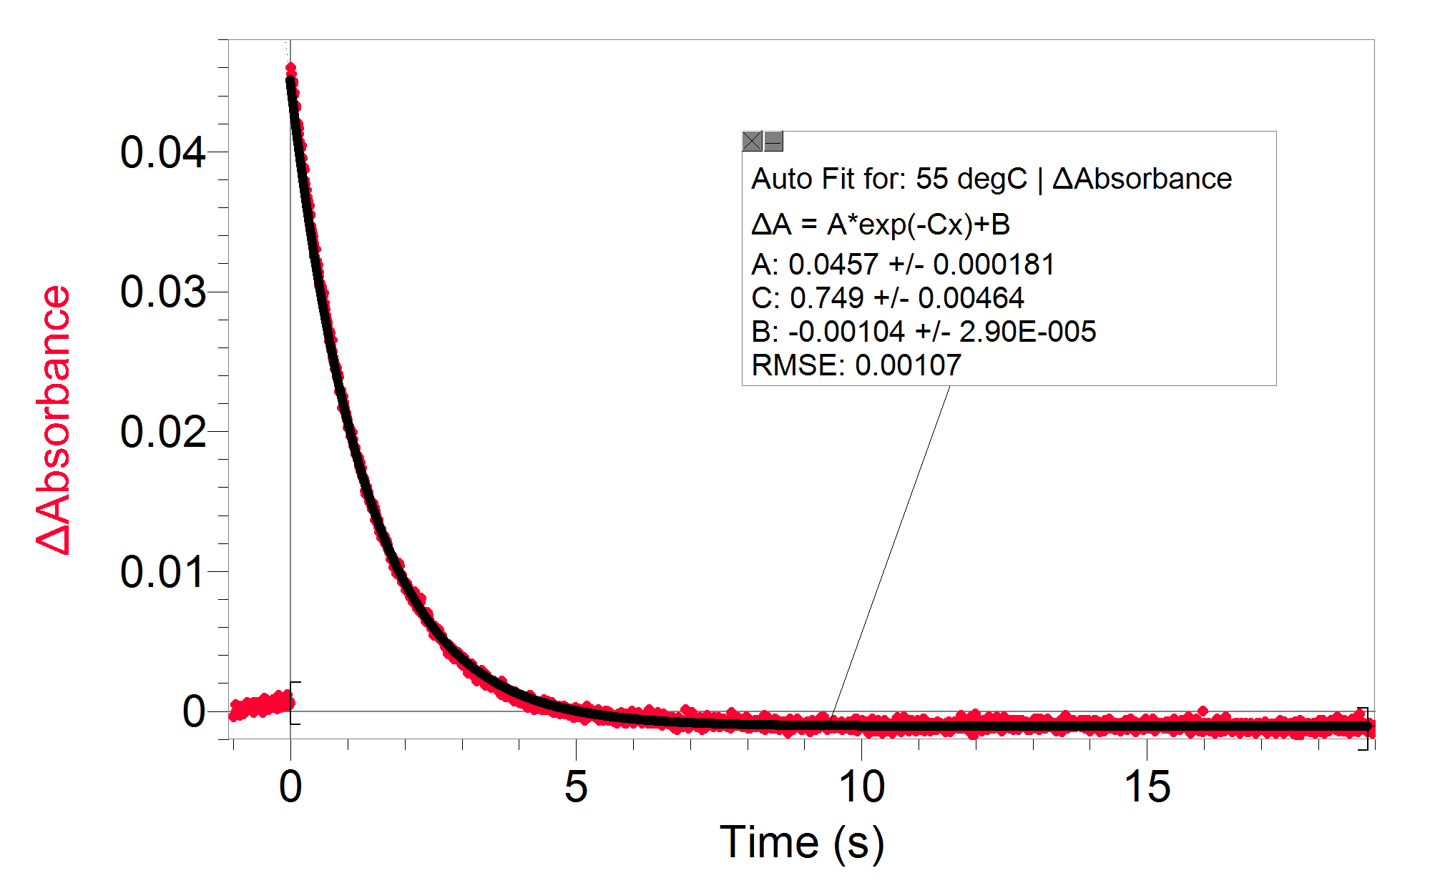
Figure 4: Example decay and exponential fit for 55°C measurement

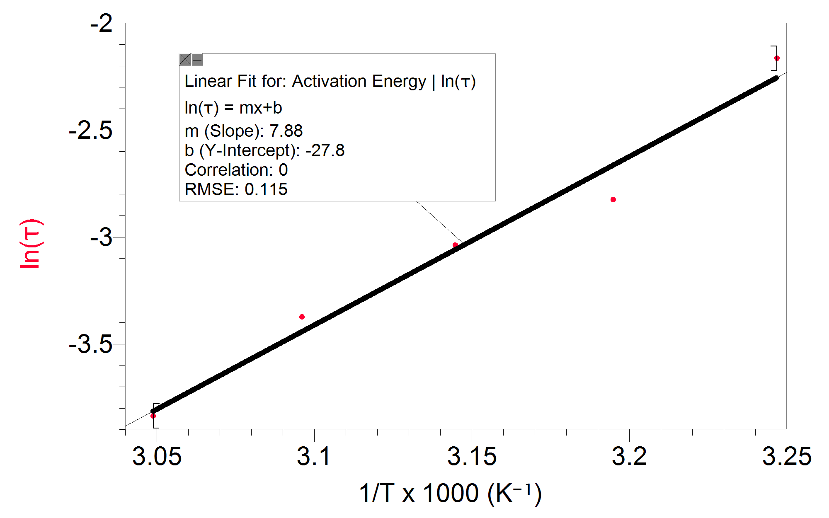
Figure 5: Actual data example of ln(τ) as a function of 1000/T

Reference: Piard, Jonathan, “Influence of the Solvent on the Thermal Back Reaction of One Spiropyran” Journal of Chemical Education. 2014, 91, 2105–2111.

